Listening to the Better
Angels of Our Nature:
Ethnicity, Self-Determination,

And the American Empire

Chapter Fourteen

The Scramble for Africa:

Part 1-The Slave Trade and

the Search for Timbuktu

David Steven Cohen

“Africa’s diverse peoples resulted from its diverse geography and its long prehistory,” writes Jared Diamond. “Africa is the only continent to extend from the northern to the southern temperate zone, while also encompassing some of the world’s driest deserts, largest tropical rain forest, and highest equatorial mountains. Humans have lived in Africa far longer than anywhere else; our remote ancestors originated there around 7 million years ago . . .” The continent of Africa is divided into three major zones and two fringe zones. The major zones are the Sahara Desert, the savanna, and the tropical rainforest. The fringe zones include the Mediterranean and South African coastlines (although with climates similar to the Riviera region of the northern Mediterranean) and the so-called Sahel located between the Sahara Desert and the savanna and rain-forest zones.

There are also several highlands, including the Atlas Mountains in the northwestern part of the continent, the Kenyan and Ethiopian or Abyssinian highlands in the eastern part. The continent is drained by three major rivers valleys and several minor ones. The Nile River flows northward from the Ethiopian highlands to the Mediterranean Sea where its forms the wide Nile Delta. Along the banks of the Nile are papyrus swamps known as the sudd from which the name Sudan comes. The Congo River Basin has it source in several tributaries in the so-called Great Lakes region of central equatorial Africa and flows west to the Atlantic Ocean. The third major river is the Niger, which forms a large fishhook shape in western Africa and empties into the Gulf of Guinea along which has become known as the Gold Coast. The minor river valleys include the Senegal River flowing to the north and west in northwest Africa; the Zamezi River flowing to the east in southeastern Africa to empty into the Mozambique Channel between the mainland and the island of Madagascar; and the Orange River and its tributary the Vaal, flowing from east to west in South Africa to empty into the South Atlantic Ocean.

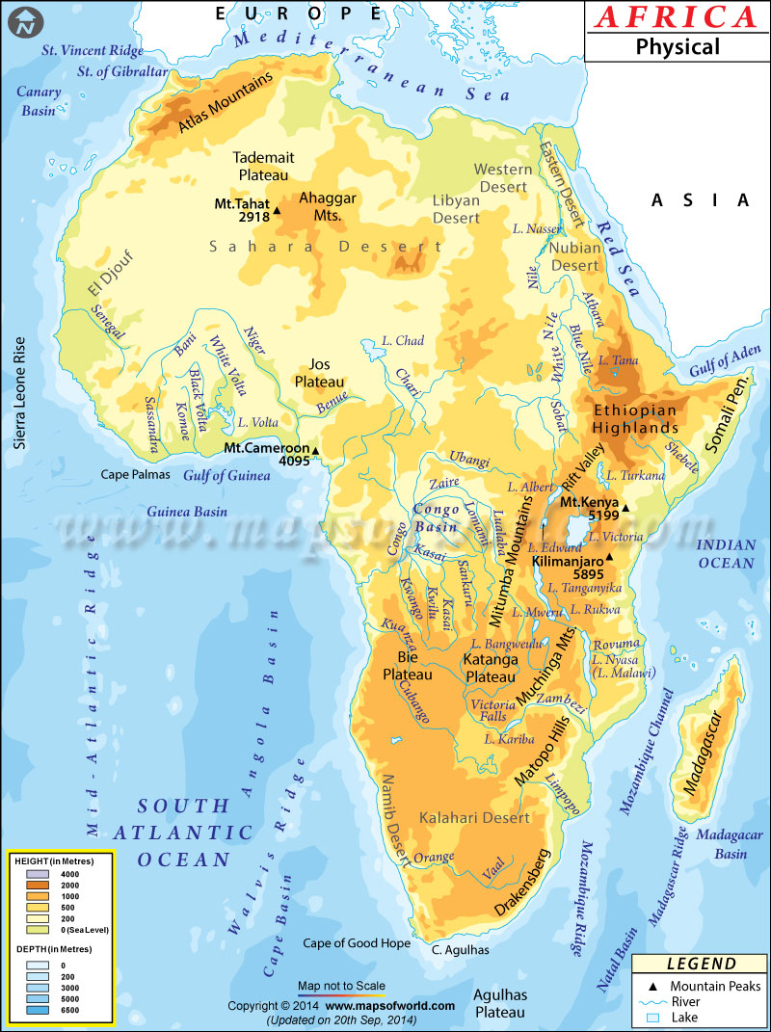
http://www.mapsofworld.com/physical-map/maps/africa-physical-map.jpg

The Sahara Desert spans most of North Africa. It consists of rock rather than sandy stretches interspersed by waterholes or oases. It is a desert region that is dry, hot during the summer, and dry during the winter. This is a region of nomadic peoples living in tents, oasis agriculture, in which camels are used for transportation.

North of the Sahara along the shores of Mediterranean Africa is a narrow region in which the climate is similar to that of southern Europe. It includes the Atlas Mountains, the Spanish Ifni, northern Morocco, Algeria, Tunisia, a coastal strip to Tripolitania, and an upland in Cyrenaica, Libya. At the higher elevations there are deciduous and coniferous trees, and at lower elevations cedars and cork oak trees, The crops that were grown in North Africa with its Mediterranean climate similar to the Fertile Crescent of the Middle East, including barley, wheat, peas, beans, lemons, almonds, figs, grapes, and olives.
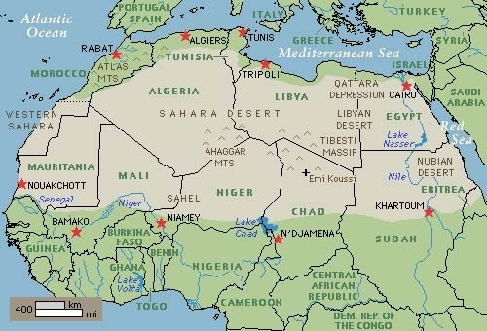
http://a.static.trunity.net/images/179848/500x340/scale/sahara_desert_02.jpg

To the south of the Sahara is the Sahel, which is a borderland between the desert and the savanna. It consists of semi-arid grasslands, woodlands, and shrublands interspersed with isolated plateaus and mountain ranges. It is the oldest region in Africa of agricultural cultivation, where as early as 5000 B.C. sorghum and African rice were grown. The domestic Guinea fowl originated here at about the same time. Along the bend of the Niger River in what is today the country of Mali, were situated the trading towns of Timbuktu, Gao, and Djenné. In the Sahel, where the rains come in the summer rather than the winter, the crops are sorghum and pearl millet, which Diamond calls “the staple cereals of much of sub-Saharan Africa.”

The savanna is the grasslands and forest region. It is hot and humid in summer and dry and warm in winter. It consists of steppe grasslands in Angola and western South Africa as well as a continent wide strip south of the Sahara Desert, open savanna (grassland and woodland) in another continent-wide strip north, east, and south of the rainforest, temperate grassland in eastern South Africa. The region extends from Senegal on the west to Lake Chad on the east, and as far south as Somalia. In the Ethiopian highlands the crops include chat (a narcotic), ensete (which is like bananas), noog (an oily plant), finger millet (brewed into beer), and teff (a grain used to make bread). In addition coffee is thought to have originated in Ethiopia and spread to Arabia and then around the world. West Africa is the home of African rice, yams, oil palm, and kola nuts (a caffeinated narcotic chewed by West Africans). In the southern part of the continent these grasslands are known as the veld, which comes from is the Dutch and German word veldt or grasslands The agricultural here traditional makes use of hoes with some grazing animals and people tend to live in towns.

“Most Americans and many Europeans equate native Africans with blacks, white Africans with recent intruders, and African racial history with the story of European colonialization and slave trading,” writes Diamond. However, he adds, “Even before the arrival of white colonialists, Africa already harbored not just blacks but . . . five of the world’s six major divisions of humanity, and three of them are confined as native to Africa. One-quarter of the world’s languages are spoken there. No other continent approaches this human diversity.” The five groups mentioned by Diamond are blacks, whites, African Pygmies, Khoisan, and Asians. More Asians and whites live outside Africa today. Blacks formerly lived only in Africa, but today only Pygmies and Khoisan live only on that continent. In 1400 A.D. blacks (including Zulus, Somalis, and Ibos) lived primarily in the southern Sahara and in sub-Saharan Africa. Whites (including Egyptians, Libyans, and Moroccans) lived in the northern Sahara and the northern coastal region of Africa. The Khoisan include both the San and the Khoi, previously known as the Bushmen and Hottentot. Today, the names San and Khoi are preferred. The San were hunter-gathers, and the Khoi were herders of livestock. The Pygmies were hunters who were widespread throughout the equatorial forests until they were displaced by Bantu farmers. The Pygmies are the only African group that doesn’t have its own language. Instead they speak the languages of the people who live next to them.

Africa’s 1,500 languages are classified into five language families: Afro-Aisiatic (which includes the Semitic sub-family), Niger-Congo (not-Bantu), Niger-Congo (Bantu), Nilo-Saharan, Khoisan, and Austronesian. The Semitic languages (which include Aramaic, Hebrew, and Arabic) according to Joseph Greenberg, a linguist at Stanford University, are only one of six branches of the Afro-Asiatic languages. The Afro-Asiatic region covers a large part of north Africa from the Atlantic Ocean, through the southern and eastern Mediterranean to the Arabian Peninsula to the Horn of Africa. It is thought that like the other Afro-Asiastic languages it arose in Africa and spread to the Near East. The Afro-Asiatic-speaking Caucasians which include five linguistic subgroups: the Hamito-Semitic which originated in Arabia and Mesopotamia, the Berber along the northwest coast of Africa, the Ancient Egyptian in the middle Nile valley, the Chadic in the Sahara (after which the country of Chad is named). The Negro population in the upper Nile Valley had a distinct language family known as Sudanic (after which the country of Sudan was named), including Twi (the language of the Ashanti-Fanti people of the Gold Coast), Ewe (the language of the Togoland), Yoruba and Dahomey (in Nigeria), Wolof or Jolof (spoken in Gambia and Senegal), Temne and Mende (in Sierra Leone), Mandingo (in central Sudan), Ibo, Nupe, and Efik (in eastern Sudan).

The other major language families in Africa include the Nilo-Sharan languages found in pockets in north central Africa, the Niger-Congo languages found along the West Africa and the Congo River basin, the Bantu languages (which is a branch of the Niger-Congo family) found vast savannahs of south central Africa, and the Khosian languages found in South Africa and other pockets such as Tanzania. The Niger-Congo speaking peoples include the Mande or Mandingo in western Sahara, the Adamawa-Eastern in the eastern Sahara, and the Bantu in southeastern Nigeria and the Cameroon Highlands, including Kongo. “Evidently,” Diamond says, “the Niger-Congo language family arose in West Africa; the Bantu branch of it arose at the east end of that range, in Cameroon and Nigeria; and the Bantu then spread out of that homeland over most of subequatorial Africa. That spread must have begun long ago enough that the ancestral Bantu language had time to split into 500 daughter languages.” The Bantu expanded from the Cameroon Highlands into the rainforest and pushed the Pygmy further into the interior. From there the Bantus pushed into the savanna lands. Diamond says that “all of Africa’s indigenous crops—those of the Sahel, Ethiopia, and East Africa—originated north of the equator. Not a single African crop originated south of it. This already give us a hint why speakers of the Niger-Congo languages, stemming from north of the equator, were able to displace Africa’s Pygmies and subequatorial Khoisan people.”

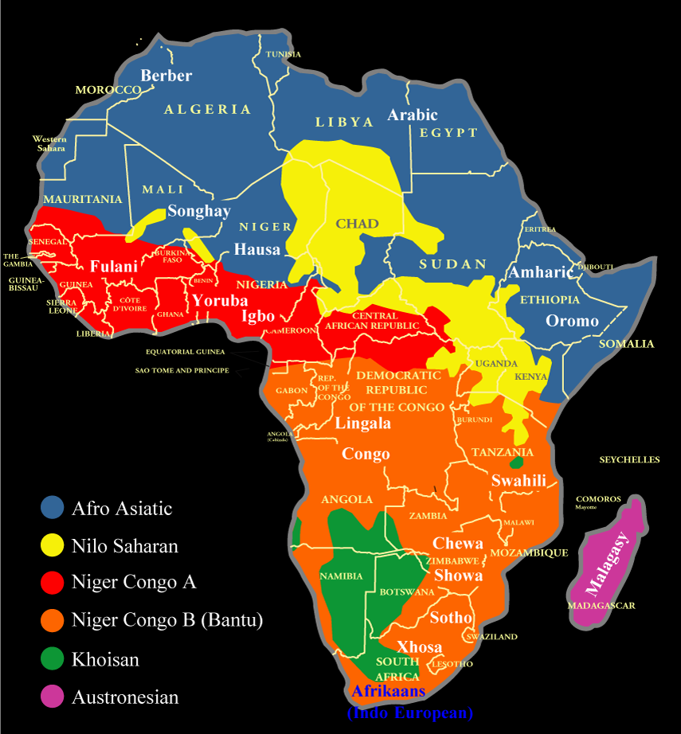
http://www.nationsonline.org/maps/African-language-map2.png

As early as 2000 B.C. iron-making was brought by the Berber traders from Egypt to the western Sudan, which lead to the development of the early African kingdom of Ghana. Other metals such as bronze and brass were developed by the people of the Guinea Coast and the Congo. Metal tools enabled them to make door posts, boxes, stools, masks, and drums from wood and human and animal forms carved in ivory. One of the early items of trade within Africa was salt, which was rare in the Sudan region between the Sahara and the rain forest. The Berbers developed harvested salt in the north-central deserts which they exchanged for gold and Negro slaves to work in the salt works. The Berbers also had camels to transport the salt across the Sahara to peoples of the Niger Basin. Salt also contributed in the rise to power of the Empire of Ghana, which gained control of the mid-Sahara salt mines, but not the gold mines to the south at the headwaters of the Niger River. The Phoenicians founded the city of Carthage in the ninth century B.C. and introduced bronze and iron making. In the second century B. C. the Romans conquered Carthage and introduced irrigation systems and monopolized trade with central Africa. It became part of the Byzantine Empire in fifth and sixth centuries A.D.

In the spring of 640 A.D. Muslims under the Caliph Omar crossed the Nile and within four years all of North Africa from Egypt to Carthage was paying tribute to them. Between 670 and 683 Islam conquered present-day Algeria from Byzantium. Early trade routes across the Sahara transporting gold, ivory, ostrich feathers, and slaves to the Greeks, Carthaginians, and Romans on the Mediterranean and textiles, metal ware, and salt to the Sudan to the south. Camels from Persia were introduced to Egypt in 525 B.C. They were brought by the Romans to the town of Ghadames between Algeria and Libya in 47 B.C. and quickly adopted by the Berbers. Under the Ottoman Empire the region was known as the Barbary States and known for piracy on the Mediterranean Sea.

In 634 A.D. the Bedouins, who had converted to Islam, defeated the Byzantine Christians and laid siege to Damascus. In the spring of 640 A.D. Muslims under the Caliph Omar crossed the Nile and within four years all of North Africa from Egypt to Carthage was paying tribute to the Arabs. Between 670 and 683 Islam conquered present-day Algeria from Byzantium. The Berbers speak their own language, and therefore they were unable to read the Koran in Arabic. The Tuareg Berbers initially opposed the Arab invasion of the Sahara, and most remained nomads near the oases or caravan traders. The Arabs tended to own the better oases. Some of the Berbers resisted the Arabs, but in 711 Berber converts under General Tarif crossed into Europe and defeated the Spanish Christians at Mount Tarif (Gibraltar, today). The Berber and Arab conquerors became known as the Moors. One of the early items of trade within Africa was salt, which was rare in the Sudan region between the Sahara and the rain forest. The Berbers developed harvested salt in the north-central deserts which they exchanged for gold and Negro slaves to work in the salt works. The Berbers transported the salt across the Sahara to peoples of the Niger Basin. This resulted in the rise to power of the Empire of Ghana, which gained control of the mid-Sahara salt mines, but not the gold mines to the south at the headwaters of the Niger River.

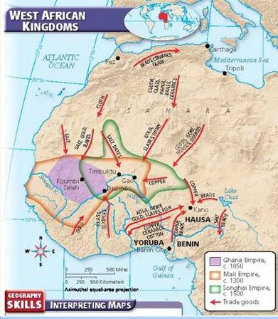
http://farrellworldcultures.karnscity.wikispaces.net/file/view/Africa_West_African_Kingdoms.jpg/196474800/391x448/Africa_West_African_Kingdoms.jpg

Around 1230 the Mandinka ruler Sundiata Keita overthrew the kingdom of Ghana and established the Muslim kingdom of Mali. Sundiata became known as the “Lion King of Mali” in an epic poem of the Mandinka people that went into oral tradition through retelling by generations of griot (storytellers). One of his successors was Mansa Musa, who in 1324 made a legendary pilgrimage to Mecca with an entourage consisting of 60,000 men, 12,000 slaves, and 80 camels bearing gold that he distributed to the poor along the way. It is thought that his pilgrimage was the beginning of the storied wealth of the Niger River region. A significant number of Mandinka were brought to North America as part of the trans-Atlantic slave trade. Today, the Mandinka people are distributed in several West African countries, including the Gambia, Guinea, Mali, Sierra Leon, the Ivory Coast, Senegal, Burkina Faso, Liberia, Guindea-Bissau, Niger, and Mauritania.

The Yoruba are black Africa’s largest population. The Yoruba state of Oyo (near Ibadan in modern Nigeria) had developed stone carving, iron-making, and bronze-working. As Songhai and Islam infringed from the north and Benin from the south, the Yoruba had to develop a military organization by the end of the sixteenth century. Robert Farris Thompson writes: “Yoruba urbanism is ancient, dating to the Middle Ages, when their holy city, Ile-Ife, where the Yoruba believe the world began, was flourishing with an artistic force that later provoke astonishment in the West.” On the savannas to the northeast of the Yoruba were the Hausa people. Both the Fanti and the Ashanti acquired slaves from the interior and sold them to the Europeans. Wiedner writes that “Before the end of the seventeenth century the Ashanti had changed from a peaceful, agricultural people into a military alliance that expanded first by conquest, then by threat and persuasion.” The Ashanti acquired salt, tools, and European goods by trade with the Fanti and through this trade the savanna tribes became dependent on the Ashanti. The demand for slaves in America in the eighteenth century resulted in the Ashanti obtaining an arsenal of arms and ammunition. After 1805 the Ashanti tried to push out the Fanti as the middle man in this trade.

To the west of the Yoruba were the Ashanti people in present-day Ghana. They were descendants of the Akan people who migrated from the upper reaches of the Volta River in the thirteenth century A.D. to the region of the lower Volta occupied by the Ga people. The Ashanti became the main producers of gold from inland regions the upper Niger. Another Akan people known as the Fanti settled along the Gold Coast just west of the Ga. The Portuguese made treaties with the Fanti tribes at a trading posted they established in 1482 at Elmina on the Gold Coast to exchange gold from the interior for salt, cloth, and tools.

“In all West Africa south of the Sahara, and in the Congo, agriculture is the mainstay of the productive economy, though in the northern savanna country herding is also important. In all the area gardening is done with the hoe, the heavy agricultural work being performed by the men, the crops being tended by women,” writes Melville Herskovits. “In addition to the basic agricultural organizations are various craft groupings, which reflect a division of labor that makes for specialization in various callings—ironworkers, cloth weavers, wood carvers, traders, dealers in object of supernatural moment, potters, basket makers.”

Jared Diamond poses the question: “Why Europeans were the ones to colonize sub-Saharan Africa?” and not the other way around. His answers are first, Eurasia native animals were cows, sheep, goats, horse, and pits that were easily domesticated, whereas the native animals of Africa, such as buffalo, zebra, bush pig, rhino, and hippopotamus were not easily domesticated. He notes, however, that Hannibal had “tamed” African elephants in his unsuccessful war against Rome. Second, Eurasia had developed more domestic plants than the Sahel, Ethiopia, and West Africa. Third, only about a third of the African continent is located in the sub-Saharan region north of the equator, occupied by farmers and herders before 1000 B.C. Thus, Diamond claims “all other things being equal, more land and more people mean more competing societies and inventions, hence a faster pace of development.” Finally, Diamond maintains that Africa’s main axis is north-south, whereas Eurasia’s is east-west. “As one moved along a north-south axis, one traverses zones differing greatly in climate, habitat, rainfall, day length, and diseases of crops and livestock. Hence crops and animals domesticated or acquired in one part of Africa had great difficulty moving to other parts.”

Under Prince Henry the Navigator that Portugal sought to open a sea route to the gold mines on the west coast of Africa to bypass the Moors and the Sahara desert. He sent ships to trade for gold and Negro slaves as early as 1418, first from the Berbers at Arguin (modern Mauritania) and later by the time of his death in 1460 from the so-called Gold Coast. It was in this trade that Christopher Columbus of Genoa gained his initial navigational experience in the employ of the Portuguese. By the 1480s the Portuguese were obtaining gold on the so-called Gold Coast, at the mouth of the Senegal River and at El Mina in the Gulf of Guinea. In 1497 Vasco de Gama navigated around the Cape and, according to Pakenham, “opened up the seaway to the Indies. The seaway supplanted the land route across Asia, and long the coast of Africa lay the main road of world trade.” In March 1498 da Gama navigated along the east coast of Africa he came upon Zenj ports of Muslim traders. “At the same moment a new kind of African export came on the market, which was even more important for world trade during the next 300 years than African gold had been in the Middle Ages.” This was the trade in slaves along the so-called Slave Coast west of the Niger River destined for plantations in Brazil, the West Indies, and North America. In response to the Portuguese traders the Yoruba along the Niger Delta made the Dahomeans into their vassals in a military confederation.

Between 1509 and 1510 Afonso d’Albuquerque completed the conquest of all the Arab, Indian, and Malayan entrepôts on the east coast of Africa and the trade routes from Mozambique to Hormuz in Persia, Malacca on the Malay Straits, and Goa on the Indian subcontinent. The Portuguese took over the trade in Monomotapa gold, slaves, and ivory from East Africa in exchange for Asian cloth, metal products and glasswork. Portuguese and Goan settlers were encouraged create large plantations on the upper reaches of the Zambezi River. However, Portugal’s main interest was in Goa and the Spice Island rather than Africa. The Mombasa, Malini, and Kilwa people, who had been ruled for years by the Arabs, disliked the tributes and trade restrictions that were imposed upon them. Starting in 1622 Oman helped evict the Portuguese from East Africa, and by 1650 the coast was mostly Arab dominated. In response to the Portuguese traders the Yoruba along the Niger Delta made the Dahomeans into their vassals in a military confederation.

To the west of the Yoruba were the Ashanti people in present-day Ghana. They were descendants of the Akan people who migrated from the upper reaches of the Volta River in the thirteenth century A.D. to the region of the lower Volta occupied by the Ga people. The Ashanti became the main producers of gold from inland regions the upper Niger. Another Akan people known as the Fanti settled along the Gold Coast just west of the Ga. The Portuguese made treaties with the Fanti tribes at a trading posted they established in 1482 at Elmina on the Gold Coast to exchange gold from the interior for salt, cloth, and tools. In 1580 King Philip II of Spain inherited the Portuguese, which deprived Portugal of its main trading partner, the Netherlands. The Dutch had been trying for eight years to become independent from Spain. Instead of trading with Portugal, the Dutch began to send its own fleets to India and East Asia.

“The Hispanic nations of the Iberian peninsula were the first to begin the slave trade, and the last to quit. In the fifteenth and sixteenth centuries, the Spanish and Portuguese carried the rudimentary institutions of the South Atlantic System from the Mediterranean to the Atlantic Islands, then to Santo Domingo and Brazil,” writes Philip Curtin. In the seventeenth and eighteenth centuries, the Dutch, English, and French dominated the slave trade, but, in the nineteenth century, Brazil and Cuba accounted for the vast majority of slaves imported—and by that time the northern powers had made their own slave trade effectively illegal.” Donald Wiedner writes: “After 1530, however, Spanish expansion to Cuba and the American mainland along with Portuguese settlement in underpopulated Brazil created new markets for African slaves. Before 1550, the old mines near Elmina began to give out, so the Fanti middlemen began supplying slaves for the Americas.” In 1576 as the Bantu people along the southwestern coast of Africa began to lose power, the Portuguese established a slave depot at Luanda in present-day Angola, which came to replace the Congo region as the leading provider of slaves. In the seventeenth century, the Dutch West India Company usurped the slave trade from the Portuguese on the west coast of Africa. The Dutch made their own treaties with the Fanti and seized control of the Portuguese fort at Luanda. Until the 1670s the Dutch held a virtual monopoly on the Atlantic slave trade.

In 1660 a group of London merchants received a royal charter from King Charles II for the Company of Royal Adventurers Trading to Africa. Its leader was Charles II’s brother, James, the Duke of York, later King James II. Its original purpose was to exploit the gold fields along the Upper Gambia River, but it soon became involved in the slave trade. The company was granted a monopoly over English trade with West Africa. In 1664 the British Admiral Robert Holmes attacked the Dutch trading posts in Africa, prompting a war between Britain and the Netherlands. By 1667 the company was heavily in debt and it lost most of its forts on the Africa coast. In 1668 a new company named the Gambia Adventurers was granted a ten-year license to the African trade north of the Bight of Benin.

In 1672 the earlier company was restructured as the new Royal African Company with additional powers to establish forts and factories, maintain an army, and exercise martial law in West Africa in pursuit of trade in gold, silver, and slaves. When the Gambia Adventurers license expired in 1678, it was merged into the royal African Company. The slaves bound for America were branded either with the letters DY for the Duke of York or RAC for Royal African Company. From 1694 to 1689 the company allied itself with a merchant named John Cabess [or Cabessa] and nearby African kingdoms in deposing the King of Eguafo (in Ghana, today) and establishing a fort and factory in the town of Komenda. After the Glorious Revolution in 1698 the Royal African Company lost its monopoly and the African trade was open to all English merchants who were willing to pay a ten percent levy to the company. After 1731 the company stopped buying and transporting slaves in favor of trade in ivory and gold dust. The gold was sold to the English Mint to be made into gold coins known as guineas. In 1752 the Royal African Company was dissolved and it was succeeded by the African Company of Merchants.

In June 1788 nine members of the Saturday’s Club (an elite eating club) met at Albans Tavern in London. Among those present were Sir Joseph Banks, a wealthy and influential botanist who had accompanied Captain James Cook on his first expedition around the world; Henry Beaufoy, a Quaker abolitionist who was also a Member of Parliament; the Bishop of Llandaff, a scientist and abolitionist; Sir Joh Sinclair, a mathematician who later became governor-general of India; and Lord Rawdon, who commanded British forces at the Battle of Bunker Hill during the American Revolution, later became the governor of Bengal and owner of the island of Singapore. At this meeting the group founded the Association for Promoting and the Discovery of the Interior or Africa, later known simply as the African Association. Its first goal was to explore the Niger River and discover the ancient city of Timbuktu. “Though the prospect of profitable commerce with the unknown continent was certainly a motivating factor (it was probably no accident that the St. Albans worthies set their sights on Africa so soon after England lost her vast American territories, only five years before, in 1783), the group had more noble motives as well: the abolition of the slave trade and a sincere desire of Knowledge.”

The main port in the Kingdom of Dahomey on the Guinea Coast was Whydah, about 150 into the interior. “There are no traditions among these people that they acted as middlemen for traders farther inland; they were, in fact, avoided by the merchant folk, such as the Hausa, since the stranger in their kingdom was himself fair game,” says Herskovits. “The peoples raided by the Dahomeans lived no farther from the coast than 200 miles, while most of their victims came from much near. Tribes to the east and west, rather than to the north, were the easiest prey, and hence the Nago (Yoruba) of Nigeria and the people of the present Togoland are found to figure most prominently in native lists of the annual campaigns.”

Both the Fanti and the Ashanti acquired slaves from the interior and sold them to the Europeans. Wiedner writes: “Before the end of the seventeenth century the Ashanti had changed from a peaceful, agricultural people into a military alliance that expanded first by conquest, then by threat and persuasion.” The Ashanti acquired salt, tools, and European goods by trade with the Fanti and through this trade the savanna tribes became dependent on the Ashanti. The demand for slaves in America in the eighteenth century resulted in the Ashanti obtaining an arsenal of arms and ammunition.

After 1805 the Ashanti tried to push out the Fanti as the middle man in this trade. The Yoruba state of Oyo (near Ibadan in modern Nigeria) had developed stone carving, iron-making, and bronze-working. As Songhai and Islam infringed from the north and Benin from the south, the Yoruba had to develop a military organization by the end of the sixteenth century. Between 1724 and 1729 the King of Dahomey conquered much of the coast and became middle-men in the slave trade. The Dahomeans enlisted an elite corps of virgin women known as Amazons to conquer neighboring states such as the Ouidah (or Whydah). In the mid-nineteenth century Dahomey attempted with its Amazon army to take control the port at Lagos, but failed. In 1861 the port was occupied by Britain.

On the savannas to the northeast of the Yoruba were the Hausa people. Kano was a Hausa city in northern Nigeria. It is located between 500 and 600 miles from the coast. Between 1804 and 1820 the Fulani leader Usuman (Othman) dan Fodio fought against the Hausa states and eventually conquered parts of Yorubaland and the old Songhai. The Fulani Empire launched slave raids in the Cameroon Highlands. His lieutenant Ahmadu Lobo extended Fulani control over the Mandingoes who lived bet ween the Niger and Senegal rivers. Ahmadu Lobo established the Massina Empire. In 1838 the Tuscolor Negroes on the eastern border of Senegal came under the control of El Hadj Omar. The Tuscalor extended their control toward Senegal and the Niger Valley under Omar and his son Ahmadu Lobo II. In 1847 a Muslim commoner named Samory became the leader of the Mandingoes in the southeastern section of the French colony. Both the Tuscolor and the Mandingoes attacked the Woloff tribes that were allied with the French colonists. Napoleon III sent as governor of Senegal General Louis Faidherbe, who when he arrived in 1854 attempted to peacefully contain the Mandingoes and Tuscolor. By 1879 this policy was not working, so the French launched a campaign to conquer the savannas over the next nineteen years.

“Large numbers of slaves were shipped from the Niger Delta region, as indicated by the manifests of ships loaded at Calabar and Bonny, the principal ports,” writes Herskovits. “These were mainly Ibo slaves representing a people which today inhabits a large portion of this region.” Calabar Negroes was a generic name for Ibo slaves. Philip Curtain says that there two tendencies at work in designating the African places of origin in the official records. “One was the European habit of identifying nationalities customarily shipped from a particular African port by the name of the port, as in the case of ‘Senegalese.’ The second was to pick one ethnic group or linguistic term to identify a much larger group, as in the case of ‘Bambara.’ These tendencies make for confusion and overlapping terminology. . . . These overlapping variants make it difficult to equate ethnic identifications with particular coastal regions of the slave trade. ‘Mandigue’ (or Mandingo in English) was originally a term attached to the Malinke-speaking people of the Gambia valley, but it later spread to all speakers of Mande languages.”

Robert Farris Thompson notes that, “The slave traders of the early 1500’s first applied the name ‘Kongo’ solely to the Bakongo people. Then gradually they used the name to designate any person brought from the west coast of Central Africa to America. Similiarly, the meaning of ‘Angola’ broadened over the centuries. ‘Ngola’ once referred only to the ruler of the Ndongo part of the Kimbundu culture in what is now the northern part of Angola. . .Then the term became the name of not only modern Angola but sometimes the whole west coast of Central Africa, from Cape Lopez in northwestern Gabon to Benguela on the coast of Angola proper.”

Between 1701 and 1810 about 50 percent of the overall Trans-Atlantic slave trade was conducted by the France and England. More than 70 percent of the slaves in the English trade came from the Guinea Coast from Cape Mount to the Cameroons. Philip Curtin identifies six subregions: Senegambia (Senegal and Gambia, today); Sierra Leone (Guinea-Comakry, Guinea-Bissau, and parts of Senegal and Liberia); the so-called “Windward Coast” (on either side of Sierra Leone); the Gold Coast (the Republic of Ghana); and the Bight of Benin (Togo and Dahomey); the Bight of Biafra (centering on the Niger River Delta from the Benin River on the west to Cape Lopez in Gabon on the south). Lesser numbers came from “Angola” (in its broad sense consisting of most of Central Africa) and southeastern Africa (from the Cape of Good Hope to Cape Delgado, including the island of Madagascar). Philip Curtin revised the total number of slaves imported to the Americas from 1451 to 1870 from 20 million to approximately 10 million. Almost 90 percent of these slaves were not sent to North America, but to the Atlantic fringe of South America from Brazil through the Guianas and to the coast and islands of the Caribbean. The slaves from Senegambia were sent primarily to the French Caribbean island of Martinique and French Guiana.

Robert Farris Thompson writes that “Africans from Kongo and Angola shared fundamental beliefs and languages. When they met on the plantations and in the cities of the western hemisphere, they fostered their heritage. Kongo civilization and art were not obliterated in the New World: they resurface in the coming together, here and there, of numerous slaves from Kongo and Angola.” One of the best examples is no the folk religion known as Voodoo. “There are thousands of deities in Yoruba territory, western Nigeria and eastern Benin Republic, but only the most widely worshipped and important survived the vicissitudes of the Atlantic Trade,” writes Robert Farris Thompson. “These deities include Eshu, spirit of individuality and change; Ifá, god of divination; Ogú. Lord of iron; Yemoja, goddess of the seas; Oshun, goddess of sweet water, love, and giving; Oshoosi, god of hunting; Obaluaiye, dread spirit of disease and earth; Nana Bukuu, his mother; Shángó, the fiery thunder god, who inspired thousands of Afro-Americans (two Afro-American religions—Shángó in Trinidad and Xango in Recife in Brazil—bear his name). . . . In Haiti occurred a deep synthesis of the main forms and tenets of the classical religions of the Yoruba, the Dahomeans, and the Bakong that was partly informed by the saints of the Roman Catholic Church and by their attributes. The result was vodun: formally speaking, one of the richest and most misunderstood religions of the planet.”

The voodoo (or Vodun) folk religion was brought from Haiti to New Orleans. Hershovits notes that Papa Lébat (in New Orleans) or Papa Legba (in Haiti) who is related to the Dahomean trickster. The Dahomean serpent-god Dan (who is the god of good fortune) is related to Damballa (in Haiti) or Danny (in New Orleans). He also mentions the syncretistic association of voodoo deities with Catholic saints. “The identity of Legba [or Liba] . . . and St. Peter follows in principle the syncretism of Haiti; . . . Liba, guardian of gate and crossroads, is conceived as St. Peter, guardian of the keys.”

Not only the deities, but also the music and instruments have African roots. “The Congo orchestra consists of three drums of different sizes called manman, timebal, and tri-congo,” writes Thompson. “In their cylindrical shape, double heads and method of head-attachment they are remarkably like European drums of which they may be merely copies. The head tension is obtained by two wooden rings. Unlike the other drums which are positioned vertically or sloped, the timebal is kept horizontal on a chair or some other support. It is played with sticks. . . . It is the timebal, people say which gives the true Congo music, the other drums being merely there to back it up with crié [cries] and ralé [spells].” Albert Métraux notes that in Haitian Voodoo, “The drum is not only a musical instrument, it is also a sacred object and even the tangible form of a divinity. The mysterious object with which it is endowed is conceived of either as a nanum (soul), a sort of vaguely defined life-force, or as spirit called huntó, a Dahomean word used also for the big manman drum and the man who beats it. . . . Time and again in the course of ceremonies, hungan [male priest] and mambo [female priestess] will kiss the ground in front of the drums and pour out liberations to them. . . . Sacrifices and offerings to the drums are part of the ritual obligations of Voodoo societies and constitute a ceremony known as ‘putting the drums to bed’ (coucher tambour), or bay manger tambour (feeding the drums).”

In West African cultures music, dance, and art are closely related. Art historian Robert Farris Thompson argues that throughout sub-Saharan Africa there is a “broad conception of dance” in which “dance is widely is not restricted to the moving human body, but can combine in certain contexts with things and objects, granting them autonomy in art, intensifying the aliveness of an image must embody to function as a work of art. . . . Africa thus introduces a different art history, a history of danced art, defined in the blending of movement and sculpture, textiles, and other forms, bringing into being their own inherent goodness and vitality.” Thompson argues that the concept of “Getting down” is essential both to African art and dance. He notes that “water-spirit dancers in Yorubaland insist that when the sound of the master drummer ascends in pitch the dancers correspond by dancing ‘high,’ i.e., upon their toes, to the maximum vertical extent of their frame. But they bend, gradually, closer to the earth, as they dance until, at one point, they crouch and whirl.”

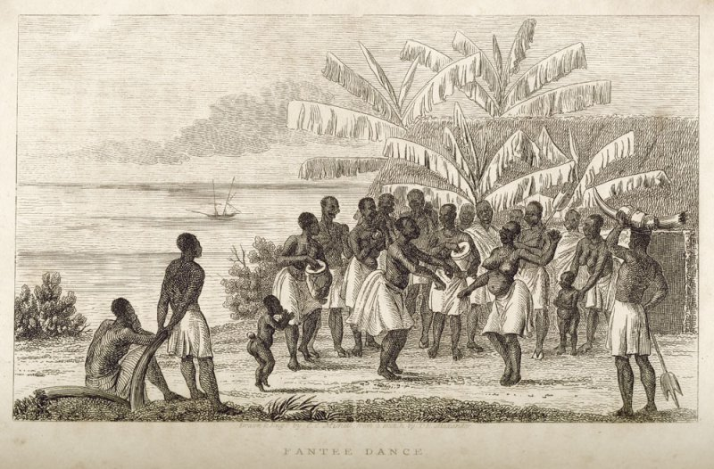
https://niiash.files.wordpress.com/2014/12/fanti-dance-gold-coast-1835-james-edward-alexander-narrative-of-a-voyage-of-observation-among-the-colonies-of-western-africa-london-1837.jpg

He compares that posture seen in Ibibio female sculpture from Nigeria.

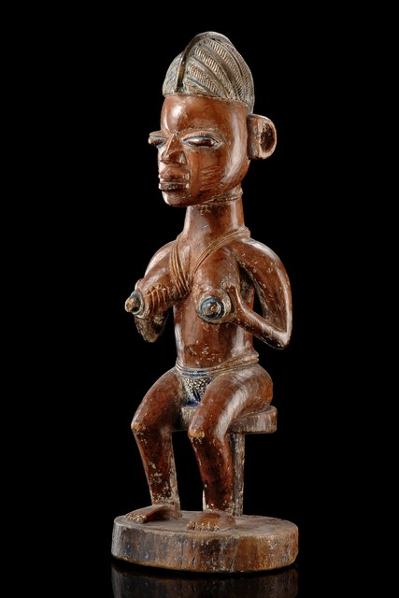
http://www.tribal-art-auktion.de/en/catalogue164/d10_321/

Another musical characteristic of West African music is the call-and-response that Thompson sees replicated in the solo-and-circle or solo-and-line in African dance.

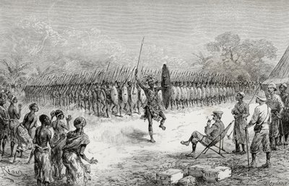
Stanley watching the dance of the Bandusumma at Urisi
http://imageweb-cdn.magnoliasoft.net/bridgeman/fullsize/kw441407.jpg

Alfred Metraux says that “Dance is so closely linked with the worship of loa [spirit or demon] that Voodoo can be regarded as one of the ‘danced religions. Dancing is a ritual act from which emanates a power that affects the supernatural world. Drum rhythms and dances attract the spirits. That is why they are assigned a predominating role in nearly all ceremonies. If the music and dancing pleases to such an extent that they are affected, even against their will, then it is because they themselves are dancers who allow themselves to be carried away by the supernatural power of rhythm.”

There are also West African survivals so-called “day names” given to children according to the day of the week on which they were born, for example, the male Cudjo and female Juba for Monday, the male Cuffee or Cuffy and the female Pheba or Phibbi for Friday, and the male Kwame and female Mimba for Saturday. An African-American rhythmic sequence by slapping one’s hands to the knees or to the chest called “patting juba” (known as hambone in Kentucky) or dancing to this slapping rhythm known as dancing “Juba.” Juba (or jibba, jiba) was the name slaves gave to a stew made up of the week’s leftovers from the plantation house, which was fed to them. It became the basis of a slave song.

Juba dis and Juba dat,
and Juba killed da yellow cat,
You sift the meal and ya gimme the husk,
you bake the bread and ya gimme the crust,
you eat the meat and ya gimme the skin,
and that's the way,
my mama's troubles begin.

J. L. Dillard distinguishes between African survivals and Pidgin English. He defines a pidgin as “a language which has no native speakers. . . When the pidgin becomes the only language of a speech community, it then becomes a Creole.” He states that: “Although many of the slaves may not have had to relinquish their African languages immediately, they all found themselves in a situation in which they had to learn an auxiliary language in a hurry in order to establish communication in the heterogeneous groups into which they were thrown. This mixing of speakers of a large number of languages, with no lone language predominant, is the perfection condition for the spread of a pidgin language, which is in a sense the ultimate in auxiliary languages.” Dillard says that Pidgin English became the language of most slaves in what is today the continental United States. He cautions, however, contrary to popular misconception, a pidgin is not a derogatory term to linguistics.

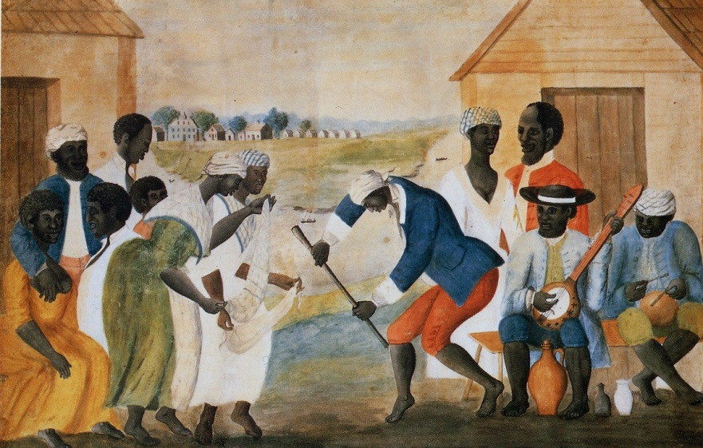
http://upload.wikimedia.org/wikipedia/commons/3/31/SlaveDanceand_Music.jpg

A folk painting titled The Old Plantation in the Abby Aldrich Rockefeller Folk Art Collection, which was found in South Carolina, contains many of these African survivals. Both men and women in front of the slave cabins are wearing headkerchiefs. Hershovits also says that the headkerchief was a West African cultural survival in the United States, the West Indies, and the South American country of Guiana. “The headkerchief was common enough so that it came to be accepted as the integral part of the conventional portrait of the Negro ‘mammy,’” writes Hershkovits. He notes that in Charleston, South Carolina, married women wore a “peculiarly-tied” kerchief on their heads. In Haiti mambos (Voodoo priestesses) wear white headkerchiefs. The central male figure is dancing with a stick. According to
Errol Hill, the stick dance known as the Calinda, which he says is “probably of African origin, that became part of the Carnival celebration in the West Indies. “It was witnessed in Bequia, a small island dependency of St. Vincent, by E. L. Joseph, who described it in 1838 as an agile, dexterous dance performed to Negro drums, while the dancers engaged in mock combat with their ‘beau-sticks,’ which were about thirty inches in length. . . Lafcadio Hearn also saw a ‘holiday caleinda’ danced in Martinique in 1888, when it was accompanied by song-chants as well as drums, and, in the eighteenth century, slaves in San Domingo were heard singing calinda airs to entertain themselves in the evening.”

One of the musicians is playing the banjo. The antecedent of the American banjo can be found in various African gourd instruments. Richard Jobson, an early traveler to Gambia from 1620 to 1621, wrote: "There is, without doubt, no people on the earth more naturally affected to the sound of musicke then these people . . . They have little varietie of instruments, that which is most common in use, is made of a great gourd, and a necke thereunto fastened, resembling, in some sort, our Bandora; but they have no manner of fret, and the strings they are either such as the place yeeldes, or their invention can attaine to make, being very unapt to yeeld a sweete and musicall sound, notwithstanding with pinnes they winde and bring to agree in tunable notes, having not above six strings upon their greatest instrument . . ." Another European traveler, Thomas Edward Bowdich, wrote in 1819: "The Mosees, Mallowas, Bournous and natives from the more remote parts of the interior, play on a rude violin: the body is a calabash, the top is covered with deer skin, and two large holes are cut in it for the sound to escape; the strings, or rather one string, is composed of cow's hair, and broad like that of the bow with which they play, which resembles the bow of a violin.”

The earliest reference to the instrument as a banjo was a 1689 reference to a West Indian instrument made from a gourd with a neck and strings made of horse hair that was either strummed or bowed “related to the banza. In March 1784 Johann David Schoepf described an instrument carried by slaves on a slave ship in the Bahamas that he calls a Banjah. “Over a hollow calabash (Cucerb lagenaria L.) is stretched a sheepskin, the instrument lengthened with a neck, strung with four strings… In America and on the Islands they make use of this instrument greatly for dance.” In his Notes on the State of Virginia (1781-1782), Thomas Jefferson writes: "The instrument proper to them [Slaves] is the Banjar, which they brought hither from Africa, and which is the original of the guitar, its chords being precisely the four lower chords of the guitar." In 1774 Nicholas Creswell notes a gourd banjo in Maryland: “[T]hey [Negroes] generally meet together and amuse themselves with Dancing to the Banjo. This musical instrument (if it may be so called) is made of a Gourd something in the imitation of a guitar, with only four strings and played with the fingers in the same manner."

Another musician is playing an hourglass-shaped drum known as a “talking drum.” It has two drumheads connected by leather tension cords, which allow the player to modulate the pitch of the drum by squeezing the cords between his arm and body, thereby mimicking human speech. The drum is beaten by one or two curved or straight sticks. These drums are known as Dondo or Odondo in the Akan languages (Fante, Twi, Baoule) and Dundun or Gangan in Yoruba. These drums were used by the West African griots (storytellers), and their origin can be traced back to the Ghana Empire.

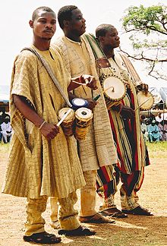
Yoruban talking-drummers. The man on left holding omelo ako and batá and the other two men holding donduns
http://en.wikipedia.org/wiki/Talking_drum#mediaviewer/File:Kwarastatedrummers.jpg

The abolition of the slave trade and slavery itself in the Western Hemisphere was accomplished piecemeal. The Haitian Revolution of 1791 began as a slave rebellion, and its leader Toussaint L’Ouverture in 1801 wrote a constitution that abolished slavery in the first black republic in the Americas. Revolutionary France abolished slavery 1794, but Napoleon restored slavery in the French colonies in 1802. In 1807 Britain banned the slave trade, and in 1834 it banned slavery as well. Under the U.S. Constitution of 1787 the international slave trade was to be ended in 1808. By 1804 all the northern states had abolished slavery (some by a gradual abolition under only the children born to slave parents would be free), but it wasn’t until after the Civil War that slavery was abolished throughout the United States under the Thirteenth Amendment to the Constitution, ratified in December 1865. Spain abolished slavery at home and all its colonies (except Cuba, Puerto Rico, and Santo Domingo) in 1811. Cuba abolished the slave trade in 1862, but didn’t abolish slavery until 1886. Spain abolished slavery in its colony of Puerto Rico in 1873. Santo Domingo abolished slavery in 1822, which was confirmed in 1844 under its new constitution as the Dominican Republic. In 1821 Simón Bolívar gradually abolished slavery in Gran Colombia (Venezuela, Colombia, Equator, and Panama). Brazil abolished the slave trade in 1831, but it was seldom enforced prior to 1850.

“By the 1850s, west coast merchants had found acceptable alternatives to the forbidden market in slaves,” writes Pakenham. “The steamboats, carrying Birmingham buttons and Manchester cottons to Africa in exchange for oil and nuts, also carried a new generation of explorers to try, with God’s help, to open the interior.” In the mid-nineteenth century France expanded its holding from bases on the Ivory Coast into Dahomey and the mouth of the Senegal River. These holdings became French Equatorial Africa. In competition with the French, Britain expanded its holds from the Gold Coast, Nigeria, and the Crown colony of Sierra Leone, established as a homeland for freed slaves. Portugal’s claims to Portuguese Guinea, Angola, and Mozambique were recognized by France and Germany as an attempt to stop British expansion in southern Africa.

“In the Middle Ages Africa had been the El Dorado, the gilded place,” writes Thomas Pakenham. “Two thirds of the world’s gold supply in the late Middle Ages came from West Africa.” In the fourteenth century Mansa Musa, the king of Mali, arrived in Cairo on a pilgrimage to Mecca with 500 slaves each carrying four pounds of gold. This began a caravan trade across the Sahara Desert from Jenne and Timbuctu. Europeans minted the gold into coins for use in the developing trade for silk in China and spices in the Moluccas. “To tap this West African gold was one of the principle aims of the Portuguese navigators of the fifteenth century. No one knew where, beyond the Sahara, in what kingdoms of forest or swamp, the trickle of gold originated. But the Portuguese saw they could divert this trade from Italy to Portugal if they could find a direct seaway to and from West Africa.”
Timbuktu is located in central Mali today, about 8 miles north of the Niger River on the southern edge of the Sahara Desert. Timbuktu is surrounded by sand dunes, and its streets are covered by sand. During most of the year there is too little rain for traditional agriculture, but during the rainy season that begins in June or July African floating rice is sown. The growing season ends from September to December when an annual flood caused by heavy rain in the headwaters of the Niger and Bani rivers in what is today the countries of Guinea and the northern Ivory Coast. The town was settled in the early twelfth century as the southern terminus of a trans-Sahara trade route. Controlled by Berabich (or Barabish) tribe of Arabic-speaking desert nomads, the trade consisted of salt, gold, ivory, and slaves. Slabs of rock salt from the Taoudenni mining center in the Sahara about 400 miles of Timbuktu were transported by large caravans of several hundred camels in a three-week journey to Timbuktu, where it would be trans-shipped by water to other places in Equatorial Africa. In early November and late March the caravans would depart from Timbuktu with food for the salt miners.
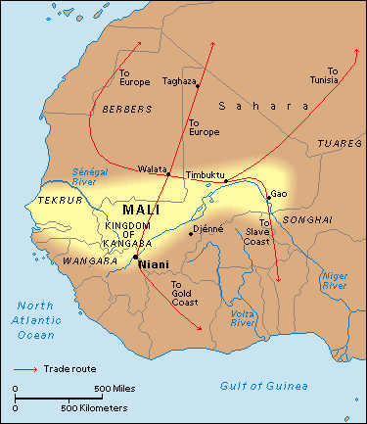
http://s.hswstatic.com/gif/willow/history-of-mali0.gif

Since around 1300 A.D. Timbuktu was part of the Malian Empire, when it was a center of trade by Arabs, Berbers, and black Africans, and some Jews, Venetians, and Portuguese in black slaves from Sudan (meaning at that time, the savanna and sahel across Africa south of the Sahara) and gold from the gold mines in West Africa (worked by black slaves for black and Arab masters) in exchange for European manufactured goods, horses, and slat mined in the desert. The Arabs conquered this region in the seventh century. “Having taken their empire, the Arabs sealed it off. Foreigners who dared set foot in any part of it were confronted with a harrowing chose: either take a vow of abiding allegiance to Islam, forsaking all other loyalties, or face decapitation.” Nomadic Tuareg Berber tribes briefly took control of the city, but in 1468 it became part of the Songhai Empire. While the official language of Mali, about 80 percent of Timbuktu’s population speaks Koyra Chiini, a language in the Songhay linguistic family. About 10 percent speak Hassaniya Arabic and another 10 percent speak Tamashek (spoken by both Ikelan and Tuareg ethnic minorities).

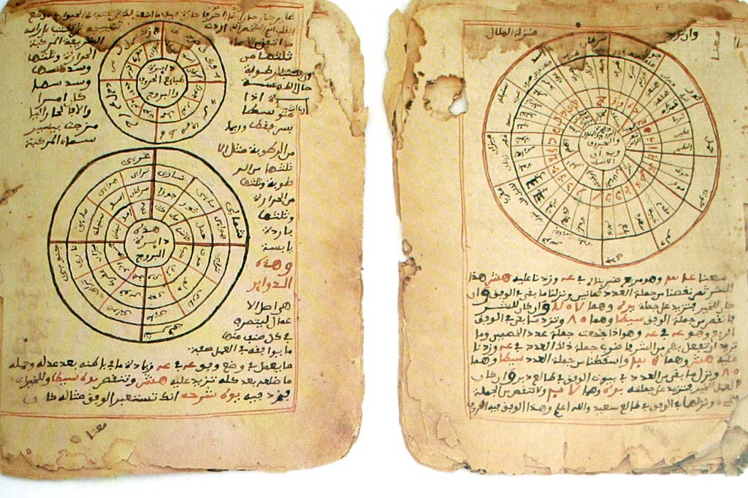http://en.wikipedia.org/wiki/Timbuktu#mediaviewer/File:Timbuktu-manuscripts-astronomy-mathematics.jpg

Timbuktu was a center of Islamic learning as early as the thirteenth century, but under the Mali and Songhai empires it experienced its Golden Age. The Songhai ruler Askia Mohammad I (1446-1538) encouraged a trade in books and manuscripts from all over the Islamic world. Wealthy merchant families sponsored the establishment of libraries and madrasahs (institutions of learning) which attracted scholars from all over North Africa. One of these madrasahs was the Sakore Madrasah and Mosque. Ahmad Baba was perhaps Timbuktu’s greatest scholar. He was born in 1556 in Araouane, a small village in the Sahara Desert (in Mali today). At an early age he moved with his father to Timbuktu to study. As a man he wrote more than 40 books, until 1608 when he was exiled to Morocco for sedition, after Moroccan forces under Judar Pasha (a Spanish eunuch) defeated the Songhai emperor Askia Ishaq II in 1591. The Ahmad Baba Institute founded in 1973 in Timbuktu is named in his honor.

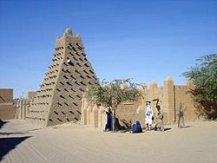
http://en.wikipedia.org/wiki/Timbuktu#mediaviewer/File:Timbuktu_Mosque_Sankore.jpg

In 1591 a Moroccan army defeated the Songhai Empire and moved the capital from Gao to Timbuktu. After 1612 a foreign elite known as the arma ruled Timbuktu virtually independent from Morocco. A Spanish Moor named Leo Africanus visited Timbuktu as a representative of Fez, but he was taken captive by Christian pirates and presented as a slave to Pope Leo X, who freed him. In 1526 he published a book titled The History and Description of Africa and the Notable Tings Contained Therein.
The houses of Timbuktu are huts made of clay-covered wattles with thatched roofs. In the center of the city is a temple built of stone and mortar, built by an architect named Granata, [Ishak es Sahili el-Gharnati, brought to Timbuktu by Mansa Suleyman] and in addition there is a large palace, constructed by the same architect, where the king lives. The shops of the artisans, the merchants, and especially weavers of cotton cloth are very numerous. Fabrics are also imported from Europe to Timbuktu, borne by Berber merchants.
The women of the city maintain the custom of veiling their faces, except for the slaves who sell all the foodstuffs. The inhabitants are very rich, especially the strangers who have settled in the country; so much so that the current king ['Omar ben Mohammed Naddi, not in fact the king, but representative of the ruler of the kingdom of Songhai] has given two of his daughters in marriage to two brothers, both businessmen, on account of their wealth. There are many wells containing sweet water in Timbuktu; and in addition, when the Niger is in flood canals deliver the water to the city. Grain and animals are abundant, so that the consumption of milk and butter is considerable. But salt is in very short supply because it is carried here from Tegaza, some 500 miles from Timbuktu. I happened to be in this city at a time when a load of salt sold for eighty ducats. The king has a rich treasure of coins and gold ingots. One of these ingots weighs 960 pounds [a gross exaggeration].
The royal court is magnificent and very well organized. When the king goes from one city to another with the people of his court, he rides a camel and the horses are led by hand by servants. If fighting becomes necessary, the servants mount the camels and all the soldiers mount on horseback. When someone wishes to speak to the king, he must kneel before him and bow down; but this is only required of those who have never before spoken to the king, or of ambassadors. The king has about 3,000 horsemen and infinity of foot-soldiers armed with bows made of wild fennel which they use to shoot poisoned arrows. This king makes war only upon neighboring enemies and upon those who do not want to pay him tribute. When he has gained a victory, he has all of them--even the children--sold in the market at Timbuktu.
Only small, poor horses are born in this country. The merchants use them for their voyages and the courtiers to move about the city. But the good horses come from Barbary. They arrive in a caravan and, ten or twelve days later, they are led to the ruler, who takes as many as he likes and pays appropriately for them.
The king is a declared enemy of the Jews. He will not allow any to live in the city. If he hears it said that a Berber merchant frequents them or does business with them, he confiscates his goods. There are in Timbuktu numerous judges, teachers and priests, all properly appointed by the king. He greatly honors learning. Many hand-written books imported from Barbary are also sold. There is more profit made from this commerce than from all other merchandise.
Instead of coined money, pure gold nuggets are used; and for small purchases, cowrie shells which have been carried from Persia [Cowrie shells, widely used for money in West Africa, sometimes came in fact from even farther away, from the Maladive Islands of Southeast Asia], and of which 400 equal a ducat. Six and two-thirds of their ducats equal one Roman gold ounce [A Sudanese gold ducat would weigh .15 oz.].
The people of Timbuktu are of a peaceful nature. They have a custom of almost continuously walking about the city in the evening (except for those that sell gold), between 10 PM and 1 AM, playing musical instruments and dancing. The citizens have at their service many slaves, both men and women.
The city is very much endangered by fire. At the time when I was there on my second voyage [probably in 1512] half the city burned in the space of five hours. But the wind was violent and the inhabitants of the other half of the city began to move their belongings for fear that the other half would burn.
There are no gardens or orchards in the area surrounding Timbuktu.

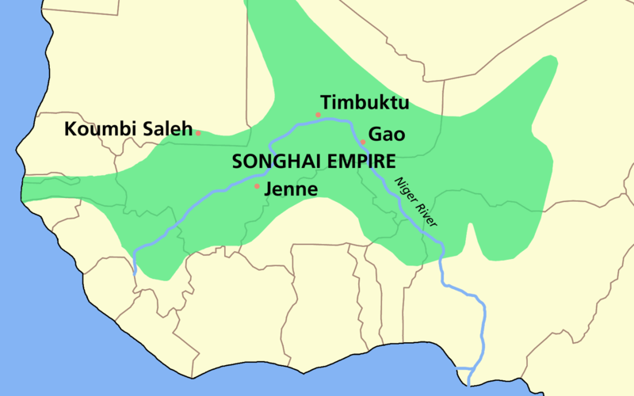http://en.wikipedia.org/wiki/Askia_Mohammad_I#mediaviewer/File:SONGHAI_empire_map.PNG
In 1468 the Songhai conquered Timbuktu, and in 1475 the town of Djenné. The Songhai state named after its leading ethnic group, the Songhai people, existed around the Niger River town of Gao since the eleventh century. The empire was ruled by the Sonni dynasty from about 1464 to 1493 and then by the Askiya dynasty from 1493 to 1591. Askia Ishaq II (1588-1591) was the last ruler of the empire. He was defeated at the Battle of Tondibi in 1591 by an army sent ty al-Mansur of Morocco led by Judar Pasha (a Spanish eunuch) to take control of the Trans-Saharan trade routes.
It is estimated that between the seventh century to the end of the nineteenth, between 9 and 13 million slaves were sent north across the Sahara. Frank Kryza says that “This is comparable to the numbers shipped seaward during the four centuries of the Atlantic slave trade, though the Sahara traffic has received less public discussion.”

The British sent a number of expeditions in attempts to cross North Africa. The first was John Ledyard, an American who had lived among the Iroquois, served in both the British navy and army, sailed with Captain Cook on his last voyage in which he was killed in Hawaii, and traveled across Russia to Siberia in a failed attempt to establish a fur-exporting business. In June 1788 Ledyard left England for Cairo in attempt to cross Africa from east to west, but he died in Cairo from an accidental doze of sulfuric acid before he could proceed further. The second explorer, Simon Lucas, attempted to cross Africa from north to south. Lucas was a wine merchant, who had gone to Cadiz as a young man to learn about sherry, but he was captured by pirates and sold as a slave to the bey of Morocco. After three years in captivity he became the British consul to Morocco. He remained in Morocco for sixteen years, and then returned to London as an Arabic interpreter at the Court of St. James. The African Society then hired him to proceed to Gibraltar, then to Tripoli, and finally to Fezzan (a desert kingdom south of present-day Libya). He left England in August 1788, while Ledyard was still in Cairo. He reached Tripoli in October, but the bashaw of Tripoli, Ali Karmanli, warned him that no Christian had ever attempted such a trip. Despite the warning Lucas left Tripoli in February 1789 accompanied by two Fezzan sheikhs who said they would escort him along the Mediterranean coast to the port city of Misurata. There he was warned about warring tribes that would block his way into the interior, and he finally decided to abandon his effort and return to England. Later in 1798 Lucas became the consul to Tripoli.

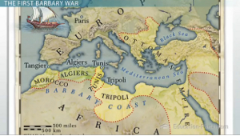
http://study.com/cimages/multimages/16/barbary-coast-map.jpg

“The regency of Tripoli was the most important of three kingdoms on the southern Mediterranean coast (Algiers and Tunis being the two others) which owed their nominal independence to the Turkish sultan,” writes Kryza. Tripoli was ruled by a bashaw, a title equivalent to governor. The bashaw at the time of Major Laing’s arrival was Yusuf Karamanli. In 1816 British navy had impressed Yusuf Bashaw by its bombarding Barbary Coast pirates in Algiers for enslaving Christians. The bashaw quickly freed his Danish, Italian, Spanish and Greek slaves before the British did the same in Tripoli. Kryza says that, “The bashaw realized that the age of piracy was ending. Under his reign, piratical practices had already been the cause of war in 1805 between Tripolitania and the United States. In 1819, a combine Anglo-French squadron appeared off the shores of Tripoli. The bashaw and other Barbary rulers were ordered to give up attacks on Mediterranean shipping or face grim consequences from the world’s two greatest navies.” The British Colonial Office also ingratiated itself with the bashaw by providing him was a £40,000 loan.

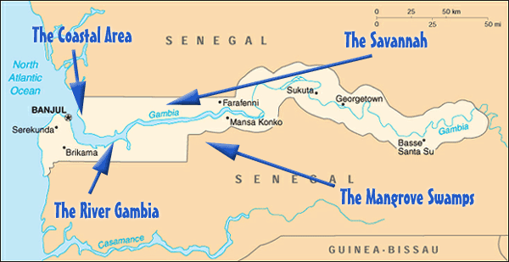
http://akbarn.com/public_html/AfricanCountry/Gabon/Gambia/gambia_map.gif

The African Association next sent an expedition led by an Irish major named Daniel Houghton to reach Timbuktu by way of the mouth of the Gambia River on the west coast of Africa. He proceeded as far as the rapids at Barra Kunda Falls, which was the farthest inland that one could navigate the river. From there he proceeded on foot, but he was lured into the Sahara by native traders who robbed and killed him in 1791 in what is today Mali.
The African Association then sent Mungo Park, a Scottish physician who had been a ship’s surgeon on an East India Company ship sent to Sumatra. In May 1795 Park departed for the town of Jilifree on the north bank of the Gambia River. He then proceeded inland, despite being harassed by local tribesmen demanding payments for crossing through their territory. At one point he was taken prisoner by Muslim horsemen who wanted to kill him, but he managed to escape. He managed to overcome fever, hunger, thirst, and sandstones to emerge from Muslim territory into the region of the Bambara, who turned out to be friendly. He proceeded east towards the town of Segou, and in June 1796 he became the first European to reach the Niger River at a point at which it flowed eastward into the interior. Park then wanted to follow the Niger to Timbuktu and then continue to the mouth of the river. However, he needed to turn back about 400 miles from Timbuktu, and after wandering for an entire year finally reached the Atlanta in June 1797 by way of the Gambia River. Kryza writes that Park “was the first white man to penetrate the forbidding interior of Africa for the sole purpose of finding out what lay there, and to come back alive.” Park returned to Peebles, Scotland, to practice medicine. One of his friends was the Scottish novelists Sir Walter Scott.

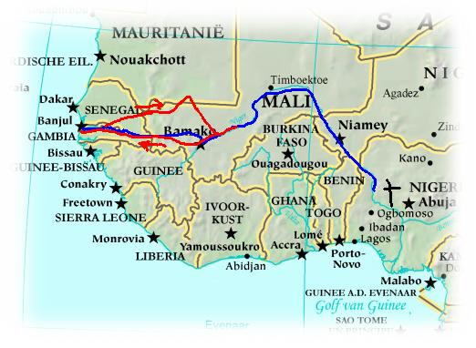
http://www.mundocuriososencillo.com/ConquistaTierra/Imagenes/MugoPark/Parkroutes.jpg

Park was convinced that past Timbuktu or the great lake in Wangara the Niger River turned south and flowed into the Congo River. In 1804 he convinced the British government to send Parks on another expedition to test this theory by again going up the Gambia River, then go overland to the Niger River, and finally down the Congo. Park departed in January 1805 and in two months arrived at Goree at the mouth of the Gambia. Commissioned as a brevet (i.e., a commission granted for meritorious conduct without authority) captain, Park recruited British soldiers, sailors, and convicts to man his military expedition. They traveled by boat up the Gambia River to the town of Kayee, where Park hired an English-speaking Mandingo guide name Isaaco. By the end of June they reached the Niger River, but at the cost of losing three-quarters of his men to dysentery and attacks by Muslim tribesmen. When they reached Timbuktu they faced hostility on the part of its inhabitants, and they decided to proceed without entering the city. With his party reduced to one officer, three soldiers, and Isaaco, they reached Segou on the Niger River in September. Sending Isaaco back to the coast with letters, Park proceeded in November down the Niger River and was never heard from again.

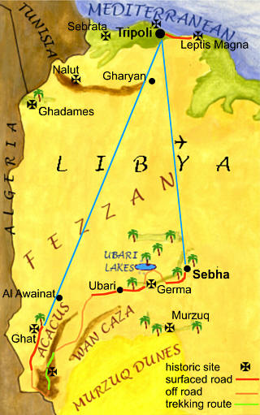
http://www.ewpnet.com/libya/extreme.jpg

Before Park returned from his first expedition, Sir Joseph Banks recruited Friedrich Hornemann, the German son of a Lutheran pastor, to embark on another attempt to cross the Sahara from Cairo. Hornemann arrived Alexandria just before Napoleon invaded Egypt in the summer of 1797. Hornemann was able to recruit a fellow German named Jospeh Frendenburgh, who had converted to Islam, and the two in September 1798 with some financial assistance from Napoleon departed westward across the Sahara bound for the Fezzan. They passed through the oasis at Siwa and arrived at Murzuk (Mursuch), where Frendenburgh died from disease contracted in the mosquito-infested oasis. After a seven month stay in Murzuk, Hornemann traveled northward to Tripoli, where he was received by the British consul at the time, Simon Lucas. In the spring of 1800 Hornemann returned to Murzuk to resume his travels to Tibuktu and the Niger River. He too was never heard from again. Between 1809 and 1817 the African Association sent the Swiss explorer Jean Louis Burkhardt to try again from Cairo. Burkhardt tried to accomplish what others had failed to do by disguising himself as a Muslim. However, he died from dysentery before he could depart on his journey. “Having failed in assaults from the north (Tripoli), the east (Cairo), and the west (Gambia), the membership [of the African Association] now proposed that an effort be made from the south,” writes Kryza. “It was now known at the time that the Niger River emptied into the Gulf of Guinea . . ., and so, in a cruel irony, the starting point of the expedition was in fact its destination.”

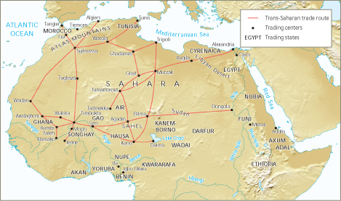
http://highered.mheducation.com/sites/dl/free/0072963786/817718/ch01_map2.jpg

“Meanwhile, in England, a discernable transition was taking place in the temper of African exploration,” Kryza notes. “Spurred by the wars in Europe and Britain’s rivalry with France, the Colonial Office and the Admiralty, chose to take a larger role in Africa.” The British government decided on a two-prong strategy. One prong was for the Colonial Office to send Major John Peddie with the assistance of the Royal Africa Corps to map the course of the Niger River from Senegal. He arrived there in November 1815, but died from coastal fever before he could proceed inland. Peddie was replaced by Captain Thomas Campbell, who started inland, but had to turn back because of hug swarms of bees. He too died and was replaced by two military surgeons, Dr. William Gray and Dr. John Dochard. Gray was taken captive, and Dochard had to turn back before reaching the Niger River.

The second prong, commissioned by Sir Joh Barrow, secretary of the British Admiralty, was to search for Timbuktu and the Niger River from the mouth of the Congo River. Barrow chose Captain James Kingston Tuckey to lead the expedition. They were able to navigate up the Congo as far as Yallala Falls. From there they proceeded overland for another 200 miles before they had to turn back. Of the 54 men who started out on the expedition, only 19 made it back to the coast. Tuckey himself died shortly after their return in October 1816.

In 1821 Sir Charles MacCarthy, the British governor of Sierra Leone, sent a mission to Gambia and the Mandingo country. It was led by a young Scottish officer named Lieutenant Alexander Gordon Laing. One this and two other missions Laing traveled 200 miles into the interior through the town of Falaba, the seat of the Soolima tribe, as far as the source of the Rokelle River. In 1823 Laing was promoted and sent to the Gold Coast, where a war had broken out between the British and the Ashanti people. In the conflict MacCarthy was taken captive and slain. Laing was sent back to England to report to the Secretary for War and the Colonies, Henry Bathurst, on the events in Africa. Bathurst was an avid abolitionist, and he founded the British Colonial Office. Lord Bathurst believed that the shorted route to Timbuktu was by traveling south from Tripoli.

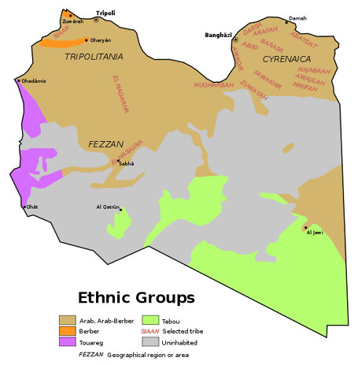
http://images.china.cn/attachement/jpg/site1007/20110322/0019b91ec74f0ef28a9009.jpg

The first British expedition from Tripoli was led by a twenty-seven-year old Scottish surgeon named Joseph Ritchie along with a twenty-three-year old naval officer named George Lyon and a shipwright named John Belford. They left Tripoli disguised as Moors. The bashaw suggested that they accompany the new bey (the Turkic title of chieftain or tribal leader) of Frezzan, Mohammed El Mukni, who was leaving Tripoli with armed Arabs on a trip to capture slaves from black African villages. They left Tripoli in March 1819 and arrived in Murzuk, the capital of the Fezzan, in May. There Lyon came down with dysentery, and once he recovered Ritchie fell ill with bilious fever. Finally, in July El Mukni and his slave hunting party left without them. Finally, in November Ritchie died from his illness. Though sick themselves, Lyon and Belford continued on to Tegheri about 100 miles south of Murzuk. There they came in contact with the Tebu tribe, who were black Africans, rather than Berbers, and the northernmost of the Tebu people whose territory included northern Chad, Niger, and Sudan today. The Tebu were nominally Muslims, but they departed from traditional Muslim ways. Lyon was able to make friends with the Tebu and also with their enemies, the Tuareg, who were, according to Kryza, “the dominant nomads of the central and western Sahara.” But Belford became too sick at Tegheri to continue, and in February 1820 Lyon and Belford joined a slaving caravan to return to Tripoli. Lyon reported back to London that the Niger River flowed into Lake Chad in northcentral Africa. Now the British became focused on the ancient African kingdom of Bornu (or Borno in northeastern Nigeria today), located southwest of Lake Chad.

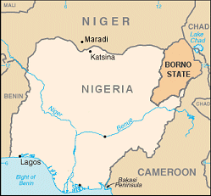
http://www.studentnewsdaily.com/wp-content/uploads/2014/03/image1369.gif

The next British expedition into the African interior toward Bornu was led by another Scottish physician, Dr. Walter Oudney. Dr. Oudney recruited his friend, Lieutenant Hugh Clapperton, who was the son of a Dumfrieshire physician and an experienced naval officer who had sailed the Mediterranean, the South China Sea, and the Pacific. Clapperton fought against the United States on Lake Huron in the War of 1812 and against the French in the Battle of Mauritius. A third member of their party was Lieutenant Dixon Denham, who taught at the military college at Sandhurst. Denham assumed that he was the leader of the expedition due to his political social connections.

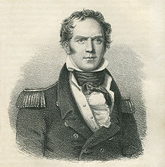
http://upload.wikimedia.org/wikipedia/commons/thumb/a/a9/Hugh_Clapperton_portrait.jpg/220px-Hugh_Clapperton_portrait.jpg

The British consul in Tripoli at the time was Colonel Hanmer Warrington. Oudney and Clapperton arrived in Tripoli in October 1821. Denham didn’t arrive until mid-November with his own instruction from the Colonial Office. Once they reached Bornu, Oudney was to remain there as Vice-Consul to the Sultan, and Denham and Clapperton were to explore to the south and east for the Niger River and follow it to its mouth. Yusuf Karamanli would provide an escort of 1,000 armed men in exchange for £5,000. But after continued negotiations it turned out that the bashaw had no intention of providing the escort. Oudney and Clapperton departed for Murzuk from Tripoli in February 1822 without an escort. Denham was to join them later. After a strenuous trip across the desert, they reached Murzuk, where they were told the new bey of Fezzan, El Ahmar, was to provide an escort to Bornu. However, they learned he was about to leave for Tripoli, not Bornu. Denham, who joined them in March 1822, decided to return to Tripoli to recruit a new escort.

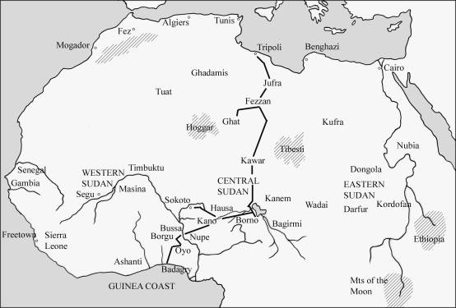
http://www.thelongridersguild.com/clapperton-map.jpg

While Denham was away, Oudney and Clapperton made exploratory trip into the desert west of Murzuk toward the oasis of Ghat, the territory of the Ajjer Tuareg tribe. On his previous trip of Murzuk, Lyon had promised the Ajjer Tuareg Hatita ag Khuden a Sheffield sword, and before he left Murzuk, Denham presented him with the promised sword. Hatita promised to serve as a guide and protector for Oudney and Clapperton on their explorations. When Denham reached Tripoli, he found that the bashaw would not provide another escort and Warrington was no help. So Denham decided to return to London to complain in person to Lord Bathurst about Yusuf Karmanli’s treatment of an official British expedition. In other to counter Denham’s complaint, Yusuf Karmanli arranged for an additional fee for a wealthy Fezzanese merchant named Abu Bakr Bhu Khallum, who was planning to return to Fezzan with a party of 300 men to escort Oudney and Clapperton on to Bornu. Out-foxed by the bashaw, Denham returned to Tripoli. Denham then traveled with Abu Bakr Bhu Khallum and a party of Meghara Arabs back to Murzuk.

In November 1822 the Bornu mission with Abu Bakr Bhu Khallum’s caravan left Murzuk, traveling south across the desert toward Lake Chad. Clapperton and Oudney were both sick with fevers they developed in Murzuk. There continued to be disputes between Denham and the two Scots, Oudney and Clapperton. In January 1823 the party reached Bilma, the capital of the Tebu territory and the center of the salt trade mined from nearby salt lakes. The Tebu were under the rule of the Tuareg. The Tebu did the salt mining and the Tuareg could a portion as a tax. Finally in February the party reached Lake Chad, which Kryza describes as “a body of water the size of Switzerland never before seen by a white man.” The lake, a main caravan routes to Tripoli, and major cities were under the control of the kingdom of Bornu, whose capital, Kukawa, was a few miles southwest of the lake . The expedition proceded to Kukawa, where they were received by Bornu’s ruler, Sheikh Alameen Ben Mohammed El Kanemi.

The Europeans stayed in Kukawa for an entire year, while they sent out exploratory parties. Both Oudney and Clapperton were sick most of the time, while Denham indulged himself with pleasures provided by native women. Despite orders from the Colonial Office against participating in raids to capture slaves, Denham accompanied a combined force of 2,000 Bornu soldiers and Meghara Aras to help the sultan of Mandara to the southeast of Kukawa to counter an invasion of Fulani tribesmen. Abu Bakr Bhu Khallum’s motive was to take new captives as slaves to transport back to Tripoli. In the ensuing battle Bhu Khallum was killed, and Denham barely able to escape with his life.

Meanwhile, Clapperton and Oudney explored the shores of Lake Chad in the hope of finding the source of the Niger River. But the lake had only one river that fed it, and none that flowed from it. The Niger River was to the west of Lake Chad, but the Sokoto caliphate, ruled by Sultan Mohammed Bello, lay between Bornu and the river. In December Oudney and Clapperton departed Kukawa for the Sokoto caliphate without an armed escort. As the caravan approached the territory of the Hausa near the equator, Oudney, who was already sick from tuberculosis before he left Scotland, worsened, and in January 1824 he died.

Clapperton continued to the slave-trading city of Kano in Muslim northern Nigeria today. There he visited Hajji Hat Salah, the governor of the city and vizier to Sultan Bello. Hat Salah promised to accompany Clapperton to meet the sultan in Sokoto, but he changed his mind after a reverse he suffered in trying to suppress a rebellion by a local chief. So Clapperton departed without him to Sokoto, 250 miles northwest of Kano on the other side of a Hausa state hostile to the caliphate. He arrived in March 1824 and had an audience with Sultan Mohammed Bello. In their negotiations, the sultan promised to allow the British to build a trading post on the coast, “an easy commitment for a landlocked ruler to make,” says Kryza, because “his borders did not extend to the ocean.” But powerful Arab merchants in Sokota were concerned that a British presence might destroy their caravan trade in slaves, gold, and ivory. The sultan misled Clapperton by telling him the Niger flowed east toward the Nile, and he refused to give Clapperton permission to proceed with his explorations. Tired and sick, Clapperton decided after two months in Sokoto to return to Kukawa. There he reunited with Denham, who returned from his own explorations. The two returned to Tripoli in January 1825.

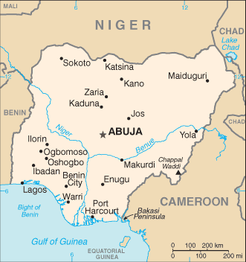
http://www.mobilecomms-technology.com/projects/nitel-gsm/images/4-mtel-coverage.gif

Upon their return they learned that Lord Bathurst had sent another explorer on a mission to find Timbuktu, a young Scot named Captain Alexander Gordon Laing. In May 1825 Laing arrived at the Mediterranean port of Tripoli. Meanwhile, Clapperton back in London convinced Lord Bathurst to send him on a more dangerous route inland from Sierra Leone 450 miles east to Timbuktu. The route was 700 miles shorter than the northern route taken by Laing. “For his part,” says Kryza, “Lord Bathurst had high hopes that Clapperton would meet Laing in the African heartland, where the two men could join forces, greatly enhancing their chances of success by acting in concert over what Bathurst reckoned to be the smaller probability that either man would succeed alone.” Clapperton’s instructions were to endeavor by every means to put a stop to the slave trade.

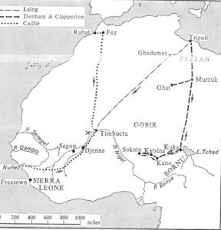
http://www.redlandsfortnightly.org/images/tripoli.jpg

In July 1815 Laing departed for expedition into the interior. He has chosen as his guide Sheikh Babani, who was a slave trader who knew the caravan routes across the Sahara. Sheikh Babani took Laing on a roundabout route from Tripoli to Ghadames (a crossroads in the caravan trade since Roman times) in order to avoid bandits. He arrived in September after a 1,000-mile, two-month detour. From Ghadames Laing was supposed to proceed using the Tuareg Hatita ag Khuden as his guide. But Hatita would only take him as far as Tuat (the region of oases in the western part of the Algerian Sahara known also as In Salah or Insalah, today), because the territory between Tuat and Timbuktu was controlled by the Chaamba Arabs and two Tuareg tribes (the Hoggar and the Ifora), both of whom were enemies of Hatita tribe, the Ajjer. After spending more than a month at In Salah, Laing decided to depart in January 1826 across the Tanezrouft (the heart of the desert) toward the Hoggar (the plateau in the central Sahara) with a party of only 45 men and 100 camels but without an escort.

Along the way, they were joined by 20 armed Hoggar Tuareg, whom they were afraid to turn away. Several days after they passed the oasis of Wadi Ahnet, the Hoggar Tuareg surroundered Laing’s tent and attacked. Laing had suspected that Sheikh Babani might have betrayed him, because he was unmolested. Despite his serious wounds, Laing survived the attack, and his party continued with Laing tied to the saddle of his camel. In April they reached an oasis named Azaud, where they were welcomed by Sheikh Mokhtar of the Kunta Arab tribe. Laing stayed there for three months while he tried to recover from his wounds. But then the entire camp came down with dysentery, which killed Mokhtar, Sheikh Babani, and other members of Laing’s party. Mokhtar’s son, Sidi Mohammed, was anti-Christian and uncharitable. In later summer Laing was strong enough to leave Azaud with an escort on the promise he would pay Sidi Mohammed the equivalent of 1,000 Spanish dollars. They headed south to the southern edge of the desert within reach of Timbuktu.

In August 1826 Laing entered Timbuktu, not disguised as a Muslim, but as “a Christian envoy of the King of England.” He presented him before city’s governor, Othman bin Boubakr. The governor received him well, and Laing was free to travel to Kabara, the port district on the Niger River. But rather than seeing the reported wealth of Timbuktu, the city had decay because of periods of warfare between black Africans, Berbers and Arabs over control of its trade routes. He visited the Sankore Mosque with its collection of Arabic manuscripts and the university, founded by Mali’s Muslim rulers in the sixteenth century, which was still a center of Islamic learning. When Laing arrived in Timbuktu, the Tuareg, who had controlled the city, had fled in the face of an attack by the Fulani satrap, Seku Hamadu, who had not yet taken control of the city. Laing stayed in Timbuktu for more than a month, until Sheikh Othman received a message from Sultan Bello telling him to send the “Christian traveler.” Othman told Laing that if he didn’t leave immediately, he would probably be killed by Fulani warriors. In late September Laing left Timbuktu, but instead of risking his original purpose to follow the Niger downstream to its mouth, he departed for the Ashanti lands of Sierra Leone, from there to the west coast of Africa, and eventually back by sea to the Mediterranean Sea and Tripoli to rejoin his wife. But Laing never made it to Tripoli. Instead in August 1828 Sheikh Babani’s nephew, Alkhadir, and Bongola, a freed slave, both of whom accompanied Laing appeared in Tripoli. Bongola said that Laing had been murdered by Arabs.

Meanwhile, Clapperton departed for Africa in August 1815 on the HMS Brazen along with a Scottish physician named Dr. Thomas Dickson. En route it captured two Spanish slave traders off the coast of Africa and freed its slaves. In November it reached Whydah, where its physician Dr. Dickson was put ashore to explore the interior of Dahomey, but he was killed in a fight with a native tribe and killed. In December the Brazen dropped Clapperton and the rest of the expedition at the slave-trading station of Badagri. From there Clapperton with a British trader named Houtson as a guide departed inland on the Lagos River through friendly Yoruba territory and then on foot through dense rainforest for Sokoto. Unfamiliar with the climate of the rainforest, Clapperton slept at night in the open, and he soon came down with a fever caused by mosquito bites. Clapperton and other members of his party had to be carried in hammocks, but when they reached the village of Jannah (Jonah) their carriers abandoned them. Jannah was known for its woodcarvers as well as its slave traders.

Despite the loss of several members of his party, Clapperton proceeded to the northern boundary of western Nigeria, which was the frontier of the Yoruba territory. There he encountered warriors sent by the sultan of Katunga, who escorted them in January 1826 to the town of Katunga, the capital of Yorubaland. There Houtson left the party to return to Badagri. As the first white man to reach Katunga, the local king, Mansoleh, welcomed him. In March Clapperton crossed the Moussa River into the land of the Borgu (in northern Benin and northwestern Nigeria). Outside the town of Kaiama, the capital of Borgu, they met an escort of horse-mounted warriors sent by Yarro, the king of Kaiama.

Clapperton and his party then proceeded to the Kingdom of Wawa, which was at the intersection of roads linking Ashanti and Dahomey to the west of the Niger River with Hausaland and Bornu to the east. In Wawa Clapperton had to deal with a rich, 300-pound Arab widow named Zuma, who insisted on marrying either Clapperton or his young Cornish servant, Richard Lemon Lander. They managed to extradite themselves from this situation and proceed to Bussa, where Mungo Park had died. They arrived there in March 1826 and saw the Niger River for the first time. “In any event,” writes Kryza, “Mungo Park had set a terrible precedent that was to haunt subsequent explorers. Driven to the edge of sanity, Park had massacred many Africans, forgetting that he, not they, was the trespasser.”

In his travels Clapperton heard that the Niger River flowed south to the sea, but his instructions were to go north to find Sultan Bello in Sokoto. When he reached Kano in July, he learned that war had broken out between the Sokoto caliphate and the kingdom of Bornu. Clapperton described in his journals the Fulani people, their Muslim religion, the iron in the local hills, and the utilitarian art of their blacksmiths. But the local governor of Kano, Hajji Hat Salah, was suspicious that Clapperton might be in league with their now enemy, the Bornu leader El Kanemi in Kakawa. When El Kanemi launched an attack on Kano, Clapperton surreptitiously left Kano, leaving Lander behind bound for Sokoto on a camel through torrential rain. He had to rest for several days at Jaza on account of a sickness, but he was met their by Sultan Bello’s gadado (prime minister) who was sent to escort him to Sokoto. They reached Sokoto in October 1826.

“In Clapperton’s absence, Arab advisers had apparently convinced Bello that British explorers were on a mission of conquest, and that Clapperton particularly was the representative of a great power that would eventually seize his country and dispossess him,” says Kryza. Bello also was suspicious of Clapperton’s plan to visit El Kanemi, and he refused permission for Clapperton to proceed to Kukawa. In Kano Lander received a message that Clapperton wished Lander to rejoin him in Sokoto with all of his baggage left there. In fact, the message came from Bello, not Clapperton. Lander reached Sokoto in December to Clapperton’s surprise. Bello insisted that Clapperton show him the letter from King George IV of England to El Kanemi, and when he saw that Clapperton was bringing gifts to Kanemi, Bello seized Clapperton’s baggage.

While held as de facto captives, both Clapperton and Lander came down with illness. Nevertheless, Clapperton continued to make entries in his journal, including a conversation he had with Bello how in the district of Umburm belonging to his cousin Jacoba, the people ate human flesh. “I said I did not think any people existed on the face of the earth that eat their own kind as food. . . . [T]he sultan said he had send them eat human flesh, they said it was better than any other; that the heart and breasts of a woman were the best part of her body.” In March 1827 the sultan gave Clapperton and Lander permission to leave Sokoto, but they were too sick with malaria to go anywhere. The next month Clapperton died in Lander’s arms.

Although Lander was sick with malaria as well, he decided not to carry out Clapperton’s dying wish that he return by the northern route to Tripoli. Instead, Lander decided to return the way he came, that is, to Badagri on the western coast of Africa. Here arrived there in November 1827. However, on his return Portuguese slave traders from Brazil convinced the king of Badagri that Lander was a spy. The king forced Lander to drink a poison liquid to prove his innocence, but Lander tricked them by quickly returning to his hut to vomit the poison. In February 1828 a British brig named Maria rescued Lander from Badagri. It took him to the island of Fernando Po, where he met the new governor of Sierra Leone, Dixon Denham. But Denham lived only for a few more month, before he died in May 1828 in Freetown, Sierra Leone, from “coastal fever.” Lander returned to England, where he published Clapperton’s journals in 1830. Later than year Lander returned to Africa with his brother, where they followed the course of the Niger River to its mouth. In 1832 he made a third trip to Africa, but was killed by Africans in 1834 at the age of twenty-nine.

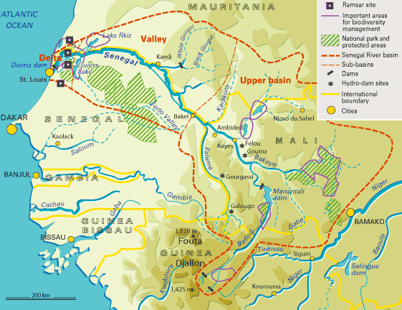
http://1.bp.blogspot.com/_YftuKO4Vcdc/TPED2-YaGCI/AAAAAAAAAaQ/c9sWL214xqg/s1600/detailed_senegal.gif

“When the rivalry between Britain and Napoleonic France spilled over into Africa, exploration took a new, political dimension,” writes Kryza. “While the African Association’s explorers pushed up the Gambia, French traders moved up the Senegal.” In 1824 the French Société Géographique offered a cash prize of 10,000 francs for the first expedition to go to Timbuktu and return, thereby launching an international competition between Britain and France. In August 1830 a French squadron arrived off the coast of Tripoli and demanded that Yusuf Bashaw sign a treaty with France under which he paid France 800,000 francs part of which was to repay French creditors. Also, Tripoli was to restore to France its status as “most favoured nation.” The British consul Warrington protested to the bashaw, but to no avail. “Yusuf Bashaw realized that he was now in deep trouble,” says Kryza. “He could not raise the large indemnity required by the French while his economy was in such a parlous state, not to mention the drain on his purse of perpetual tribal skirmishes in his hinterlands. News of the French capture and occupation of Algiers aroused fears of a Franco-Egyptian conspiracy to take over Tripolitania, especially if the British, his only ally, deserted him.”
“The row with the French was the last blow for the Karamanli dynasty, which had ruled Tripoli for 125 years,” says Kryza. “In 1835, Yusuf Karamanli was overthrown and Tripoli once again fell under direct Turkish rule.”

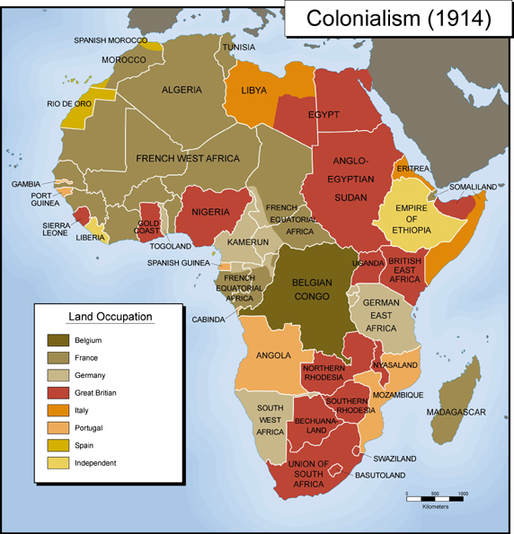
http://exploringafrica.matrix.msu.edu/images/colonialism1914.jpg

“Deliberate extension of European power probably began with Emperor Napoleon II in 1861,” writes Wiedner. “He revived France’s dormant interest in Senegal in order to enhance national glory and to generate a wave of popular loyalty at home.” The French had established a trading post in Mauritius in the seventeenth century. The colony consisted of two ports--St. Louis and Dakar—and a string of trading posts along the Senegal River 300 miles into the interior. In 1879 the French Governor of Senegal, Briére de l’Isle, began pushing further up the river with the intention of building a trans-Sahara railway linking Algeria and Senegal by way of Timbucktu and then possibly building a spur to the western Sudan. However, this plan came to naught in 1881, when Colonel Flatters was turned back by the Tuaregs. The French also had outpost to the south in the Gulf of Guinea, notably a treaty port at Cotnonou on the coast of Dahomey and trading posts on the Ivory Coast. Pakenham says, “In both areas, French authorities and businessmen were deeply suspicious of their British neighbours in Sierra Leone, the Gold Coast and the Oil Rivers (modern Nigeria).”

Muhammad es-Sadok, the Bey of Tunis, as an Ottoman pasha was a vassal of the Turkish sultan. He was a Turk, not an Arab. His cousin, Ahmed, was the first Muslim ruler to abolish slave trade. Sadok, appointed a twenty-seven-year-old Jew named Mustapha ben Ismael as his Prime Minister. The French Consul in Tunis, Théodore Roustan, had cultivated a relationship with Mustapha, but this came to a sudden end in 1880, when a French bank took control of a vast coastal estate named the Enfida that Mustapha wanted for himself. The Bey then began to favor the Italian Consul in Tunisia, Licurgo Maccio. Sicily was only ninety miles from Tunisia, and it too had it sights on a colony there. The French had made a considerable investment in Tunisia, having constructed a telegraph line to Algeria, and in the process of building a railway to link the two countries. Mustapha attempted to take possession of the Enfida estate by enlisting the help of a Maltese Jew who was an English citizen and who as a neighboring landowner claimed the pre-eminent right to buy the estate. Roustan appealed to the French prime minister Jules Ferry and his Cabinet, who sent a French battleship, the Friedland, to the Tunisian coast. The British cabinet of Lord Gladstone responded by sending its own battleship, the Thunderer, to counter the French show of naval force. Both ships withdrew, but the affair, according to Pakenham “made the British appear to support the Italians.”

“Tunis was the strategic key to Algeria,” writes Pakenham. “It was also the key to regenerating France.” In April 1881 French forces crossed the border from Algeria into Tunisia killing and wounding Kroumir tribesmen who tried to defend their livestock and cornfields. The Bey appealed for help from the British, the Italians, and other European powers to no avail. Nor did the Ottoman sultan make good on his promise of support. The Bey also sent for help from his brother, Ali Bey, who had a camp at Sidi Salah near the Algerian border and was allied with the Kroumirs. Ali Bey, who was heir apparent to the Tunisian throne, sent a message to the French about their intentions, and the French responded that they had crossed the border with the permission of his brother. When Ali learned that the French had bombarded the frontier port of Tabarca and were advancing along the coast, he decided to retreat rather than confront the unstoppable French advance. The Bey’s other brother, Taib, betrayed him and was willing to accept a French protectorate. Three weeks after the French invasion, the Bey was forced to sign the Treaty of Bardo that made Tunisia, in the words of Pakenham, “a French protectorate in all but name.” Morocco and Tunisia, unlike Algeria, were protectorates under international treaties. The French had to act in the name of the Sultan of Morocco and the Bey of Tunisia. In 1912 the Sultan of Morocco turned over foreign affairs, but not internal affairs, to France. This was done through a French resident-general within the sultan’s court. In fact, the French controlled both external and internal affairs in Morocco.

In November 1889 the French Governor of Senegal, Colonel Briére de L’Isle, sent Lieutenant-Colonel Gustave Borgnis-Desbordes on a mission to connect the upper Senegal River with the upper Niger River with a chain of forts and a telegraph and railroad line. In February 1883 Desbordes established a stone fort at the Bambara village of Bamako on the upper Niger River, which according to Pakenham was “the foundation stone of a vast new French empire in the western Sudan.”

French expansion into the interior of northwest Africa prompted Britain to do the same. In 1873 and 1874 they fought against the Ashanti, whom they defeated, but they did not occupy their lands. In that year they established the Gold Coast Crown Colony. The Ashanti were a military association established in the eighteenth century. The symbol of the federation was the Golden Stool. The British thought it was a throne and sought to obtain it so that the Queen could sit on it. The Ashanti considered it a sacred object that no one should sit upon even their own ruler. The Ashanti were now surrounded by the British to the north and along Gold Coast and the French who controlled Ivory Coast.

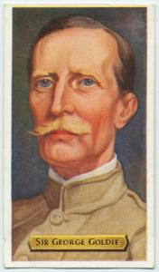
http://images.nypl.org/index.php?id=1200124&t=r

“The conventional wisdom at this period was that the British flag was a handicap to British trade, states Pakenham. “At any rate, it could only follow trade after several generations, when life was complicated enough to demand formal sovereignty and business was big enough to carry the costs.” In 1877 an English merchant named C. Goldie Taubman (later Sir George Taubman Goldie) came to the Niger Delta to manage his brother-in-law’s trading firm, Holland Jacques and Company. He began to acquire British and French trading enterprise under his United African Company. In 1881 George Goldie and a group of investors received a charter for National African Company to trade on the Niger River. According to Pakenham, Goldie “came from a family which had been landed gentry on the Isle of Man for generations. The Goldie Taubmans had made their pile in the eighteenth century smuggling trade, but then settled down as conventional squires, landlords and magnates.” In 1882 it became the National African Company, Ltd. Like its competitor, the French Equatorial Africa Company, his company had its own army. The National African Company in January 1883 met with the British Foreign Office with their concern that the French might establish a monopoly on trade along the Niger River. Hewitt returned to London in April to lend his support to the effort.

Edward Hewett, the British Consul for the Bights of Benin and Biafra, according to Pakenham, was the “unofficial ruler of the Niger.” His “empire” extended from Lagos to the Rio del Rey. When he arrived in Africa in 1880, he had established control of the warring African leaders. Pakenham says that “Formal empire was essential for two reasons: to break the power of the African middlemen who made it impossible for Europeans to trade safely and profitably on the Oil Rivers—and to keep out the French.” The Ibo king Ja-Ja of Opobo was at war with the people of Qua Ibo. Pakenham writes that “Hewett could cite the attacks on company property, as he cited King Ja-Ja’s atrocities, to show that informal empire was not enough.”

Goldie’s success alarmed French minister of foreign affairs, Gabriel Hanotaux, about Goldie’s next move. The Conservative British prime minister, Robert Cecil, Lord Salisbury, assured Hanotaux that Goldie had pledged not to proceed further up the Niger River, and so the French quickly occupied the town of Bussa. “The news that the French had hoisted the tricolor at Bussa reached London in April 1879 and thrust this obscure mud-walled town on the banks of the Niger to the centre of international politics,” writes Pakenham. “Bussa was a strategic post on the river immediately below the rapids, giving the French access to the whole middle and lower Niger.”

The French Prime Minister Léon Gambetta was sending French traders to the region. The Compagnie Franςaise de l’Afrique Equatoriale (CFAE), a subsidiary of the French firm Desprez and Huchet, had established a station on the Niger, and in 1882 the Senegal Company did the same. Commandant Antoine Mattei, the Agent-General of the CFAE departed from his headquarters at Bass at the center of the Niger delta and navigated a couple of steamboats up the Niger River to the Islamic kingdom of Nupe, one of the Sudanic states of the Sokoto Empire. By 1883 there were thirty-three French “factories” on the river, more than the British had.

In October 1884 Goldie bought out the French Company. Britain had established a protectorate over the entire Niger and Cameroon coast in 1883, but Goldie’s National African Company underwrite all the expenses. By October Granville Leveson-Gower, the British Foreign Secretary, that the Oil Rivers be made a royal protectorate under the Colony Office as opposed to the Foreign Office. But Goldie had another idea, that was, for the colony to be administered under a royal charter to the National African Corporation. This would check the French advance in the Niger at no expense to the British government.

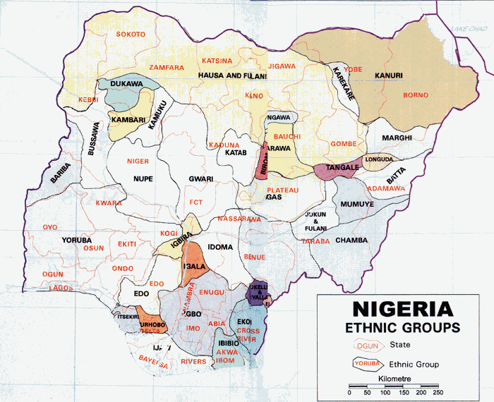http://www.onlinenigeria.com/map.gif

Not only was Goldie’s colony experiencing opposition from the French on the Sokoto frontier, but there were rebellions among Brassmen (African middlemen in the Niger trade) in the Niger Delta, defiance of the Company’s treaty with Busa by the Nupe and the Illorin (two Islamic warrior states on the middle Niger engaged in the slave trade against the Yoruba), and the British governor of Lagos, Sir Gilbert Carter, who wanted to annex the Illorin to Lagos. When in 1896 the Emir of Ilorin attacked an outpost of the Lagos police, Goldie personally led a force of British regulars and the Royal African Company’s army against the Emir of the Nupe, thought to be the weaker of the two native peoples. In January 1897 Goldie’s army defeated Nupe and Fulani warriors outside the walled city of Bida. Three weeks, later he conquered the walled city of Ilorin.

Meanwhile, Germany had established trade with the Gold Coast and the Dahomean slave stations in 1847. In 1884 Germany annexed a stretch of coastline known a Togoland. From there they expanded inland until they reached the eastern borders of the Ashanti. In July 1884 the German gunboat named the Möwe carrying Dr. Gustav Nachtigal, the new Imperial Consul-General for the west coast of Africa, took possession of Cameroon from British traders there. Under orders from the German Chancellor Otto von Bismarck, Nachtigal was also to seize Little Popo (Togoland) and Angra Pequena in southwest Africa adjacent to the British Cape Colony. Previously, Bismarck had been opposed to overseas colonies. Pakenham argues that Bismarck changed his mind because France had no stake in these particular colonies in West Africa, and this might promote an alliance between German and France. Furthermore, now the German public wanted their country to get involved in the scramble for Africa. In July Dr. Nachtigal declared Togo and Cameroon as German protectorates. Fearing that the Cape Colony was about to annex not only Angra Pequena, but the entire coast north of the Orange River, German took possession of it in July as German Southwest Africa (the Republic of Namibia, today).

In November 1884 to February 1885 a conference was held in Berlin attended by Britain, France, Germany, Spain, Portugal, Belgium and the United States. The conference affirmed the doctrine of “effective occupation” as the right to govern particular regions of Africa. Britain received title to the Niger River Delta, France to land north of the Congo River, and the independent Congo Free States was to be administered in trust by King Leopold and his International Association. This arrangement was formalized in 1885 by the Berlin Act. For Bismarck stripping Turkey of Tunis and awarding it to France would deflect French attempts to retake Alsace and Lorraine, which it lost in the Franco-Prussia War. Pakenham says that Bismarck wanted the French to have “a healthy new outlet for their energies—meaning one where there was no possibility of a clash with Germany.” Under the principle of ‘effective occupation” European powers claimed a territorial sovereignty in Africa if they had treaties with local leaders and established administrative rule there. Yet many European countries only controlled the trading posts on the coast. At the Berlin Conference of 1884-1885 organized by the German Chancellor, Otto von Bismarck, France, Britain, Germany, and Portugal agreed to the so-called “hinterland theory,” namely, that a colonial power with a coastal administration could lay claim to an unlimited amount of territory in the interior. As part of the agreement, France and Britain agreed to divide the interior along a line running from Say in Niger to Baroua on the northeast coast of Lake Chad with France getting the territory north of the line and France the land to the south. Thus, Britain claimed the Nile Basin and France the basin of Lake Chad.

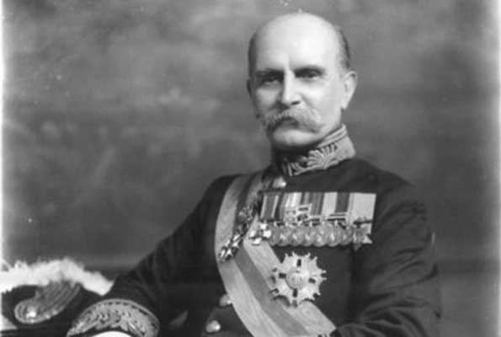
http://www.monitor.co.ug/image/view/-/1369060/highRes/343105/-/maxw/600/-/wbvjpe/-/special01px.jpg

In 1892 the French established another base in Dahomey in 1892 by defeated the native King Behanzin. Goldie hired Frederick Lugard in 1894 to go to Borgu to negotiate treaties with the native rulers on the lower Niger River. Lugard made a treat with the ruler of the town of Nikki, but as soon as he returned toward the Niger, the French came in from Dahomey, saying the Lugard’s treaties were null and void. The British had nominal control of the Ashanti, but the Ashanti territory extended only a couple of hundred miles into the interior. The wooded mountains of Upper Volta to the north were controlled by Samori, the Dyula warlord expelled from the western Sudan by the French, whose main export was slaves. In September 1898 the French captured Samori and sent him to exile in Gabon, where he died. Then, Lebon organized an attack from the west, northwest, and north on George Taubman Goldie’s British National African Company’s private empire in the lower and middle Niger River. In response, the British Colonial Secretary Joseph Chamberlain in 1895-1896 sent a force against the Ashanti capital of Kumasi. “They found some skulls and other traces of human sacrifice, a convenient discovery since their official object was to end the bloodthirsty reign of King Prempeh,” Pakenham maintains . “But the main aim of the expedition was not humanitarian; Chamberlain wanted to confirm British supremacy over Ashanti and pre-empt French encroachments.”

Britain and Germany reached an agreement to establish spheres of influence in the Zenj Empire, with Britain receiving “primary interest” in Zanzibar Island and the northern Zenj coast and Germany along the southern coast. In 1884 Germany formally annexed Togoland along the northwestern coast of Africa. The German and French settlements along the coast pushed the Ewe people further inland. German expansion reached the borders of the Ashanti confederation. Prempeh, the Ashanti leader or ashantihene, protested the infringement of Europeans on their lands. In 1896 the British colonial governor issued an ultimatum to the Ashanti that they reopen trade routes, abandon the tradition of human sacrifice, and pay an indemnity. When the Ashanti refused the British attacked Kumasi, the Ashanti capital. They deposed Prempeh and went on a search for the Gold Stool, the symbol of the Ashanti confederation, so that Queen Victoria as the “Protectoress of the Ashanti” could sit upon it. This was considered an insult by the Ashanti who resumed warfare against the British. By 1901 the Ashanti were defeated and Prempeh and his generals were imprisoned on Seychelles Islands in the Indian Ocean. The Ashanti kingdom became a Crown colony in 1902.

Chamberlain had come to the conclusion that he should buy out Sir George Goldie’s Royal African Company, but he needed Goldie’s support if fighting were to develop with France. In February 1898 Chamberlain sent to the Niger a West African Frontier Force (WAFF) under the command of Major Fred Lugard, who had driven the French out of Uganda. In May Lugar’s second in command, Lieutenant James Willcocks with his Hausa recruits, came in contact with French forces at the village of Kanikoko, two miles from the French post at Kiama. But rather than fight, Willocks and the French officer exchanged protests, then shook hands and drank toasts to each other.

In June 1898, France and Britain signed the so-called Niger Convention in Paris. Under it Britain gained a so-called “sphere” above the rapids at Ilo, which included Bussa and most of Borgu as well as the empire of Sokoto on the north. France gained a narrow triangle from the eastern frontier of Dahomey to western Borgu as far of the city of Nikki. Shortly after the signing of this convention, the British government took over Goldie’s Royal African Company.

In December 1899, after Chamberlain had paid Goldie’s Niger Company £850,000 to relinquish control of Nigeria, Sir Frederick Lugard left to become the new High Commissioner for the Protectorate of Northern Nigeria. Lugard launched a series of raids against the Fulani in northern Nigeria, followed in 1902 with an invasion of Kano. After destroying Kano, his force proceeded against Sokoto, the capital of the Fulani federation. There the defenders fled without a fight. In January Lugard informed the Colonial Office that he intended to launch an expedition against the Munshi, who had burned the Niger Company’s post at Abinsi on Benue River in southern Nigeria and closed the river to navigation. The Secretary for the Colonies, Lord Elgin, ordered Lugard not to proceed. Lugard was prepared to defy this order, but in the northwest of Nigeria in the village of Satiru, a Mahdi named Mallam Isa led a revolt against the British. The two political Residents, a white officer and most of the black mounted infantry were hacked to death. In March 1906 Lugard diverted a strong force to Satiru to avenge the killings. With the help of the new British-appointed Sultan of Sokoto, Lugard’s forces killed about 2,000 (by Lugard’s own estimate) men, women, and children in the Satiru. Prisoners were decapitated and their head put on spikes. Shortly after, Lugard resigned his position, and after a year he was appointed the Governor of Hong Kong.

The new British prime minister, Arthur Balfour, was in favor of a new policy of reconciliation toward France. The reason was according to Pakenham: “It would end, once and for all, those dangerous disputes about African territory which had bedeviled relations between the two countries ever since the British had taken Egypt in 1882. It would also help resolve the still more vital question of strategic defence. The British Admiralty were looking for a naval ally to help defend Britain and the Empire.” In April 1904 France and Britain singed an entente. France agreed to give Britain a free hand in Egypt. The two countries also agreed to rectify the border of Nigeria. A secret understanding allowed the French to take control of most of Morocco.

In 1900 Britain officially annexed Nigeria as a colony in the British Empire. The former Bornu Empire with its majority Kanuri Muslim population initially constituted a sovereign sultanate. But in 1903 both the Bornu Sultanate and the Sokoto Caliphate came under British rule. The British used the educational institutions there to spread Christianity among the population. Nigeria achieved its independence in October 1960, and become the most populous country in Africa. Yet the country was divided into three major ethnic groups and more than two hundred minor tribes. The Hausa and the Fulani live in the north. The Hausa are the descendants of the Sudanic people who established a twelfth century empire and converted to Islam in the fourteenth century. The Ibo live in the southeast, and the Yoruba in the southwest. Both are African Negroes, many of whom converted to Christianity. The Ibo tended to be the economic and political leaders of the country.

In 1966 the Hausa revolted against Ibo domination and the slaughter thousands of Hausa in and around Kano, causing a million Ibo seek refuge in the south. In May 1967 the Eastern Region dominated by the Ibo seceded as the Independent Republic of Biafra, which contained most of the petroleum resources of the country. During the Civil War that resulted, Britain, Egypt, and the Soviet Union backed the Nigerian government, while France backed the Biafrans. By the end of the war, it is estimated that between one and three million people were dead. Between 1966 and 1999, with a brief period between 1979 and 1983, Nigeria was under a military rule. During the 1970s Nigeria experienced an oil boom, and it joined the Organization of Petroleum Exporting Countries (OPEC). During the early 1990s ethnic conflict developed as some of the minority ethnic groups in the Niger Delta, particularly the Ogoni and the Ijaw, felt they were being exploited by foreign oil corporations (Royal Dutch Shell and the American Chevron Corporation) backed by the central government.

In 1980 a Muslim fundamentalist sect known of the Yan Tatsine (“Followers of Maitatsine”) initiated rioting in Kano, the largest city in northern Nigeria, resulting in four to five thousand deaths. The Nigerian military cracked down on the sect, killing it leader Maitatsine. The resentment that resulted led to the founding in 2002 of another Islamic sect known as Boko Haram (literally meaning, “Western education is Forbidden”) in the city of Maiduguri, the capital of the northeastern state of Borno. Its leader Mohammed Yusuf, who was a follower of the radical Sunni Salafist Islam, established mosques and schools that attracted poor Muslim families into its vision of establishing an Islamic state. For its first seven years Boko Haram pursued its agenda peacefully. In 2009 some of his followers had a violent confrontation with the local police in Maiduguri over their refusal to wear motor cycle helmets. The Boko Haram in July retaliated by attacking police station in Bauchi. The Nigerian military then surrounded the home of Mohammed Yusuf, in which he and some of his followers were barricaded. Yusuf was arrested, but when he tried to escape from the local police station, he was recaptured and publicly executed outside the police station by the Nigerian security forces. The violence then spread across several states in northeastern Nigeria in which over a thousand people were killed.

In 2010 Boko Haram reorganized under a new leader, Abubakar Shekau, who is an ethnic Kanuri. In 2009 Shekau had survived an attempt on his life by Nigerian security forces. Two years later Boko Haram carried out a series of bombing in Bauchi, Zaria, and the UN headquarters in Abuja. The Nigerian government declared a state of emergency in Borno state in May 2013, and the French military forced out of Mali, where they had become entrenched, both Boko Haram and Al Qaeda in the Islamic Maghreb (AQIM), with which they had become allied. In November of that year, the United States designated Boko Haram as a terrorist group. In April 2014 Boko Haram kidnapped 214 girls from a government secondary school in the primarily Christian town of Chibok in the Nigerian state of Borno. The girls were to convert to Islam and to marry soldiers in Boko Haram. In January 2015 First Lady Michelle Obama weighed in on the kidnapped girls by holding up a sign with the hash tag “#Bring Back Our Girls.” The U.S. sent military forces to help find the girls to no avail, and the United States has condemned the actions of Boko Haram.

But now the effort against Boko Haram has become part of the international War on Terrorism. Since 2007 the Israeli government has been sending Israeli-made arms to the Nigerian government. But on March 9, 2015, the Jerusalem Post reported that the Obama administration in the summer of 2014 halted an effort by the Israeli government of Prime Minister Benjamin Netanyahu to resell American-made Chinook helicopters to the Nigerian government as a violation of U.S. Conventional Arms Transfer policy.

The War on Terrorism paradigm, however, overlooks the ethnic dimension of this conflict. The primarily Muslim State of Bornu was incorporated into British colony of Nigeria, which was an artificial creation of the British combining many ethnic groups as well as the predominantly Muslim north with the predominantly Christian Niger Delta. While it’s true that there was a long history of Muslims in the north enslaving black Africans in the south, it is also true that both the French and the British engaged in the Trans-Atlantic slave trade with the connivance of the coastal African ethnic groups as middlemen. In fact, the art, music, dance, and religion of the Yoruba and Dahomean people brought to North America and the West Indies as slaves were instrumental in the formation of Afro-American culture. It was only in the nineteenth century that Britain and France abolished slavery and the slave trade in favor of colonialism and conversion of native peoples to Christianity. Furthermore, the long term effect of Christian missionaries, who were in the forefront of British colonization of Nigeria, was to worsen the relationship between the Muslim north and the Christian south of the country. Thus, it is all too easy for the West to take the moral high ground in regard to captivity and forced conversion instead of understanding the complicated interplay between ethnicity and empire that shaped this region.

Jared Diamond, Guns, Germs, and Steel: The Fates of Human Societies (New York and London: W. W. Norton, 1997), p. 377.
Richard Joel Russell, Fred Bowerman Kniffen, and Evelyn Lord Pruitt, Culture Worlds. rev. ed. (London: Macmillan, 1969).
Diamond, op. cit., p. 388.
Ibid., p. 377.
Ibid., p. 385.
Ibid., pp. 388-389.
Robert Farris Thompson, Flash of the Spirit: African and Afro-American Art and Philosophy (New York: Vintage Books, 1983), pp. 3-4.
Donald L. Wiedner, A History of Africa South of the Sahara. (New York: Vintage Books, 1962), p. 63.
Melville J. Herskovits, The Myth of the Negro Past (1941; Reprint, Boston: Beacon Press, 1958), p. 81.
Diamond, op. cit., pp. 397, 399.
Thomas P. Pakenham, The Scramble for Africa: The White Man’s Conquest of the Dark Continent from 1876 to 1912 (New York: Random House, 1991), p. 17.
Philip D. Curtin, The Atlantic Slave Trade: A Census (Madison: University of Wisconsin Press, 1969), p. 15.
Wiedner, op. cit., p. 50.
Frank T. Kryza, The Race For Timbuktu: In Search of Africa’s City of Gold (New York: HarperCollins, 2006), p. 13.
Herskovits, op. cit., p. 35.
Wiedner, op. cit., p. 63.
Herskovits, op. cit., p. 36.
Curtin, op. cit., pp. 184-185.
Thompson, op. cit., p. 103.
Curtin, op. cit., pp. 205, 123.
Ibid., pp. 129-130.
Ibid., pp. 268-269, 182-183.
Thompson, op. cit., pp. xv, xvi.
Herskovits, op. cit., p. 250.
Alfred Métraux, Voodoo in Haiti , trans. by Hugo Charteris (New York: Shocken Books, 1972), p. 182.
Robert Farris Thompson, African Art in Motion (Los Angeles, Berkeley, and London: University of California Press, 1974), pp. xii, 13.
Métraux, op. cit., pp. 188-189.
George R. Gibson, “Gourd Banjos: From Africa to the Appalachians,” 10/01/2001, http://www.banjohistory.com/article/detail/1_gourd_banjos_from_africa_to_the_appalachians
Megan Sullivan, “African-American Music as Rebellion: From Slave Song to Hip Hop,” http://www.arts.cornell.edu/knight_institute/publicationsprizes/discoveries/discoveriesspring2001/03sullivan.pdf
J. L. Dillard, Black English: Its History and Usage in the United States (New York: Random House, 1972), pp. 303, 74.
Errol Hill, The Trinidad Carnival: Mandate For a National Theatre (Austin and London: University of Texas Press, 1972), p. 25.
Pakenham, op. cit., p. 18.
Ibid., p. 16.
Ibid., p. 17.
Kryza, op. cit., pp. xii-xiii.
This is an excerpt from Reading About the World, Volume 2, edited by Paul Brians, Michael Blair, Douglas Hughes, Michael Neville, Roger Schlesinger, Alice Spitzer, and Susan Swan and published by HarperCollinsCustomBooks. http://public.wsu.edu/~brians/world_civ/worldcivreader/world_civ_reader_2/leo_africanus.html
Kryza, op. cit., p. xiii.
Ibid., p. 4.
Ibid., p. 69.
Ibid., p. 20.
Ibid., pp. 45.
Ibid., p. 46.
Ibid., p. 77.
Ibid., p. 103.
Ibid., p. 126.
Ibid., 137.
Ibid., pp. 229-230.
Ibid., p. 188.
Ibid., p. 215.
Quoted in ibid., p. 220.
Ibid., p. 21.
Ibid., p. 273.
Ibid., p. 274.
Wiedner, op. cit., p. 167.
Pakenham, p. 112.
Ibid., p. 114.
Ibid., p. 109.
Ibid., p. 120.
Ibid., p. 164.
Ibid., p. 182.
Ibid., p. 183.
Ibid., pp. 191, 192, 193.
Ibid., p. 515.
Ibid., p. 110.
Ibid., p. 513.
Ibid., p. 595.
“U.S. Halted Israeli Arms Transfer Nigeria,” Jerusalem Post (March 9, 2015), http://www.jpost.com/Israel-News/Report-US-vetoed-Israeli-sale-of-attack-helicopters-to-Nigeria-388985

