关于：申请中国永久居民卡的推荐信及相关证明
Regarding: Request for Letter of Recommendation and related proofs to apply for Permanent Resident Card in China
2020年8月22日
Contents
尊敬的先生和夫人们，您好Greetings Esteemed Sirs and Madams 2
自我介绍 Self-Introduction 2
对于杰出的外国人 For Outstanding Aliens 5
要求 Requirements 5
对中国的突出贡献 Outstanding Contributions to China 6
1. 中国体育总局 General Administration of Sport of China 11
2. 文化和旅游部 Ministry of Culture and Tourism 12
外国人在华最新就业评估标准 Newest Employment Evaluation Criteria for Foreigners in China 13
我出版的一些书包括：Some of my published books include: 15
学术媒体 Academic Media 18
中国急需的技能 Skills China needs 20
外国专家类别和标准Foreign Expert Categories and Criteria 23
事实核查 Fact Checking 24
结论 Conclusions 27
后记 Epilogue 30

尊敬的先生和夫人们，您好Greetings Esteemed Sirs and Madams
我的英文名字是格雷戈里·布伦达格。我的中文名字叫石龙。当我成为一名普通弟子时，少林寺给了我这个名字（恒悟）。（哈伦·拉希德是阿巴斯第五位哈里发。拉希德在伊斯兰黄金时代的鼎盛时期统治了786年至809年。）
My English name is Gregory Brundage. My Chinese name is石龙. The Shaolin Monastery gave me the name 恒悟when I became a lay disciple (俗家弟子). I converted to Islam in December 1987 and I chose the name “Abdul Rashid bin Abdullah.” (Harun al-Rashid was the fifth Abbasid Caliph who ruled from 786 to 809 during the peak of the Islamic Golden Age.)

自我介绍 Self-Introduction
我父母是在纽约的福特汉姆大学认识的。我1956年8月2日出生在新泽西州的提内克。我三岁的时候，我的家人搬到了密尔沃基威斯康星州，因为我父亲得到了在那里的州立大学任教的合同。1963年，我们全家搬到了英国剑桥，因为我父亲得到了古根海姆基金会的资助，在英国和其他欧洲国家进行研究。我们于1965年回到美国。1967年，我们搬到马德里，我父亲在富布赖特项目资助下的大学任教，之后又进行了一次穿越欧洲到罗马的长途旅行。我们在1968年底回到了美国。我父亲在罗马梵蒂冈图书馆进行了两次广泛的研究调查后，退出了天主教会。他给了我一本一九六九年夏天的《毛主席语录》。第二年夏天，我父亲派我去巴塞罗那郊外的一个农场工作，我在那里当农民；第二个夏天，我在哥伦比亚和厄瓜多尔南美洲度过。我初中毕业，1973年进入大学。1974年我18岁时，父亲说我需要自力更生，就切断了我的经济来源。在毕业四年后的15年里，我一直在大学里做全职和兼职工作，直到1988年。
My parents met at Fordham university in New York. I was born August 2, 1956 in Teaneck New Jersey. My family moved to Milwaukee Wisconsin when I was three years old because my father received a contract to teach at the state university there. Our family moved to Cambridge England when I was six years old in 1963 because my father received a Guggenheim Grant for research in the UK and other European countries. We returned to the US in 1965. In 1967 we moved to Madrid where my father taught at university funded by the Fulbright Program, which was followed by another extensive road trip across Europe to Rome. We returned to the USA in late 1968. My father quit the Catholic Church after two extended research investigations at the Vatican Library in Rome. He gave me a copy of Quotations of Chairman Mao Tse-Tung (Mao’s Little Red Book) in the summer of 1969. The next summer my father sent me to work on a farm outside Barcelona where I worked as a farmer, and the next summer I spent in Columbia and Ecuador South America. I graduated from high school at the end of my junior year and entered the University in 1973. My father cut me off financially when I turned 18 in 1974 saying I needed to be self-reliant. I worked and attended university classes full and part time for the next 15 years until 1988 after four years of Graduate School.
我热爱武术。在我年轻的时候，我被迫经常打架，主要是因为我是外国人，或者是在美国，因为我和其他男孩“不同”。我在保护自己不受欺负方面有丰富的经验。我在1969年开始正式的武术训练。我学到的一点是，我不能忽视那些欺负我的人。我必须保护自己。随着我长大，我发现欺负者找到了其他更间接和更复杂的攻击我的方式，包括诽谤和各种各样的个人和职业破坏。
During my youth I was forced to fight a lot – mainly because I was a foreigner or in the USA because I was “different” from the other boys. I can honestly report I never started a fight in my entire life. However, I have extensive experience with protecting myself from bullies. I began formal martial art training in 1969. One thing I learned is that I cannot just ignore bullies. I must protect myself. As I grew older, bullies found other more indirect and sophisticated ways of attacking me including defamation and various kinds of personal and professional sabotage.
我热爱和平。从1969年开始，我在我家对面的大学里做反越战的抗议者。我当时13岁，比绝大多数反战示威者小5到10岁。尽管这些都是在我的大学里举行的和平示威，警察还是照例逮捕抗议者，并指控我们犯下各种罪行。密尔沃基曾经是，现在仍然是美国种族隔离最严重的城市。
Starting in 1969 I was an anti-Vietnam war protestor at the university across the street from my family house. I was 13 years old, five to 10 years younger than the vast majority of anti-war protestors. Even though these were peaceful demonstrations at my university, police routinely arrested protestors and charged us with a variety of crimes. Milwaukee was and remains the most racially segregated city in the USA.
我第一次访问中国是在2007年6月底，当时我正在韩国孔阳大学教书。在北京的五天假期里，我参观了体育大学、首都体育学院和当时中国唯一一支名为《孙子兵法》的国际混血武术队，美国《功夫太极》杂志的编辑金青对我去体育大学的访问不感兴趣首都体育学院，但他确实发表了我的文章混合武术在中国。
I first visited China in late June 2007 while on vacation from teaching at Konyang University in South Korea. During my five vacation days in Beijing I visited the University of Physical Education, Capital Sports Institute and the only international Mixed Martial Art (MMA) team in China at that time called “Art of War.” The editor of American “Kung Fu Tai Chi magazine” Gene Ching was not interested in my visits to the University of Physical Education and Capital Sports Institute however did publish my article about “Mixed Martial Arts” in China.
美国《功夫杂志》Kung Fu Magazine (U.S.A.) 2008年1月/2月
中国现代混合武术的演变 The evolution of Modern Mixed Martial Arts in China
http://ezine.kungfumagazine.com/ezine/article.php?article=986
从那时起，我已经发表了超过65篇杂志文章和四本关于中国武术在中国和丝绸之路沿线的书籍。Since that time 12 years ago I have published more than 65 magazine articles and four books about Chinese Wushu Kung Fu in China and along the Silk Roads.
2009年2月3日，我来到北京，在昌平区的一所大型私立学校教英语。I very much enjoyed my short visit to Beijing in 2008 and on February 3rd 2009 I moved to Beijing to teach English at a large private school in Changping District.
然而，坦率地说，我真正感兴趣的是参观天津蓟县盘山北少林寺的遗迹，它是由天津体育大学的高文山教授发现的。为什么？
Frankly however my real interest was in visiting the remains of the lost North Shaolin Monastery on Panshan, Jixian, Tianjin, which had been discovered by Professor Gao Wenshan of Tianjin Physical Education University. Why?
1972年我十几岁的时候，我第一次开始训练少林功夫、太极拳和其他中国功夫。
I first started training in Shaolin and Tai Chi and other styles of Chinese Kung Fu when I was a teenager in 1972.
大多数杂志文章都是在网上免费的www.kungfumagazine.com。这些书在www.amazon.com 可以从我的网站免费下载：https://heartpublications.org.

Most of the magazine articles are online and free at www.kungfumagazine.com. The books are available on www.amazon.com and can be downloaded for free from my internet site: https://heartpublications.org/ .

我在北京昌平区住了11年了。我正在写两篇系列丛书：I have lived in Changping District of Beijing for 11 years now. I am in the middle of writing two long series of articles:
1） 重建北少林寺（近期竣工日期提前到2025年）
2） 丝绸之路功夫友谊之旅（我已经发表了关于参观中国武术联合会总部、国家队和丝绸之路沿线16个国家的武术学校的文章。）
- Rebuilding the North Shaolin Monastery (the construction completion date is 2025)
- Silk Road Kung Fu Friendship Tour (I have already published articles about visits to Chinese Wushu Federation headquarters, national teams and other wushu Kung Fu schools in 16 countries along the Silk Roads.)
我于去年7月，也就是2019年7月，从昌平区一所私立学校退休教书。
I retired from teaching at the private school in Changping District in July last year, 2019.

校长说，学校的老板想要所有年轻的外教，而且学校的钱有问题。The principal said the school owner wants all young foreign teachers and the school was having money problems.

从那以后，我继续写和出版武术作品，尽管COVID-19新冠病毒减慢了速度。最近我在亚马逊上出版了很多本书。 Since then I have continued mostly martial art related writing and publishing, although COVID-19 slowed things down. Most recently I have published several books people can buy on amazon.com.
现在我有10年的中国旅游签证，但是每两个月就要出国一次。疫情期间这是不可能的，所以在过去的四个月里，我一直在申请一个月的签证延期。那很贵。
At this time, I have a 10-year Chinese tourist visa, but have to leave the country every two months. Because that’s impossible I’ve been getting one-month visa extensions for the past five months. That is very expensive, especially for someone with no job.
最近，2020年9月17日，我被告知出入境局不再签发一个月的签证延期。我的10年旅游签证在2020年3月由于COVID-19流行病而失效。在北京我有朋友，包括我过去10年的女朋友（如果我有工作或者至少有收入的话，她可能会结婚）、一辆挂着北京牌照的汽车、一套房子、各种电器、大约300本书、家具等等。换句话说，北京是我的家。被迫离开中国，失去家园（由于COVID-19流行病和特朗普总统疯狂的外交政策）将是悲剧。这封邀请函包含了我为中国做出的杰出贡献和中国急需的技能的广泛证据。
More recently September 17, 2020 I was told one-month visa extensions will no longer be given. In Beijing I have friends, including my girl friend of the past 10 years that might marry me if I had a job or at least some income, a car with Beijing license plates, a home, various appliances, around 300 books, furniture, and so on. In other words, Beijing is my home. Being forced to leave China and losing my home due to the insane foreign policies of President Trump would be tragic and unjust. This request letter contains extensive proof I have made outstanding contributions to China and have skills urgently needed by China.
因此，我希望能得到一张中国永久居民卡，这样我就可以工作并继续我10多年来一直在做的事情: 在国际流行媒体和学术媒体上宣传中国武术、历史、文化和哲学。Thus, I would appreciate getting a Chinese Permanent Resident Card so I can work and continue what I have been doing for more than 10 years – Promoting Chinese martial arts, history, culture, and philosophies on a world-wide basis in the international popular and academic media.

对于杰出的外国人 For Outstanding Aliens
对对中华人民共和国有重大突出贡献或者中华人民共和国急需的外国人，发给永久居留证。This type of Permanent Residence is issued to aliens who have major and outstanding contributions to PRC or needed urgently by PRC.

要求 Requirements
1. 填妥的《外国人在中华人民共和国永久居留申请表》；Completed Application Form of Aliens for Permanent Residence in PRC;
注意：我已要求该申请，但被告知如果没有推荐信，他们将不能给我，并且需要中国政府主管部门出具的相关证明。NOTE: I have asked for that application but was told they cannot give it to me without a Letter of recommendation and related proofs issued by the competent authority of the Chinese government are required.
2. 四张蓝色背景下的近期2英寸彩色照片（不戴帽子的全脸）；Four recent 2-inch color photos (full face without hat) against blue background;
3. 有效的外国护照或能够代替护照的身份证件；Valid foreign passports or identification capable of substituting passports;
4. 由中国政府任命的出入境检验检疫局签发的健康证明，或者由中国使领馆认可的外国医疗机构签发的健康证明（健康证明自签发之日起有效期为六个月）Certificate of health issued by Entry-Exit Inspection and Quarantine Bureau appointed by the Chinese government or issued by foreign medical agencies accredited by Chinese embassies or consulate offices (the Health Certificate is valid for 6 months since it is issued);
5. 中国大使馆或领事馆认可的国外无犯罪记录证明Proof of no criminal record abroad recognized by Chinese embassies or consulate offices
6. 需要由中国政府主管部门出具的推荐信和相关证明。Letter of recommendation and related proofs issued by the competent authority of the Chinese government are required.

对中国的突出贡献 Outstanding Contributions to China

我爱中国，中国文化和中国武术。我在美国发表了65篇以上的英语文章，以促进中国武术功夫，历史和文化，以及四本书。 我在东西方之间架起了桥梁，并且我本人已经在此工作了10多年。 我用自己的大量资金来资助这些工作。 此外，我还向国际英语听众推广了“一带一路”倡议。I have published more than 65 articles in English in the United States promoting Chinese Wushu Kung Fu, history and culture, as well as four books. I build bridges between east and west and have been doing this for more than 10 years on my own initiative. I used a huge amount of my own money to fund these efforts. In addition, I have promoted the One Belt One Road initiative to an International English-speaking audience.
我的工作是非常积极的（国际英语）中国公关。我很有幽默感，我的武功故事既有趣又生动让中国可爱。我写的故事在国际上很受欢迎。My work is very positive (international English language) public relations for China. I have a sense of humor and my wushu Kung Fu stories are fun and lively. The stories I write are popular internationally.
从google.com和bing.com搜索结果来看，我是世界上最重要的丝绸之路武术功夫记者。
Judging by google.com and bing.com search results I am the world’s foremost Silk Road Wushu Kung Fu reporter.
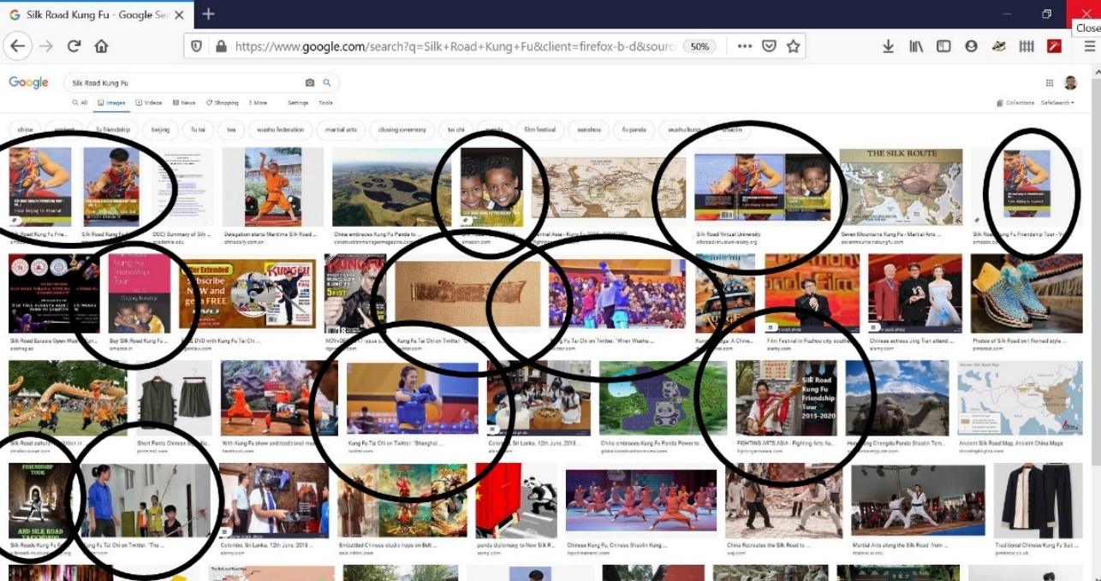
以上只是google.com图片搜索丝绸之路功夫的首页。 带圆圈的照片是我发布的照片。 以下是bing.com搜寻丝绸之路功夫形象的首页：
Above is just the first page of google.com image search for Silk Road Kung Fu. Photos with circles are my published photos. Below is the first page of bing.com image search for Silk Road Kung Fu:
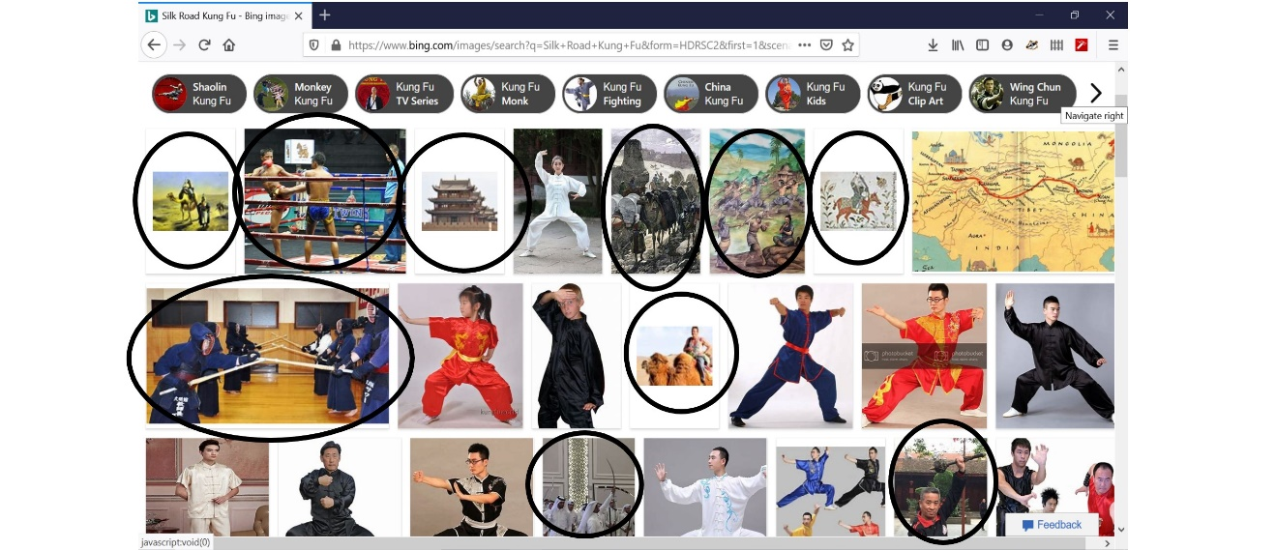
同样，在academia.edu（世界上最大的大学教授共享文章和图书的互联网站点）上，我拥有大量的读者：
Likewise, on academia.edu I have a large following:
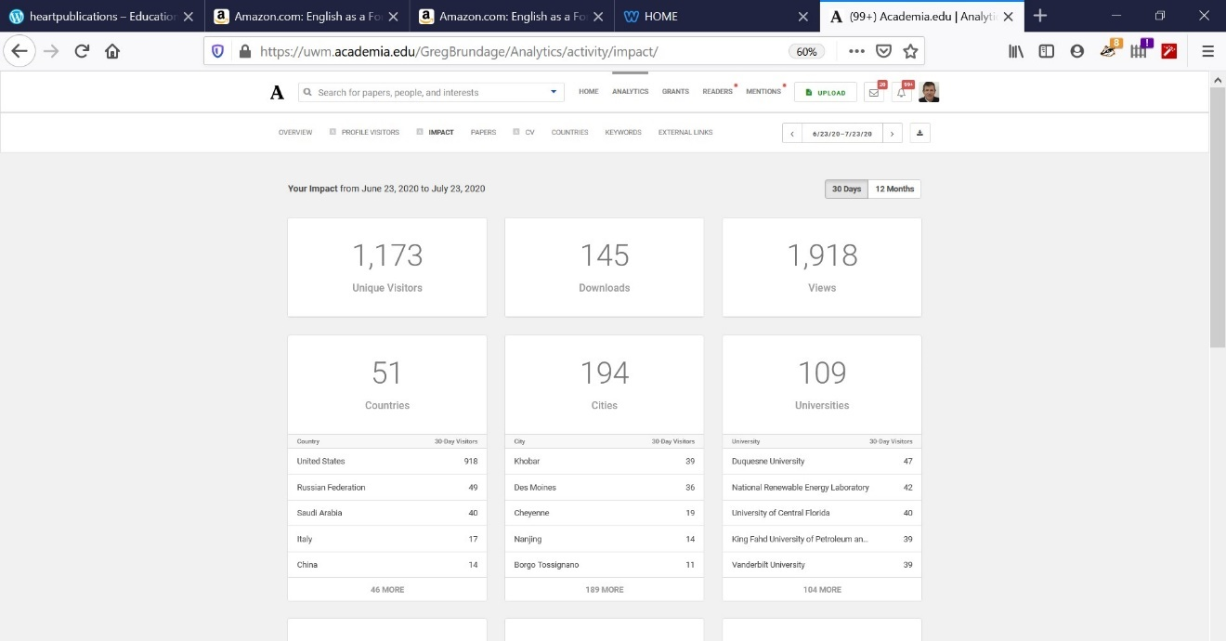
…每月有近两千次观看。 这些观点大多数来自世界各地的大学教授：…with nearly two thousand views per month. Most of those views are by university professors around the world:
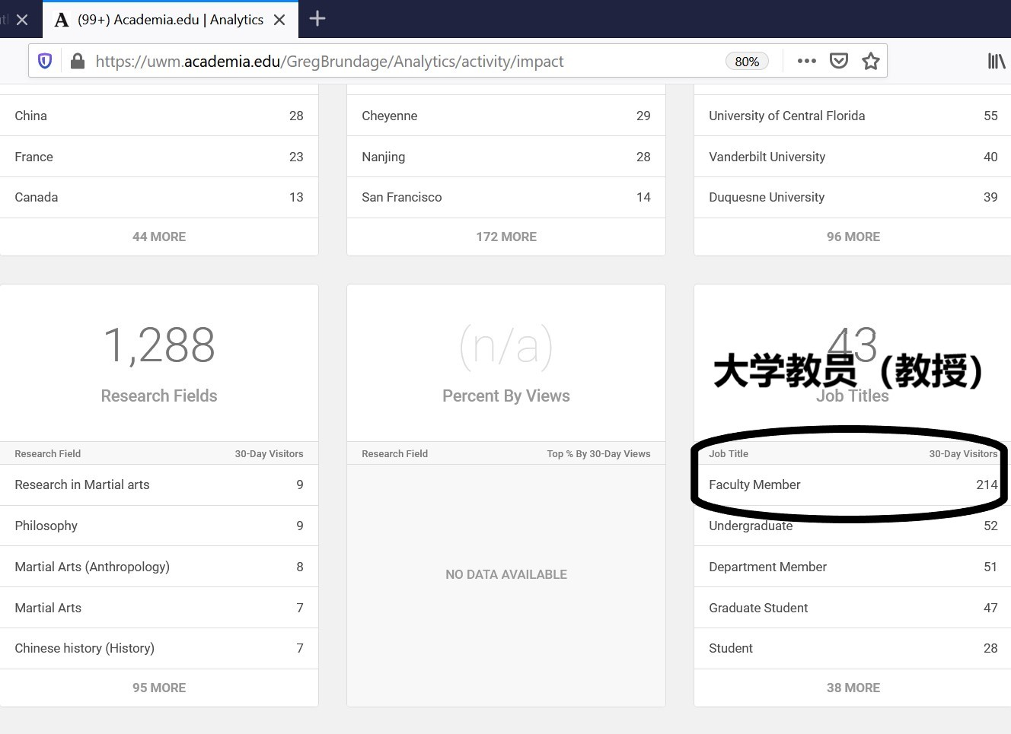
由于美国各地的孔子学院正在封闭，中美之间的文化/艺术桥梁正在迅速消失，但我继续定期撰写和出版文化/艺术故事。
With the Confucian Institutes across the USA being closed, culture/arts bridges between the United States and China are disappearing rapidly, yet I continue to write and publish culture/arts stories on a regular basis.
我的一系列文章发表在www.kungfumagazine.com网站全天候免费提供。各种各样的搜索词可以在网上找到我的文章。丝绸之路功夫似乎只是一个狭窄的市场定位。然而，丝绸之路发展项目（一带一路）是习近平主席最光荣、最著名的国际性作品，少林寺是中国现存最长的单一实体。自唐朝以来，少林一直是道德操守的堡垒，为保护无辜而不屈不挠。
My articles published on www.kungfumagazine.com are available 24/7/365 for free, and a wide variety of search terms brings up my stories. Silk Road Kung Fu may seem like a narrow market niche, but the Silk Road Development Project (One Belt One Road) is President Xi Jinping’s most glorious and famous international work, and the Shaolin monastery is the longest surviving single entity in China that has fought to protect the innocent and preserve morality in China.
从唐朝开始，少林寺就代表了中国的道德支柱。除了我的丝绸之路功夫故事，我还出版了两本关于北少林的书亚马逊网站. 虽然没有任何钱，但是丝绸之路这是中国和世界伟大而美好的文化经济链接。于是，我自己付了所有的费用。在过去的五年里，我花了两万多美元做丝绸之路的使者去了16个国家的“丝绸之路功夫友谊之旅”大多数很艰苦，没有其他人做我做的那种工作。
Since the beginning of the Tang Dynasty the Shaolin Monastery has represented the moral backbone of China. In addition to my Silk Road Kung Fu stories I’ve also published two books about North Shaolin on amazon.com. I have never been paid for any of that writing. Instead I paid all costs myself. The “Silk Road Kung Fu Friendship Tour” to over 16 countries cost me more than 20 thousand dollars over the past five years. There is no one else doing the kind of work I do.
值得注意的是，习近平主席的丝绸之路发展计划（“一带一路倡议”）是人类历史上最大的经济发展计划，我一直在我的丝绸之路功夫系列文章中推广这一计划。到目前为止，作为我系列文章的一部分，已经出版了34篇文章和两本书。这是一项独特而重要的成就。It is also worth noting that the Silk Road development plan (Belt and Road Initiative) of President Xi Jinping is the largest economic development plan in human history, and I have been promoting that plan in my Silk Road Kung Fu series of articles. Thus far there have been 34 articles and two books published as part of my series. This is a unique and significant accomplishment.
最近，在2020年8月和2020年9月，我准备了一系列PPT，以帮助中国武术功夫大师在丝绸之路各个国家的中国境外授课。 这些PPT教授基本的英语语言技能，以满足基本的交流需求，包括“ 套路”和散打训练与比赛的专用语言。 每个PPT的每张幻灯片都有录音，以帮助那些武术功夫大师发音。Most recently, in August and September 2020 I prepared a series of PPTs to help Chinese Wushu Kung Fu masters teach outside China in various Silk Road countries. Those PPTs teach the essential English language skills for basic communication needs, including specialized language for Taolu and Sanda training and competition. Each slide of each PPT has audio recordings to help those Wushu Kung Fu masters with pronunciation.
https://heartpublications.org/coaches/
可以从上面的互联网页面免费下载这些PPT。 Those PPTs can be downloaded from the above internet page for free.

我的技能组合在一起的人很短缺 Short supply of people of people with my combination of skills
我1972年开始练太极拳和少林功夫。我从1980年开始从事出版业。通过我的出版物，我不仅能够分享和交流中国武术的技巧和技巧，而且能够分享和交流指导中国武术发展的基本理念和心理。I started training in Taiji and Shaolin Kung Fu in 1972. I started publishing professionally in 1980. I have – via my publications – a proven ability to share and communicate not just the skills and techniques of Chinese martial arts but also the underlying philosophies and psychologies guiding the development of Chinese martial arts.

像我这样以英语为母语，为中国武术、历史和文化做大量（免费）媒体宣传的“人少之又少特别是现在。There is a “short supply” of native English speakers like me that do a huge amount of (free) media promotion for Chinese martial arts, history and culture.

现在，到2020年，中国需要更多积极的公共关系来平衡来自华盛顿特区的负面诽谤，我爱中国，我不愿意看到各国对她恶意的诬陷。Right now, in 2020 China needs more positive public relations to balance the very negative slander emanating from Washington D.C.

有了永久居民卡，我就可以留在这里继续做好宣传中国文化和历史的工作。
With a Permanent Resident Card, I can stay here and continue doing good work promoting Chinese culture and history.

www.kungfumagazine.com网站从来没给过我钱。在我50年的武术生涯中，我从来没有从武术中挣钱。杂志本该付给我的钱被投入广告，募集资金重建蓟县盘山北少林寺。 www.kungfumagazine.com never paid me. In my 50 years of martial art practice I never earned any money from martial arts. The money the magazine should have paid me was put into advertising to collect money to rebuild the North Shaolin Monastery on Panshan, Jixian.
《功夫太极》杂志的编辑和（少林方丈释永信的助手）“石延沛”都将对此进行验证。
(Both the editor of Kung Fu Tai Chi magazine and Abbot Shi Yong Xin’s assistant Shi Yan Pei will verify this.)
要申请永久居民卡，我需要一封推荐信和中国政府部门的相关证明。To apply for a Permanent Resident Card, I need a Letter of recommendation and related proofs from a Chinese ministry.
关于我与武术功夫相关的著作和出版物，我确定了两个可能负责向我提供我需要的“推荐信和相关证明”的中国部委：In regards to my Wushu Kung Fu related writings and publications I identified two ministries that might be responsible for providing me with the “Letter of Recommendation and related proofs” that I need:

1. 中国体育总局 General Administration of Sport of China
单位地址：北京市东城区体育馆路2号 100763
联系电话：010-87182808
Address: No. 2 Tiyuguan Road, Dongcheng District, Beijing 100763
Contact number: 010-87182808

职责包括：Responsibilities include:
管理与体育产业有关的外交事务，加强与其他国家和地区的合作。To manage foreign affairs related to the sports industry, enhance cooperation with other countries and regions.
指导和组织法律宣传教育 Guide and organize legal publicity and education
http://english.www.gov.cn/state_council/2014/09/09/content_281474986284050.htm
http://www.sport.gov.cn/n10812/lianxi_index.html
http://www.sport.gov.cn/zfs/

国家体育总局主要职责内设机构和人员编制规定
The State Sports General Administrations main responsibilities, internal institutions and staffing regulations
（八）对外联络司。负责机关和直属单位的外事工作；指导、协调、管理体育系统涉外及涉港澳台的有关事务；组织开展与国际体育组织和各国（地区）间的体育交流与合作。
(8) Department of External Liaison. Responsible for the foreign affairs work of the agencies and directly affiliated units; directing, coordinating, and managing the foreign affairs related to the sports system and Hong Kong, Macao, and Taiwan; organizing sports exchanges and cooperation with international sports organizations and countries (regions).
（十）宣传司。指导、组织体育宣传工作，推动体育文化建设，协调重大体育活动的采访报道工作，承担新闻发布工作。机关党委负责机关和在京直属单位的党群工作。离退休干部局负责机关离退休干部工作，指导直属单位的离退休干部工作。
(10) Propaganda Department (宣传司 Xuānchuán sī). Guide and organize sports publicity work, promote the construction of sports culture, coordinate the coverage of major sports activities, and undertake the work of publishing news.
http://www.gov.cn/fuwu/2014-02/22/content_2618765.htm

2. 文化和旅游部 Ministry of Culture and Tourism
北京市东城区朝阳门北大街10号100020
No. 10 Chaoyangmen North Street, Dongcheng District, Beijing, 100020
电话：Phone: 59881114
根据法律、行政法规和“三定”规定，文化部在艺术发展、文化产业、公共文化和非物质文化遗产保护四个领域主要履行以下职责：
According to laws, administrative regulations and the "three decisions", the Ministry of Culture performs the following duties in the four areas of art development, cultural industry, public culture and intangible cultural heritage protection:
（四）指导、管理艺术事业发展，指导艺术创作与生产，扶持体现社会主义核心价值观的文艺作品和代表国家水准及民族特色的文艺院团，推动各门类艺术的发展；指导、协调全国性艺术展演、展览及重大文艺活动。
(4) To guide and manage the development of art, guide the creation and production of art, support literary and artistic works that embody the core values ​​of socialism and troupes that represent national standards and national characteristics, and promote the development of various categories of art; guide and coordinate national art Performances, exhibitions and major cultural activities.
http://zt1.mct.gov.cn/col/col756/index.html
我的中国武术功夫相关出版物和简历清单附呈。Lists of my Chinese Wushu Kung related publications and resume are attached.
除了我的武术功夫出版物，我还出版了一本文学作品，题目是：英语作为外语教学（EFL）与和平研究。它提倡社会主义，批判性地分析资本主义帝国主义、政府民主制度的主要缺陷，教授促进人际和国际和平的技能，包括解决冲突的策略、咨询、外交、谈判和仲裁。它可以在www.amazon.com并且可以从
https://heartpublications.org

外国人在华最新就业评估标准 Newest Employment Evaluation Criteria for Foreigners in China
根据中国政府最新的外国人就业评估标准，我有资格就业。
According to the newest Chinese government evaluation criteria for the employment of foreigners, I am eligible for employment.
《外国人来华就业评价标准（试行）》2020-07-09
Evaluation Criteria for Foreigners Employed in China (Trial) 2020-07-09
二。外国专业人才（B类）
II. Foreign professional talents (category B)
符合《外国人来华就业指导目录》和中国经济社会发展的相应需要，有下列情形之一的，为乙类：
Foreign professionals in line with the "Foreigners Employed in China Guide Catalog" and the corresponding demands of the economic and social development of China who fall within any of the following conditions shall be classified into Category B:
（B） 具有国际公认资格证书或紧缺的技能型人才*
(B) Skilled talents with internationally recognized qualification certificates or in short supply
http://english.beijing.gov.cn/government/lawsandpolicies/202007/t20200708_1942348.html
* 在过去的10年里，我在国际媒体上宣传中国武术（在中国和丝绸之路沿线）的次数比世界上任何一个外国人都多。我主动这么做这些且没有任何收入的。I have done more international media promotion of Chinese martial arts in China and along the Silk Roads during the past 10 years than any other foreigner in the world. I have done this for no money on my own initiative.
- 曾在从西安到伊斯坦布尔的丝绸之路上乘坐火车、公共汽车和公共汽车旅行，并前往其他丝绸之路国家采访、摄影，并在许多情况下与武术大师一起训练 Have traveled on the Silk Roads from Xi’an to Istanbul on trains, busses, and buses, and traveled to other Silk Road Countries interviewing, photographing and in many cases training with their Wushu Kung Fu Masters

- 认识许多国际武术联合会的高级管理人员
…know many of the top administrators at the International Wushu Federation (IWUF)

- 已经用英文出版了几本关于中国武术和丝绸之路的书籍和65 多篇杂志文章
…have published several books and more than 65 magazine articles about Wushu kung fu in China and along the Silk Roads in English

- 我建立并维护了两个主要的推广武术功夫的大型网站
…have two main internet sites promoting Wushu Kung Fu
www.fightingartsasia.com
https://heartpublications.org/

- 在北京住了11年了…have lived in Beijing for 11 years
- 11年来，我是美国《功夫太极杂志》唯一的外国记者。那是世界上最受欢迎的功夫杂志。（中国目前没有功夫杂志。）
…have been the one and only foreign journalist for the American “Kung Fu Tai Chi magazine” for 11 years. That is the world’s most popular Kung Fu magazine. (China does not have a Kung Fu magazine at this time.)

- 我还采访了武术联合会秘书长、国家队教练和国家队队员，比其他讲英语的记者都多。（有时我也和他们的国家队一起训练）I also interviewed, and photographed more Wushu Federation Secretary Generals, national team coaches, and national team members, than any other English-Speaking journalist. (Sometimes I also train with their national teams)
我在中国也许不太出名，因为中文不太好，世界很有名，因为我的大多数文章是为国际读者写英文，让他们更加喜欢了解中国。I am not well known in China because I write in English for an International audience.
我不是电脑程序员。我使用网站模板来建立互联网网站。虽然我拥有自己的互联网域名，但我的大部分网站都是在上面托管的www.weebly.com。
I am not however a computer programmer. I use website templates to build internet sites. Though I own my own internet domain names most of my sites are mostly hosted on www.weebly.com.
- https://www.fightingartsasia.com
- https://www.silkroadresearchcenter.org
- https://triathlonchina.weebly.com
- 和其他 And others…
不幸的是，一些麻烦制造者使用Weebly.com网站. 他们用反华宣传建立互联网网站。因此，所有由weebly主办的互联网网站在中国都被屏蔽了。我仍然保持我的武术功夫网站的更新。它们在中国以外很受欢迎。我爱中国，写中国的精华。Unfortunately, some troublemakers use Weebly.com for anti-China propaganda and all internet sites hosted by weebly.com were blocked in China a few years ago. I still keep them up to date and they are popular – outside of China. I love China and only write good things about China.
最近我开了一个新的因特网站点，托管在Recently I started a new internet site hosted on www.wordpress.com
这在中国没有被封锁 Fortunately, www.wordpress.com is not blocked in China.
https://heartpublications.org (主页 Home page)
https://heartpublications.org/blog-2 (我的出版物My Publications)
https://heartpublications.org/coaches (可下载的PPT集合，旨在帮助中国武术功夫大师在丝绸之路国家教授 Collection of downloadable PPTs designed to help Chinese Wushu Kung Fu masters teach in Silk Road countries)
https://heartpublications.org/about (关于我：兴趣，爱好，目标和简历About me: Interests, hobbies, goals and C.V.)
https://heartpublications.org/contact (与我联系：电子邮件和微信名称 Contact me: email and WeChat name)
我是四本著作和50篇发表过的文章的创作者，作家和摄影师，这些文章宣扬中国武术，历史和文化。 这些包括：

我出版的一些书包括：Some of my published books include:
- 重建北少林寺系列文章，已出版《功夫》杂志（加利福尼亚州）-免费在线24/7提供
Rebuilding the North Shaolin Monastery series of articles, published Kung Fu Magazine (California) - available on-line 24/7 for free www.kungfumagazine.com

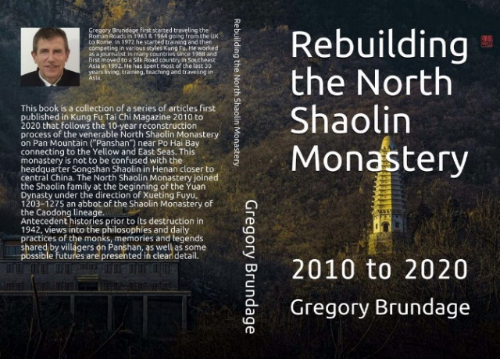
下载Download: www.amazon.com & https://heartpublications.org
ISBN: 9798661286116
- 《北少林：历史，文化与轮回》（2013年）
Book: North Shaolin: History, Culture and Reincarnation (2013)
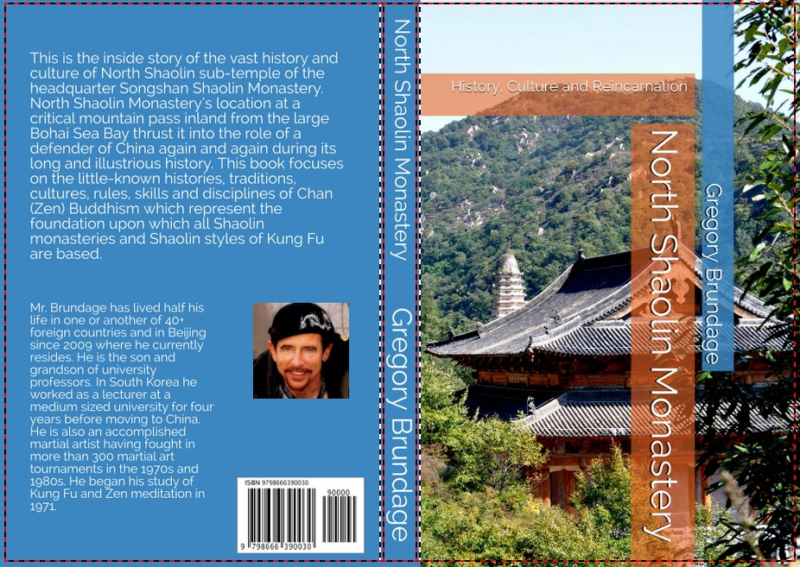
下载Download: www.amazon.com & https://heartpublications.org
ISBN: 9798666390030

(我也是少林寺的俗家弟子 I am also a sujia dizi of the Shaolin Temple)
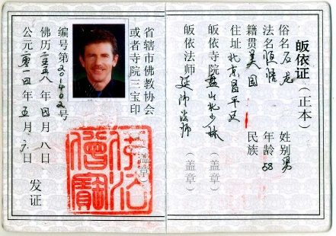

- “丝绸之路功夫友谊之旅”系列发表文章——来自16个国家的38篇文章，实地行程超过2万公里。The “Silk Road Kung Fu Friendship Tour” series of published articles - 38 articles from 16 countries traveling more than 20,000 kilometers on the ground.
Now a two-volume set of books:
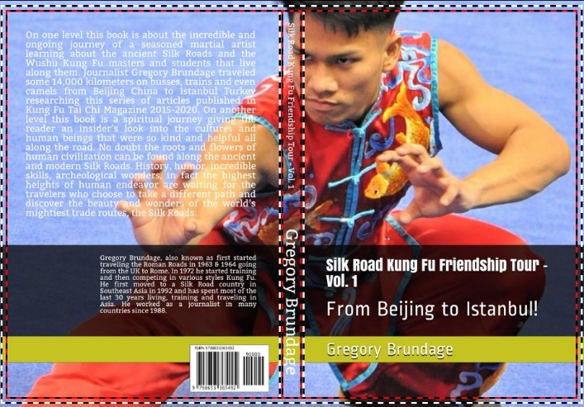
下载Download: www.amazon.com & https://heartpublications.org
ISBN: 9798653365492

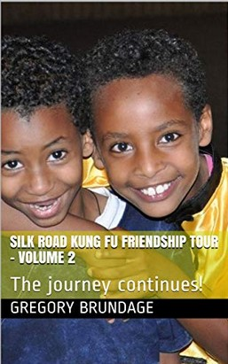
下载Downloaded: www.amazon.com & https://heartpublications.org
ISBN: 9798653721496

我写的关于武术功夫和丝绸之路的文章清单——我的出版物——太长了，写不下一封短信。所以我的简历和那张单子附在后面。
The list of my magazine publications about Wushu Kung Fu is too long for a short letter. So my C.V. with that list is attached along with this cover letter.

- 我创建并维护了一个大型网站，主要介绍武术/功夫，名为：I started and have maintained a large website mostly covering Wushu/Kung Fu called:
www.fightingartsasia.org

学术媒体 Academic Media
我的文章和出版物不仅发表在www.amazon.com还有我的网站。我也在学术网站上发表www.academic.edu。My articles and publications are not only published on www.amazon.com and my internet sites. I also publish them on academic sites like www.academia.edu.
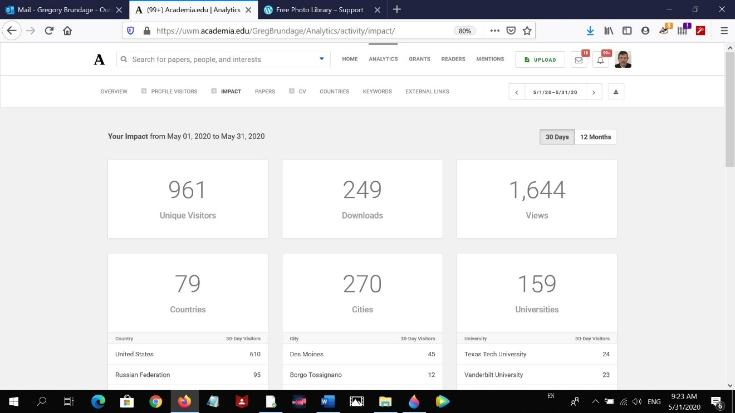
从2000年5月1日到2000年5月31日，来自159所大学的教授们阅读了我的文章和书籍。
From May 1st 2000 to May 31st 2000 mostly professors from 159 universities read my articles.
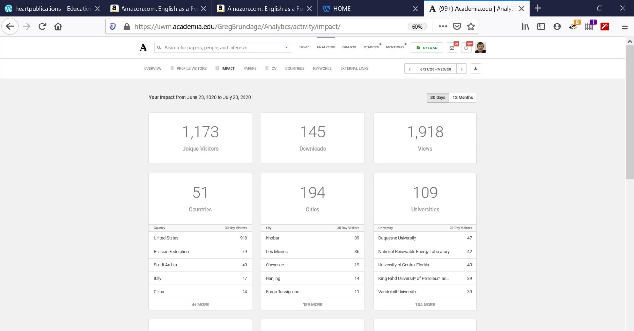
6月25日至7月25日，来自109所大学的教授（主要是教授）在www.academia.edu上阅读了我的出版物。
From June 25 to July 25th mostly professors from 109 universities read my publications on www.academia.edu.
我怎么知道“大部分是教授？”因为很多人给我写信感谢我的工作。How do I know mostly professors? Because many write to me thanking me for my work.
有时他们会提供积极的建议来帮助我的研究。Sometimes they offer positive suggestions to try to help my research.
许多大学教授在学术期刊上发表文章，然后在公众可访问的网站上免费发表文章。 为什么？ 他们对人们学到的东西更感兴趣，而不仅仅是赚钱。 我也一样。 我从出版物中赚不到钱。 我没有从amazon.com出版物中获得任何特许权使用费。 我使它尽可能便宜，以便大多数人会阅读我的书。Many university professors publish in academic journals, and then also publish on publicly accessible websites for free. Why? They are more interested in people learning something than just making money. I am the same. I make no money from my publications. I earn no royalties from my amazon.com publications. I make it as cheap as possible so the most people will read my books.
我也在其他学术网站上发表文章，比如https://www.scribd.com，以及我自己的其他网站。
I also publish on other academic sites like https://www.scribd.com, and other websites of my own.

中国急需的技能 Skills China needs
中美两国的功夫外交源远流长。1974年6月，中国政府在白宫为尼克松总统和基辛格组织了一次功夫表演。当时11岁的李连杰是中国政府派出的功夫队之一。Kung Fu diplomacy between the China and USA has a long history. In June 1974 President Richard Nixon and Henry Kissinger were treated to a Kung Fu demonstration. Then 11-year-old Jet Li was one of the Kung Fu team sent by the Chinese government.
特朗普总统的贸易战和“抨击中国”始于2018年。
President Trump’s trade war and “China bashing” began in 2017-2018.
两年后，他的“抨击中国”的影响可以通过美国的民意测验来衡量。
Two years later the effects of his “China bashing” could be measured by public opinion polls in the USA.
2019年8月13日，皮尤研究中心（Pew Research Center）
在2019年8月公布的一项调查显示，“现在60%的美国公民对中国持普遍不利的看法”。“这一比例从2018年的47%上升到皮尤研究中心开始提问以来的最高水平。”
August 13, 2019 “Sixty percent of US citizens now hold generally unfavorable view of China,” according to a survey published in August 2019 by the Pew Research Center. “This is up from 47% in 2018 and at the highest level since Pew Research Center began asking the question.”
https://www.pewresearch.org/global/2019/08/13/u-s-views-of-china-turn-sharply-negative-amid-trade-tensions
MMA是世界上发展最快的运动。与此同时，东亚武术越来越不受欢迎。特朗普总统没完没了地诽谤和诋毁中国，这并没有帮助。While MMA is the fastest growing sport in the world, East Asian martial arts are becoming less and less popular. President Trump’s endless smearing and denigration of China is not helping. Destroying the cultural bridges between China and the USA does not help.
我是其中一座桥的一部分。我是唯一一个在中国连续工作了10年的功夫记者。我非常想继续写中国武术、文化和历史故事，并在美国和互联网上发表。I am a part of one of those bridges. I am the only Kung Fu reporter that has worked consistently for 10 years in China. I very much want to continue writing Chinese martial arts, culture and history stories and publishing them in the USA and on the internet.
毫无疑问，特朗普总统将COVID-19称为“中国病毒”继续侵蚀中国在美国的形象。
There is no doubt that President Trump referring to COVID-19 as the “China virus” has continued to erode China’s image in the USA.

现在，中国比以往任何时候都需要一个多方面的积极公共关系计划。 在过去的十年中，我所有的出版物都是积极的公共关系故事，着重介绍了中国伟大而又丰富多彩的武术，历史，文化和人民。Now more than ever China needs a multi-faceted positive public relations program. All of my publications over the past 10 years have been positive public relations stories highlighting the great and colorful martial arts, history, culture and people of China.
换言之，迫切需要继续和扩大我的工作。In other words, there is an urgent need to continue and expand my work.
正如甄子丹（Donny Yan）在电影《叶问4：完结篇》（Yip Man 4）中所说：
As Donny Yan said in the movie Yip Man 4:
“我们不应该利用武术消除对我们的偏见吗？” “这是我非常想做的事。”
“Shouldn’t we use martial arts to change the biases against us? This is something I very much want to do.”

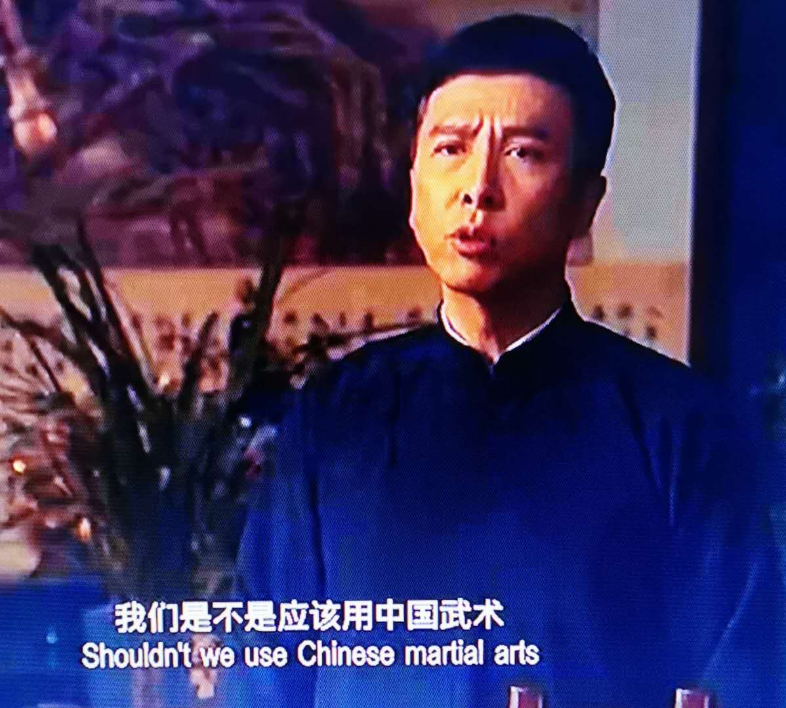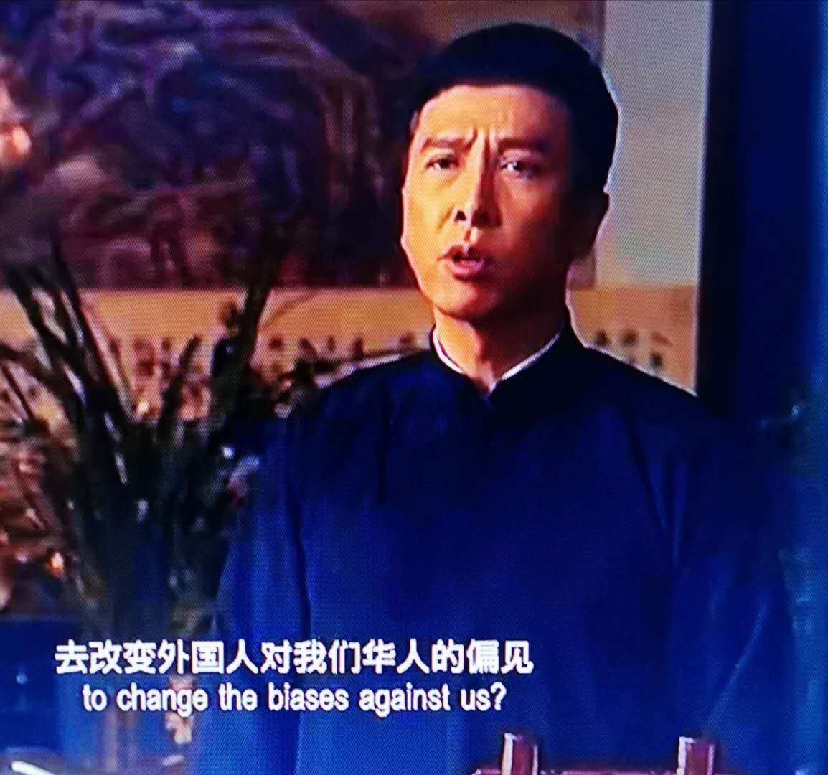

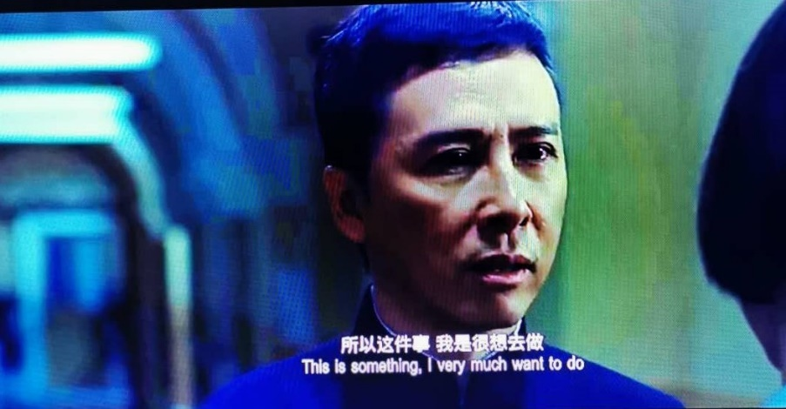
这是我做了10年的事。我没有得到任何与武术相关的出版物的报酬。现在我64岁了。我没有资格申请教师签证。我只想继续在国际媒体上推广中国武术、历史、文化和哲学。但是，如果没有永久居民卡和/或某种工作签证，我就做不到。《功夫》杂志从来没给过我钱。我那10年的工作没有挣到钱。现在我没有收入，需要就业。现在回美国对我来说不是一个选择。这也意味着我在国际流行和学术媒体上宣传中国艺术、历史、文化和哲学的工作结束了。同时，我现在知道，在这个历史时期，中国需要比以往任何时候都更积极的国际媒体。
This is something I have been doing for 10 years. I was not paid for any of my martial arts related publications. Now I am 64 years old. I am not eligible for a teaching visa. I only want to continue the work I have very successfully been doing promoting Chinese martial arts, history, culture and philosophies worldwide in the international media. However, I cannot do that without a Permanent Resident Card and/or some kind of work visa. Kung Fu magazine never paid me. I earned no money from those 10 years of work. Now I have no income and need to be employed. Returning to the USA for me at this point is not an option. It would also mean the end of my work promoting Chinese arts, history, culture and philosophies in the popular and academic international media. I know that in this historical period, China needs more active international media than ever before.

我希望电视台能够参与其中，并且我们可以用中文和英文共同推广武术/功夫，并宣传中国的悠久历史，多元文化，武术和良好的人文精神。
I hope a TV station can join in this effort, and we can work together in Chinese and English to promote Wushu/Kung Fu, and promote China’s fantastic history, diversity of cultures, philosophies, martial arts and good human spirit.

我已经通过我的出版物为中国做出了杰出的贡献，并具备了中国需要的积极的公关技巧。I have already made outstanding contributions to China via my publications, and have positive public relations skills China needs.

外国专家类别和标准Foreign Expert Categories and Criteria
要想获得在中国教英语的专家证书，你真正需要的是一个四年的大学学位，也许还有一个六周的托福证书。我知道，当我还是高中老师的时候，我在中国有10年的专家证书。To get an Expert Certificate for Teaching English in China all one really needs is a four-year university degree and maybe a six-week TOEFL certificate. I know, I had an Expert Certificate in China for 10 years while I was a high school teacher. However, previous years’ incomes, Ivy League University status, and youth earn many points towards getting the coveted Expert Certificate.
就我的武术经验而言，我于1972年开始接受功夫训练，在跆拳道和空手道方面有二级黑带，在剑道、柔道和传统射箭方面有一定的专长。在上世纪七八十年代，我参加过300多场武术比赛，在不同的杂志、不同的国家和几本书上发表了100多篇关于武术的文章。我从1980年开始为美国地理学会写作，并在美国、马来西亚、韩国和中国的报纸上发表文章。除此之外，我还做过其他类型的专业写作，比如广告和营销视频脚本。我是个职业作家。所以，我是几方面的专家。
In regards to my martial art experience I started Kung Fu training in 1972 and have 2nd degree black belts in Taekwondo and Karate and some expertise in Kendo, Judo, and traditional archery. I fought in more than 300 martial arts tournaments in the 1970s and 1980s. I’ve published over 100 articles about martial arts in different magazines, from different countries and several books. I started writing professionally in 1980 for the American Geographic Society, and have also published in newspapers in the USA, Malaysia, South Korea and China. In addition to that I’ve done other kinds of professional writing like advertising and marketing video scripts. I’m a professional writer. So, I’m an expert in several things.
我的英文出版物都让中国、中国文化和中国人在国际媒体上显得非常可爱和精彩，因此我为中国做了大量的公关工作（10年来我自己花了很多钱）。然而，对于专业作家、武术家或公共关系，似乎并没有“外国专家”这一类。有人可能会认为，既然美国正在发起一场大规模的抨击中国的运动，那么国际媒体的公共关系就显得很重要了，但这一切貌似没有什么外国专家证书授予，但是我是这方面的专家，我了解爱中国，也了解世界形式和美国。
My English language publications all make China, Chinese culture and people look very lovely and wonderful in the international media, and thus I have done a huge amount of public relations work for China (for no money for 10 years). Yet, it appears there is no “foreign expert” category for professional writers, martial artists, or public relations. One might think public relations in the international media would be important now that a massive campaign of China bashing is underway coming from the USA. But there is no Foreign Expert Certificate category for all this. A little surprising really.
或许，目前的专家类别和标准是在两年前针对中国的贸易和诽谤战争开始之前制定的。也许责任人并没有把增加公共关系作为一个需要高度专业化和专业化专家的关键技能领域。也许没关系。目前的专家地位主要取决于金钱（以前的收入水平）、常春藤盟校的地位和年龄，而不是经验、出版物或过去和正在取得的成就。Perhaps the current Expert categories and criteria were created before the trade and defamation wars against China began two years ago. Perhaps the individuals responsible didn’t think of adding Public Relations as a critical skill area in which highly specialized and professional Experts are needed. Perhaps it doesn’t matter. Current Expert status is primarily determined by money (previous income levels), Ivy League university status, and age, not experience, publications, or past and ongoing accomplishments.

事实核查 Fact Checking
作为上述工作的一部分，我对国际媒体上有关中国及其机构的一些错误信息进行了广泛的“事实核对”。
As part of the above work I have done extensive “fact checking” regarding some of the misinformation about China and its institutions in the international media.
例如，梅尔·沙哈尔（Meir Shahar）用英语撰写的有关少林寺院历史的最权威，国际上最受尊敬的书，标题是：《少林寺院：历史，宗教和中国武术》，夏威夷大学出版社于2008年出版。
For example, the most authoritative and internationally respected book about Shaolin Monastery history in English is by Meir Shahar, titled: The Shaolin Monastery: History, Religion, and the Chinese Martial Arts, published by the University of Hawaii Press, 2008.
沙哈尔在书中写道：In that book Shahar wrote that:
“他们对寺院的慷慨赞助是因为少林对王朝创始人的支持，而不是宗教虔诚。僧侣们对“佛教反暴力法”的不服从是他们繁荣的源泉
“Their generous patronage of the monastery resulted from the Shaolin’s support of the dynasty’s founder rather than from religious piety. The monks’ disregard for the Buddhist prohibition of violence was therefore the very source of their monastery’s prosperity.”
Shahar, Meir (2008) P. 51 & 52
在我的书《北少林-历史、文化和转世》中，我调查了古代佛教法律，这些法律是由最好的大学最受尊敬的学者翻译的，发现佛教僧侣确实有权在特殊情况下打架甚至杀人，因此，沙哈尔对少林的批评是不恰当的。我还调查了西方天主教的法律，发现了同样的许可。In my book: North Shaolin – History, Culture and Reincarnation, I investigated ancient Buddhist laws, translated by the most respected academics from the best universities and found that Buddhist monks do have permission to fight and even kill in special circumstances, and thus, Shahar’s criticism of the Shaolin was inappropriate. I also investigated western Catholic law and found the same permissions granted.
在另一节（第48页）中，沙哈尔引用了指控少林僧侣“酗酒、赌博和嫖娼”的文件，但是，沙哈尔在书中的那一节没有对受命僧侣和外行弟子僧侣做出非常重要的区分。
In another section (p. 48) Shahar quotes documents accusing Shaolin monks of “drinking, gambling and whoring.” But, Shahar failed in that section of his book to make the very important distinction between ordained monks and lay disciple monks.

在为我的书做研究时，我采访了北京不同大学的教授，遇到了一些为沙哈尔教授做研究和广泛翻译的人。（北京大学的一位教授以前也是我父亲在美国的历史系学生）我和他们交谈时学到的一点是，他们的工作报酬很高。在我看来，他们不太可能知道沙哈尔教授会从他们辉煌的工作中得出如此多关于少林寺的负面结论。
Doing research for my book I interviewed professors at different universities in Beijing and met some that did research and extensive translations for Professor Shahar. (One of those professors at Peking University was formerly also one of my father’s history students in the USA.) One thing I learned talking with them is that they were well paid for their work. It seems unlikely to me that they could have known that Professor Shahar would draw so many very negative conclusions about Shaolin Monastery from their brilliant work.

阅读Shahar的书可以给人一种印象，即Shaolin修道院是由欲望充沛的醉酒僧侣组成的，他们在追求物质力量时完全无视佛教原则。Reading Shahar’s book one can get the impression that Shaolin monastery was composed of monks that were drunks and patrons of whores that totally disregarded Buddhist principles in pursuit of material power.

近年来，少林寺受到了大量媒体的攻击，大多来自外国媒体。据我所知，我是唯一一个对沙哈尔教授书中一些非常消极的断言提出质疑的学者/作家。“无视佛教对暴力的禁令”以换取世俗权力是一种可怕的指控。
The Shaolin Monastery has come under a great deal of media attack in recent years, mostly from foreign media. As far as I know, I am the only academic researcher/writer to question some of the very negative assertions of Professor Shahar’s book. “Disregarding Buddhist prohibitions” for secular power is terrible accusation!

自唐朝以来，少林寺一直是中国的道德先锋。成千上万的少林僧侣为保卫中国不受外国侵略者、国内流氓和军阀的攻击而牺牲。我认为他们的名誉值得维护。The Shaolin Monastery has been the moral vanguard of China since the Tang Dynasty. Thousands of Shaolin monks have died defending China from foreign invaders, and domestic gangsters and warlords. I believe their reputation deserves to defended.
同样，在“丝绸之路”的故事中，我宣传习近平主席的“一带一路”计划。 我认为这很棒–可以帮助世界上最贫穷的国家进行基础设施建设。 我乘公共汽车，火车甚至骆驼走过丝绸之路。 我了解丝绸之路和正常的劳动人民-比大多数学者要好。 我与世界分享了那些非常美妙的故事。 我认为这是一件好事。Likewise, in my Silk Road stories I promote the One Belt One Road program of President Xi Jinping. I think it’s great – helping infrastructure development in the world’s poorest countries. I have traveled the Silk Roads on buses, trains and even camels. I know the Silk Roads and the regular working people far better than most people. And I share the those really wonderful stories with the world. This is a good thing, I think.
因为我热爱和弘扬中国、中国文化、历史、道德理念，甚至今天的国际丝绸之路工程，自然会有人不喜欢我。是的，不是每个人都这么觉得。
Because I love and promote China, Chinese culture, history, moral philosophies, and today’s international Silk Road projects, naturally some people will not like me.

我已经19年没有去过美国了。我的孩子和孙子不住在美国，我没有去美国旅游的愿望和理由，那甚至对我有些危险。 I have not visited the USA in 19 years. My children and grandchildren do not live in the USA and I have desire or reason to visit the USA.
Confucius wrote: Enter not a state that is in peril; stay not in a state that is in danger.
不要进入危险的状态；不要停留在危险的状态。

结论 Conclusions
最后，我想知道，基于我对中国的重大贡献，2）中国需要的技能，3）多个学科的外国专家水平（虽然这些技能现在在中国显然没有得到承认），以及4）是否有强烈的愿望至少在未来几年内继续这项工作，上述两个部委都可以给我推荐信和相关证明，申请中国永久居民卡。
In conclusion, I would like to know if, based on my 1) significant contributions to China, 2) skills China needs and 3) Foreign Expert level in several disciplines (though these skills are apparently not recognized here in China now) and 4) strong desire to continue this work for the next few years at least, I can be given a Letter of Recommendation and related proofs to apply for Permanent Resident Card in China by either or both of the above-named ministries.

在过去的六个月里，我一直在努力从体育部和文化与旅游部的不同官员那里得到所需的“推荐信”。不幸的是，和我交谈过的每个人都拒绝看这封信，拒绝看我的简历，也拒绝看我过去10年的任何作品。我觉得这很令人失望。可能我没有在每个部里找到合适的引荐人。然而，似乎没有人知道这些部委中的“合适人选”是谁。换言之，我一次又一次遇到“石墙”，一次又一次。
I have spent the last six months trying to get a letter of recommendation from officials in the Ministry of Sport and the Ministry of Culture and Tourism. Unfortunately, everyone I have talked with refused to look at this letter, refused to look at my C.V., and refused to look at any of my work of the past 10 years. I found that very disappointing. Probably I have not found the right people within those ministries. However, nobody seems to know who “the right people” in those ministries are.

如果读者看一下所附的文件：“丝绸之路KF友谊之旅的物流和费用”，他们会看到我在丝绸之路功夫友谊之旅中至少花费了16万元人民币（23044.02美元）。这些钱足够我在几个小而可爱的国家的小镇上买了一栋小房子。我本可以在大学做家教或兼职教书挣到退休金。
If the reader looks at the attached document: “Silk Road KF Friendship Tour_Logistics and Costs” they will see I spent at minimum 160,000 RMB (USD$23,044.02) just on the Silk Road Kung Fu Friendship Tour. That is enough money for me to have bought a small house in a small town in several smaller but lovely countries. I could have made retirement money tutoring or teaching part-time in a university.
相反，我赌（我的生命）中国的武术功夫，历史，文化，哲学和公共关系对中国足够重要，我将能够在中国找到一份基于大量工作的工作。
Instead I gambled (my life) that China’s Wushu Kung Fu, history, culture, philosophies and public relations were important enough to China that I would be able to get some job here in China based on that huge amount of work.
美国因冠状病毒危机看到索赔人数在一周内增加210万，因此失业人数超过4000万, 2020年5月28日
US job losses pass 40 million as coronavirus crisis sees claims rise 2.1 million in a week, 28 May 2020
https://www.theguardian.com/business/2020/may/28/us-job-losses-unemployment-coronavirus
回到美国对我来说是极其危险的。 我在美国工作的唯一一家报纸是非裔美国人报纸。 非裔美国人报纸的编辑指派我撰写的第一批文章是关于城市中的新纳粹组织的。 我必须了解他们的哲学，全白人私立学校，准军事集团的规模，所拥有的武器等等。 这些文章发表后，新纳粹分子反复威胁我。 他们对我了解很多。 他们知道我嫁给了一位马来西亚妇女。 他们称我为“种族叛徒”（我主要是爱尔兰人，因此是白人）。 他们称我女儿为“泥浆婴儿”。 现在，在特朗普总统领导下，白人至上主义者感到他们像神一样强大。 他们正在杀人而不受惩罚。 许多白人至上主义者是警察。
Returning to the USA would be extremely dangerous for me. The one and only newspaper I worked for in the USA was an African American newspaper. (See my C.V.) The first series of articles the editor of the African American newspaper assigned me to write was about neo-Nazi organizations in the city. I had to learn about their philosophies, their all-white private schools, the size of their paramilitary groups, the weaponry they had, and so on. After publication of those articles neo-Nazis threatened me repeatedly. They know a lot about me. They knew I was married to a Malaysian woman. They called me a “race traitor,” (I am mostly of Irish heredity and thus white). They called my daughter a “mud baby.” Now, under President Trump, the white supremacists feel all powerful. They are killing people with impunity. Many of the white supremacists are police officers.
如果我不能在中国合法工作，我必须离开。如果我去美国，我会失业无家可归。我肯定会成为白人至上主义者的攻击目标。我可能活不了多久。去美国对我来说就是自杀。用我在北京学校的一位前教师（白人至上主义者）的话说，我是一个“热爱黑鬼的穆斯林共产主义者”，这在美国是死刑。
If I cannot legally work in China I have to leave. If I go to the USA, I will be also be jobless and probably homeless. I will definitely be targeted by the white supremacists. I will probably not live long. Going to the USA would be suicide for me. In the words of one (white supremacist) former teacher at my school in Beijing, I am a “N….r” loving Moslem Communist.” That is a death sentence in the USA.

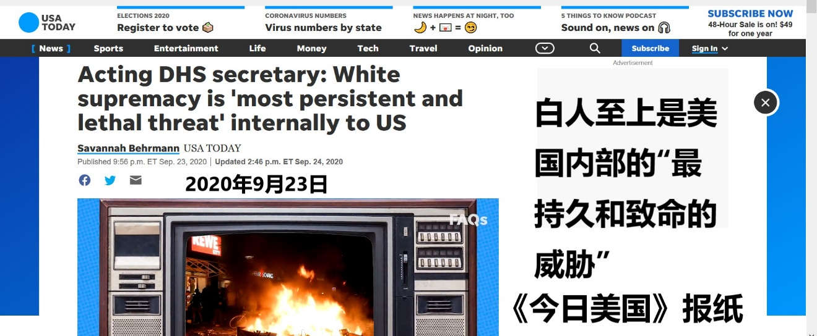
请考虑一下全世界有多少大学教授读过我发表的文章和书籍。（过去五年里，每周100所大学乘以一年中52周的时间。）我父亲是一位历史教授，在美国和欧洲一直很有名。我是社会主义者，穆斯林，不是种族主义者。在特朗普总统（以及他的白人至上主义支持者）建立的恐怖统治时期，强迫我返回美国将是最不幸的，可能是致命的。
Please consider the number of university professors around the world that have read my published articles and books. (Calculate 100 universities per week multiplied times 52 weeks in a year over the past five years.) My father was a history professor that was and remains famous in the USA and Europe. I am a socialist, Muslim and not racist. Forcing me to return to the United States during the reign of terror instituted by President Trump (and his white supremacist supporters) would be most unfortunate and possibly deadly.

请让我知道是否可以从中国某些部获得推荐信和相关证明来申请中国永久居民卡。 如果可以的话，请告诉我如何获得这封信。Please let me know if it is possible to get a Letter of Recommendation and related proofs to apply for Permanent Resident Card in China from a Chinese ministry. If it is possible, please be so kind as to inform me how I can obtain such a letter.

感谢您考虑这个请求。Thank you for your consideration of this request.

Gregory Brundage 石龙 （恒悟）
地址: 北京市昌平区电子基地C6号楼1单元601, 102200, CHINA
手机号码: 186 13801327
电子邮件: gregbrundage@live.com
（对不起，我的中文能力很差。将来我会努力提高的。）
(Sorry for my terrible Chinese language skills. I will try to improve in future.)

后记 Epilogue
美国精英希望更少的美国人了解真实的中国
US elites want fewer Americans to know the true China by Mu Lu Source: Global Times, August 20, 2020
尽管如此，对中国的误解可能是一些美国精英想要的。当越来越少的美国人知道真正的中国是什么样的时候，美国的精英们会耍花招欺骗人民。美国精英们希望通过制造新的争端来维持中美之间的紧张关系来实现他们的政治目标。
Nonetheless, a misunderstanding of China is probably what some US elites want. Only when there are fewer Americans who know what the real China is like can the US elites better play their tricks to deceive the people, and achieve their political goals by creating new disputes to maintain tensions between China and the US.
https://www.globaltimes.cn/content/1198393.shtml

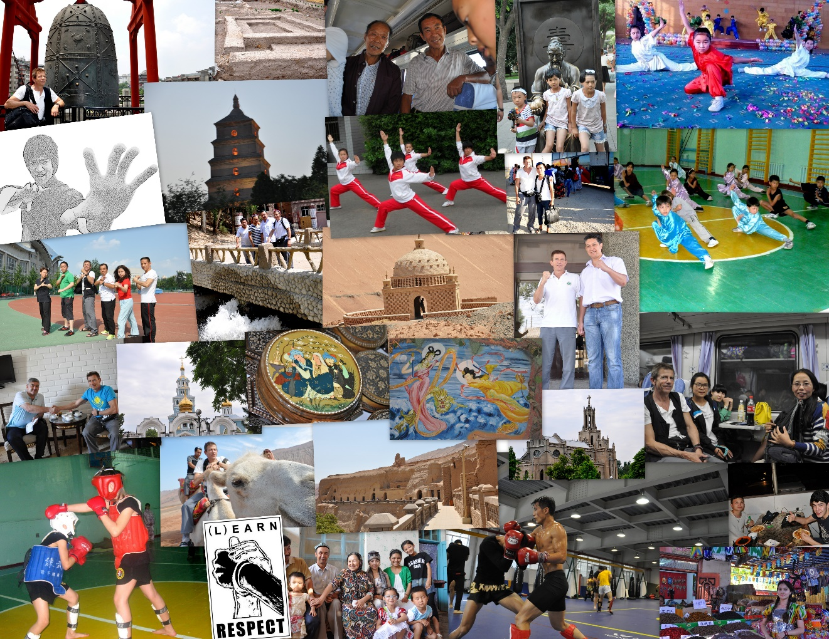
国家武术联合会团队，巴基斯坦拉合尔2018
National Wushu Federation Team, Lahore Pakistan 2018

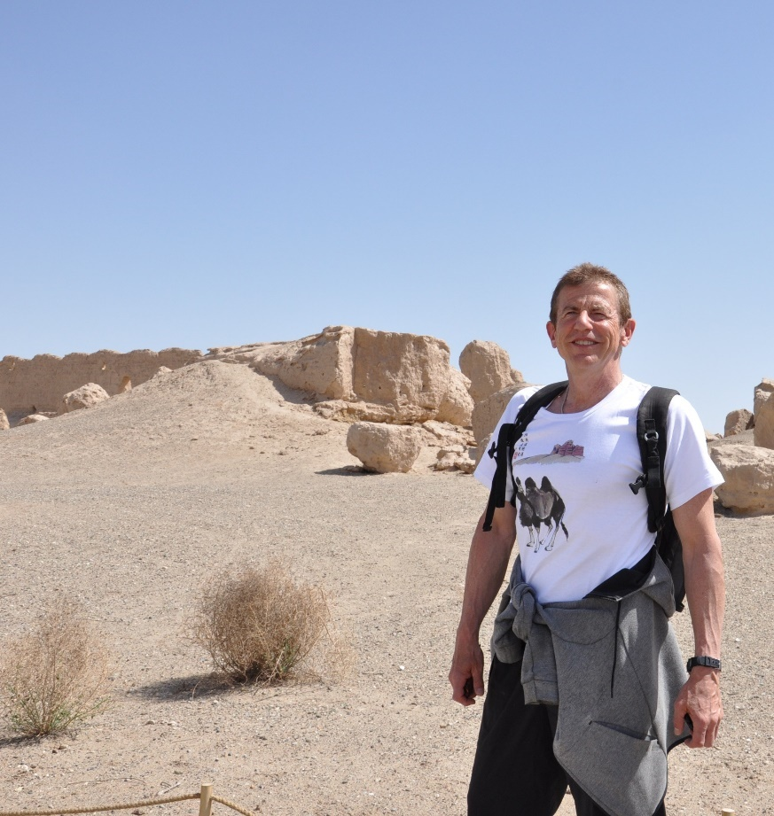
是的，我有点老了，但我有足够的力量和勇气去做很多其他人没有做过的事情。
True, I’m getting a little older, but I’m strong and courageous enough to do what many others have not done.

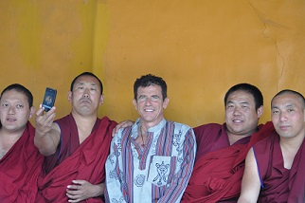
尽管压力很大，我还是保持着幽默感和同情心。
And in spite of the stresses, I keep a sense of humor and compassion.

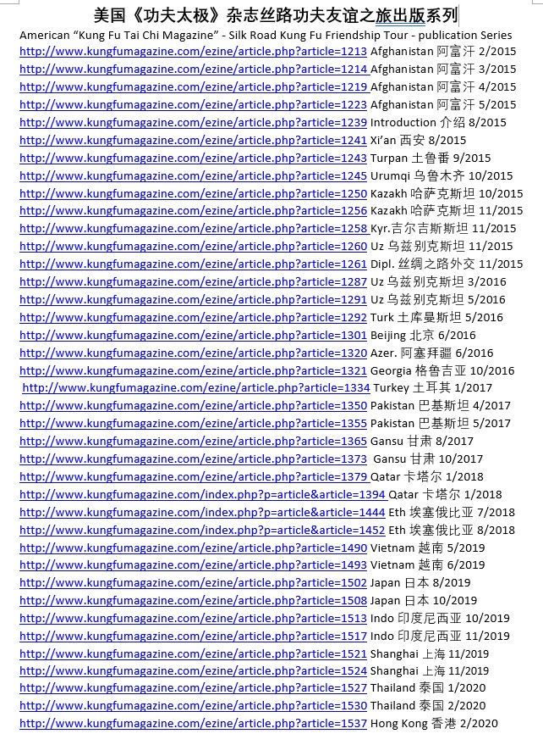
北少林文章列表North Shaolin Article List
- 2010年11月重建北少林寺-第1部分（印刷版）Rebuilding the Northern Shaolin Temple 1 (Print Edition)
- 2011年5月/6月重建北少林寺-第2部分（印刷版）Rebuilding the Northern Shaolin Temple 2 (Print Edition)
- 2011年7月 重建北少林寺-第3部分（在线版）Rebuilding the Northern Shaolin Temple - Part 3 (Online edition) http://www.kungfumagazine.com/ezine/article.php?article=961
- 2012年1月 正北少林寺新年：Chinese New Year's at the True North Shaolin Temple: 重建北少林：第四部分 Rebuilding the Northern Shaolin: Part IV http://ezine.kungfumagazine.com/ezine/article.php?article=1028
- 2013年1月/2月 重建北少林寺——第五部分：“重建全速前进！（印刷版）Rebuilding the North Shaolin Temple – Part V: “Reconstruction Full-Speed Ahead! (Print Edition)
- 2013年5月 重建北少林——第六部分白塔寺分院新年（蛇年，2013）Rebuilding the Northern Shaolin – Part VI New Years at Baitasi Branch Shaolin Temple (Year of the Snake, 2013) http://www.kungfumagazine.com/ezine/article.php?article=1093
- 2013年10月 重建少林寺北部：第七部分：盘山的重建浪潮和其他变化 Rebuilding the Northern Shaolin Temple: Part VII: Reconstruction Surge and other changes in Panshan http://www.kungfumagazine.com/ezine/article.php?article=1126
2014年1月 少林北功夫-历史背景和第七代访谈-东北蓟县盘山市的尚弥安大师（印刷版）North Shaolin Kung Fu - Historical background and an interview with 7th Generation - Master Shāng Mián Huī, from Panshan, in Jixian, northeastern China (Print Edition)
- 2014年1月 重建北少林寺：第八部分大师精神（在线版本）Rebuilding the Northern Shaolin Temple: Part VIII Spirit of the Masters (On-line edition) http://www.kungfumagazine.com/ezine/article.php?article=1144
- 2014年6月 重建北少林寺第九部分：台阶与空虚（在线版）Rebuilding the Northern Shaolin Temple Part IX: Steps and Emptiness (On-line edition) http://www.kungfumagazine.com/ezine/article.php?article=1164
- 2014年9月 福建省三个少林寺：少林南区的瑰宝第1部分：泉州（在线版）Three Shaolin Monasteries in Fujian Province: The Jewels of Southern Shaolin Part 1: Quanzhou (On-line edition) http://www.kungfumagazine.com/ezine/article.php?article=1175
- 2014年10月 福建少林三寺：南少林之宝第2部分-莆田（网络版）Three Shaolin monasteries in Fujian Province: The Jewels of Southern Shaolin Part 2 – Putian (On-line edition) http://www.kungfumagazine.com/ezine/article.php?article=1176
- 2014年10月 福建少林三寺：南少林之宝第三部分-福清（网络版）Three Shaolin monasteries in Fujian Province: The Jewels of Southern Shaolin Part 3 – Fuqing (On-line edition) http://www.kungfumagazine.com/ezine/article.php?article=1181
- Rebuilding the Northern Shaolin Temple: Part 10 - Spirit of Yun Zhao Monastery at the Peak of Pan Mountain Steps and Emptiness http://www.kungfumagazine.com/ezine/article.php?article=1190
- 2015年1月 重建北少林寺第11部分：从盘山脚下的前乡寺看重建新Rebuilding the Northern Shaolin Temple - Part 11: View from the Qian Xiang Monastery at the base of Panshan and Reconstruction News http://www.kungfumagazine.com/ezine/article.php?article=1198
- 2015年3月 重建北少林寺-第12部分：范易慧禅房-北京Rebuilding the Northern Shaolin Temple – Part 12: Fan Yi Hui Chan House – Beijing http://www.kungfumagazine.com/ezine/article.php?article=1211
- 2016年2月10日 重建北少林寺：第13部分：禅堂、山神、客厅大象——2015年夏、2016年冬Rebuilding the North Shaolin Temple: Part 13: Meditation Hall, Mountain Spirits, and an elephant in the living room – Summer 2015 and Winter, 2016 http://www.kungfumagazine.com/ezine/article.php?article=1281
- 2019年1月Rebuilding the Northern Shaolin Temple: Part 14: Guan Yin Hall Heavy Construction Finished http://www.kungfumagazine.com/ezine/article.php?article=1464
- 2019年3月 重建北少林寺：第15部分：北少林寺的起源 Rebuilding the Northern Shaolin Temple: Part 15: Origin of the North Shaolin Monastery http://www.kungfumagazine.com/ezine/article.php?article=1473
- 2020年8月 重建少林北部第16部分：扩展计划 Rebuilding the Northern Shaolin Part 16: Expansion Plans http://www.kungfumagazine.com/ezine/article.php?article=1552
我的少林研究和出版物被许多其他作家引用，包括：My Shaolin research and publications are quoted by many other writers, including: http://www.rgm.hu/index.php?mid=125

感谢您考虑我的“推荐信”请求.
Thank you for considering my request for a Letter of Recommendation from the Ministry of Sports and Culture and Tourism.

