Radicalization of Chinese students in the USA
China has some advantages in a world of interconnected supply and demand chains. I think the origin of those advantages go back to the 100 schools of thought and perhaps Taoism specifically. How so? There is an organic harmonious foundation to Taoism that is quite different from most western philosophies. While Chinese philosophies teach “harmonize with nature,” the Hebrew Bible – the “Old Testament” grants man “dominion over nature.”
It is true a highly aggressive bacteria, virus, animal, man or “civilization” can rush in and do massive killing for a while. This has happened often enough in history. But there are corrective forces built into nature that have always put an end to their reigns of terror and death.
Currently in the USA there is a culture war raging – age-old divisions of every kind are pumped up on steroids and weaponized. Each side is sabotaging the other in increasingly effective attempts to manipulate the media and public opinion.
For the most part China is sailing through this sea of madness very calmly in comparison. And, that is quite nice for the entire world, and me too because I happen to live here. The world needs stability at all times, and especially when the world’s “richest and most powerful nation” is being torn apart by tribalism and increasingly extreme economic polarization while the deadly novel coronavirus strikes the vulnerable with savage fury.
Another advantage China has over western nations is socialism. A structural defect in democracies is that they invariably decay into populism and demagoguery. “Winning(!)” and beating the other political party at election time becomes everything and there is no lie too big, no life or relationship too valuable, when it comes to winning that all-important election. If it means bombing some nation or starting WWIII, so be it! Winning is everything. Socialist countries don’t have that flaw and tend to be vastly more peaceful and harmonious by nature.
The USA has made a religion out of hating socialism and communism since the 1930s and have attacked and destroyed most socialist/communist nations. But, not all. Cuba for example has managed to maintain autonomy right off the coast of Florida despite numerous American invasions and attempts to murder Fidel Castro. And, China of course.
And fortunately, most people like and need stability. Without it civilization cannot continue. People need supply chains for water, food, medicines, communication, transportation etc.
Also, fortunately, most people are normal. Why? Most people want to get married, have children, and see their children have good lives, hoping those lives will be better than their own. Most people are not crazy. This is a huge advantage for China.
Broad support helps China withstand US shock wave
China’s flagship English language newspaper, Global Times ran this editorial headline July 28, 2020. It speaks a big and important truth.

What do most young men want most in the USA for the first time? Yes, that. And, about the only way to get it is by joining a Christian group and everyone knows it. The majority of Chinese students that go to the USA join a church.
First, the American Christians use a mutual hatred of Muslims to get the fire going. They use a lot of lies about Islam to heighten the emotions of the Chinese students.
For example, stories I’ve heard from at least a dozen Chinese students in the USA:
- “To become a Muslim you have to spit on the (Christian) cross.”
- Once I heard from a Chinese students that to become a Muslim a person must urinate on the Christian Cross.
- I also heard Muslims hate Christians, must desecrate a Bible, and other ridiculous very untrue lies.
There is also some very extremely evil “translation” of the Quran the militant Christians in the USA have that makes Muslims look we are all terrorists. Naturally there are innumerable stories about how Muslims force Christians to become Muslims and rape Christian women and all that kind of thing.
Hatred of Islam is the bond many or most Christian groups in the USA use to bond Chinese students into the fake Christian community in the USA.
Then there is the baptism. This is a profound experience for most Chinese students. They are dunked in water, usually a river or small lake and washed of all their sins, being reborn into the Christian community.
Then, the Chinese students learn more about “Christian love,” and they are introduced to fine Christian women. Usually there is a blond hair woman involved. The seduction is slow, but virtually always follows the same pattern. Jesus is love!
Then the fake Christians start teaching the Chinese students about how the Chinese government persecutes Christians. Below are some of their chats with a Chinese student in the USA.
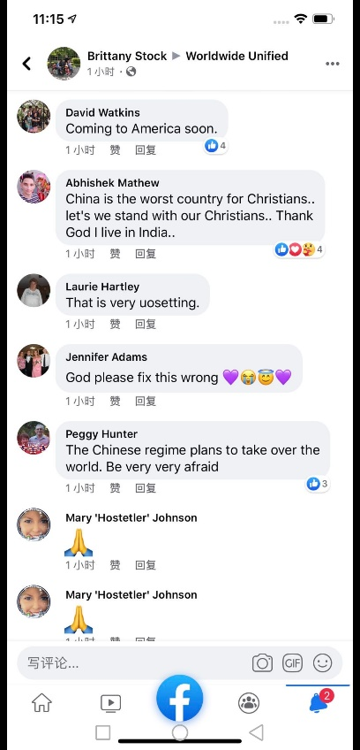
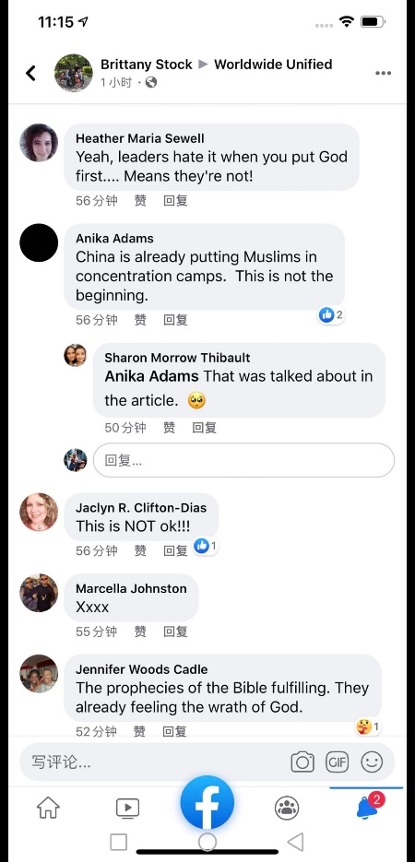
That is ambiguous. Who is feeling the wrath of God? Muslims or China?
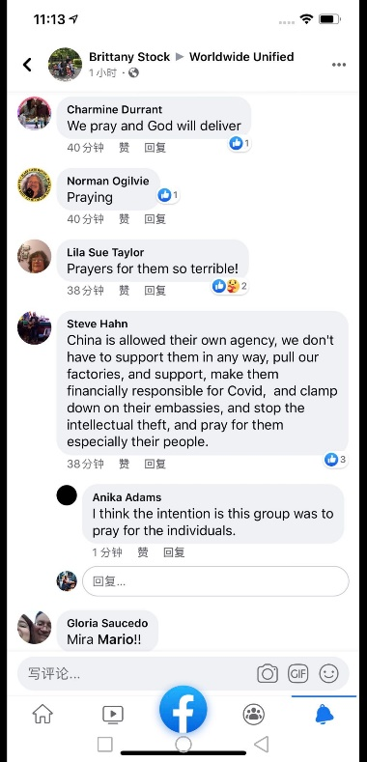

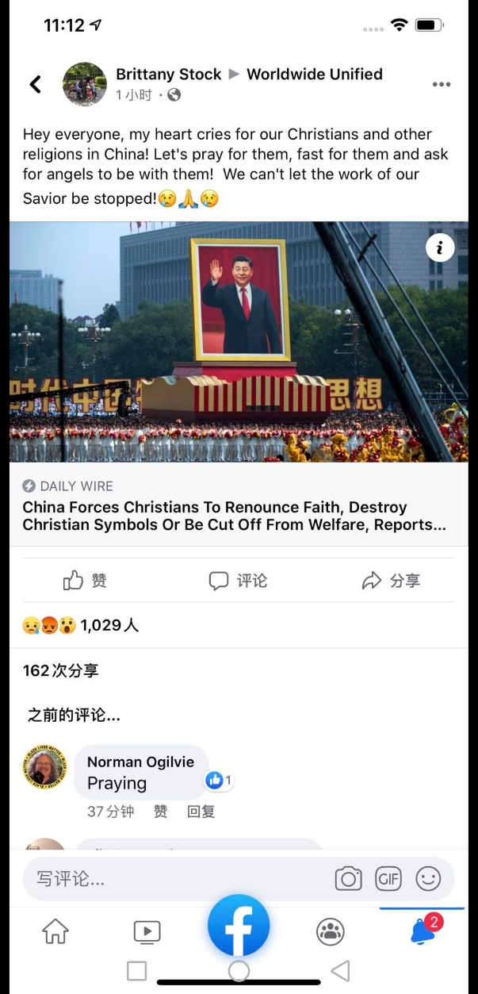

Then, the Chinese students are trained in the use of guns.
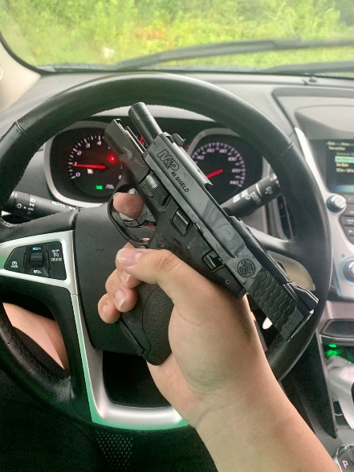

I’ve chatted with but dozens of Chinese students in the USA over the last many years. The pattern is always the same. Usually all of the above only takes about a year. By the end of four years in the USA, they are totally indoctrinated to a “Christian” perspective on life and politics.
Back in China they are welcomed and mostly given good jobs in government, industry and commerce.
Is it a surprise that there should be an anti-Muslim bias here?
After an underground Christian church took over my school in Beijing (2015-2019) I tried to apply for political asylum. Why?
1987 December I converted to Islam to get married.
1988, May - I was thrown out of my Graduate School program after the end of a four-year program. My wife was pregnant and I had a student loan. That permanently crippled me financially. I got a job working at the largest African American newspaper in the city. The first series of stories the editor assigned me to was: “Go into neo-Nazi groups and get information on their all-white private schools and militias. After the first few articles were published the leader of one neo-Nazi group threatened me.
1992 – Moved to Malaysia – the home country of my (former) wife.
1993, November - Went to the Pakistani side of Kashmir and did surveys of people’s attitudes and beliefs. One of the findings of my survey is that many Kashmiris believed Israel and Russia were helping India in its genocidal war in Kashmir. The editor of that section of the newspaper (The New Straits Times, Rose Ismail) put the quote about Israelis and Russians in a very large font caption next to one of my photos.
1994 – January – Those stories were published in Malaysia. A “Christian” reporter named Daniel Peters at The Star newspaper wrote a story about me with false quotes that made me look quite terrible and insulting the immigration department. I was fired from all my jobs, tortured by the Malaysian military, and thrown out of the country. They kept my wife and children. First my wife was passed around to the cronies of the Prime Minister, Mahathir Mohammad. Then, other ethnic communities.
1994 November – I was in Sri Lanka and found out Christian NGOs were
1995 – Returned to the USA. I was constantly harassed by FBI, local police and Indian Hindus. The Hindus liked to shout loudly about how much my wife liked having sex with them. My car was stolen several times along with what little else I owned. Dentists made my teeth worse then before I went into their offices, and double billed me.
1999 October 18, 1999 – I filed a federal lawsuit against the CIA given that CIA traitor Harold Nicholson participated in my sabotage in Malaysia, which was led by USIS Information Officer Stanley J. Harsha working out of the US embassy. It was Stanley Harsha that introduced me to the Christian Indian reporter Daniel Peters that put me out of business. Clinton had met with Prime Minister Mahathir several times. He was begging for political campaign finance. Mahathir wanted to get rid of me because his family was brought to Malaysia when he was a child from India by the British. He has always been a British agent.
2001 – I moved to South Korea – There were no Muslims or a Masjid in either of the cities I lived in South Korea. I tried to be friends with the Christian community but they kept trying to get me to go to sex parties and I always refused. I was punished for that.
2009 – I moved to Beijing. I was very surprised when I was forced at that school to sing Christmas songs. But, that seemed like a minor thing. After 2015 I was switched to a different high school within the same empire like private school. My new supervisor was a Christian fanatic (Sun Xiu Juan, AKA “Shirley”). She was – and maybe still is (I don’t know) the head minister of the largest underground church in this district of Beijing. She made my life into a hell again. I could actually listen and see her being very openly manipulated by “Christian” foreign teachers at department meetings. They encouraged her to give lectures about Jesus and love, while she simultaneously sabotaged my reputation and work. She got all of her “Christian” followers to completely take over the “counselor” positions, and they determined which students got advanced and which students were put into huge classes with the worst students. I always had to teach the largest classes with the worst students. She constantly insulted me behind my back. Many other teachers told me this. Finally, in March 2019 I was told I would not be given a new contract. She retired a very rich woman. I became jobless in July 2019. She has a “magical” control over the CEO of the school. The CEO of the school has a thousand billionaire friends, because “he helped” their children graduate from high school. In fact, it was I, the teacher of the worse of the worst students that helped those students graduate. I was teaching Year 11 and 12 high school students. The owner of that school also has friends in various government ministries.
If someone thinks about it for a minute: Foreign Christians manipulate Chinese Christian Minister and head of the English Department Sun Xiu Juan.
Sun Xiu Juan manipulates the CEO of the school.
The CEO of the school manipulates billionaires and government ministries.
Given that foreign Christians are notorious for working with the CIA (like in Malaysia and Sri Lanka) does this mean that the billionaires and government ministries are also manipulated by the CIA?
I believe it most certainly means exactly that.
They are no doubt helped by around a million of the “best educated” Chinese young people who graduated from American universities where many if not most were indoctrinated into hating Muslims, hating the socialist government of China and indoctrinated into a militarized form of fake “Christianity.”
2019 April 11 – Harassment by Saudi Arabian
I appealed the decision to not give me a new contract for 2019/2020 and at a meeting April 11th with the school Principal Diana Li, I was told my appeal was denied. After that I went to Walmart where I met the first Saudi Arabian, I’ve met in China during the past 10 years. He was quite rude and openly insulted me. That is an amazing “coincidence” considering I go Friday prayer at a mosque most weeks for the past many years, and was very polite to him. The probability of that being a coincidence is one in a million.
2019 June – I applied for Political Asylum in China.
2019, July 8 - Threats against this writer and a Chinese citizen by 中华人民共和国公安部 officer “Michael.”
He calls himself “Michael.” He is the officer in charge of all foreigners in Beijing. At the time he made a criminal threat against me and my then fiancé M.H. I was in the process of applying for political asylum through UNHCR.
Why did he threaten us?
He arrived at my apartment at 2:30 pm. I was with Miao Hui my fiancée and a Chinese citizen. I was applying for refugee status and Chinese police officer “Michael” made it clear it was too much work for the local police station to have a political asylum seeker in this district; he turned off his body camera/microphone and told us we had to move out of this district of Beijing and that he “had ways” to make us move. My fiancée was very terrified by his threat. That evening she was angry. The next day she was suicidally depressed. Nobody likes to be threatened by police, especially in such a manner – turning off his body camera and microphone.
Although I qualify by UNHCR rules for political asylum status, I gave up on getting political asylum status in China, as Chinese laws are rather harsh to such people, for example, they have no legal status, no visa, cannot take trains or airplanes, and will be arrested and fined when attempting to leave the country.
2019 July 16 – I was required to attend a big meeting hosted by UNHCR at Ta Yuan Diplomatic Office Building at 9:00 am. There I learned from other people – mostly who had already been given political asylum, that 1) a very unpleasant secret police officer who calls himself “Michael” was in charge of all foreigners in Beijing, and 2) he really is a repeata liar. For example, he said he informed all district police stations about giving temporary residence permits to refugees in their districts. However, the Muslims in the audience had been denied those residence papers. I also found out the one person he had put in jail was a middle age Muslim mother. The Christians appeared to have been having a smooth time in comparison.
Within a few days I flew to Indonesia and got a 10-year tourist visa for China. It does not allow me to work, and I have to leave the country every three months. But, I’ve lived here in China for more than ten years. This is as close to a home as I have ever had. I did not want to be chased out of China by a (large) Christian cult, the corrupt owner of a large private school and a corrupt secret police officer.

Near duplication of events in Malaysia
2019 December – My “fiancée” fell in love with a man her own age. He was introduced by a “mutual friend.” She did not tell me about it. I had been living with her for nine years. We were still living together.
2020 May – She told me she was pregnant but he would not marry her. I offered to write the details. I found out he had downloaded a menses timing APP, and had bought an ovulation testing kit. He had also never used condoms. He other words he intentionally got her pregnant as quickly as possible. He also knew his parents would not approve of a marriage if she was already pregnant. That was a “set-up.” At the 10th weeks she got a chemically induced abortion. It was very difficult for her. She continued bleeding for more than a week after.
So much of what is happening to me now in China is a duplication of what happened to me in Malaysia. I was sabotaged at my job by a “Christian” who was manipulated by foreign “Christians.”
During the last months I was in Malaysia in 1995 my wife worked at an interior design studio that was frequented by Prime Minister Mahathir’s cronies. She often had to work all night. That is strange. She was not a designer. She answered the phone and greeted guests. The design studio was very “posh.” For example, there were show bedrooms, a movie theater, and so on. All the neighbors knew she was staying out all night. That was very humiliating for me. Likewise, the security guards and neighbors here at my current apartment also know my “girlfriend” was seeing another man…

Dental hell
There are quite a number of other parallels as well. For example my first dentist here was named Wu Ai Ting. She was American educated. I must have spent at least 50,000 RMB to keep my teeth fixed up with her including three root canals. I always paid for the best materials she had, for example, made in Korea rods to be inserted for the root canals. But, all of her work fell apart, broke or became infected quite quickly. I had to get two of those molars completely removed. (I have not had the money to get implants.)
2019 May - I got a terrible gum infection and two more molars broke. In June I went to a different dentist. She started working on one large molar on the upper left side of my mouth. She said it was 50/50 if she could save it. She said the problem was the nerve. There were long delays between appointments. She drilled and drilled that tooth. After three such sessions she finally she put a temporary cap on it in early July. The cap fell off July 22nd. The 23rd I got a phone call telling me to come in to the dentist on July 24, a day before my appointment. I thought that was a surprising coincidence, but nice. I went to the dentist on the 24th and the people at the front desk told me my appointment had not been changed. I had to come back the next day. I thought that was strange. I went back to the dentist on the 25th, the originally schedule date.
As I took the elevator to the 4th floor where was a young Chinese man with a T-shirt that said in English: “You are responsible.” I thought that was a bit odd. I’ve never seen that T-shirt before.
The dentist examined my tooth – the one her partner had worked on for six weeks – and told me it would have to be pulled out. I asked her advice. She said to pull it out. But, instead she asked if I wanted her to continue the treatment her partner had started. I was confused by this, but said OK. She then did an entire root canal on the tooth next to the badly damaged tooth. I didn’t know the tooth she treated had a problem. They had not to my knowledge worked on that tooth before.
She then told me to come back in three weeks and she would pull out the tooth they had worked on for six weeks. The tooth they had worked on had been very big, but after all the “work,” it was very small with many sharp fragments. I asked if she could put the cap back on, and she said, “No, it’s against the office policies.” I couldn’t figure out why they had put a temporary cap on before, but not then. It was big and good for chewing before all the work.
So, I now have a small broken molar with a lot of sharp fragments. I can’t chew using the left side of my mouth. Also, the broken molar on the other side of my mouth (the right side) remains untouched. But at least I can chew food with it.
I still have the cap. The dentist recommended I go to a different dentist if I want the cap put back on the tooth they worked on for such a long time, the now small molar with a lot of sharp fragments. Before their work, I could chew with it and it didn’t hurt. The infection that caused the problems in the first place went away long before they started their work.
After leaving the dentist office July 25th I went outside to my bicycle and there was a WWIII motorcycle with a side car attached, and an Israeli flag. I thought that was unusual. I have never seen an Israeli flag publicly displayed like that in Beijing before.
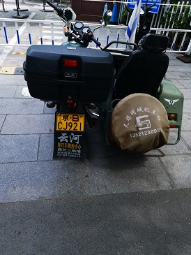
This does not necessarily mean I believe Israelis had anything to do with my bad experiences at this dentist. The school I worked at had several IT people that routinely hacked teachers’ computers. Likewise, the corrupt secret police officer who calls himself Michael certainly can read all my chat messages and could set up something like that. My fiancée had worked for an Israeli company in 2017 and had been treated very badly by them. They threatened to break her legs for example. Shortly after she quit that company, she was robbed of 800,000 RMB. The thief is in jail because she robbed other people too. The thief owns several properties but the police are unable to get my fiancées money returned. I was told the thief is living like a queen in jail. My former fiancée (but still close friend) is still in debt due to that robbery. I personally suspect the Israeli company’s complicity in that crime, but obviously cannot prove it.
The corrupt secret police officer Michael could easily know all the details of this from reading my and my friend’s chats. He could just as easily arrange for a WWII motorcycle with a side car with an Israeli flag on it to appear just outside the dentist after a rather bad experience at the dentist. I went into the dentist thinking my tooth would be fixed. Instead it was worse than before. And of course, I had to pay for each of the visits. This is a duplication of events in Malaysia.
Other forms of harassment
Very low frequency random dual tone harassment
For about the last year my apartment has had a very low frequency random dual tone sound. It cannot be heard by most people most of the time, but in the quiet of the night it seems quite loud to me. It wakes me up and makes it very difficult to go back to sleep.
Flat tires on my bicycle
From April till the end of June or about three months my bicycle got flat tires every few days. During my 11 years in this district I never had more than one flat tire in a year. Usually it was a nail or screw. These flat tires this year were caused by some very, very tiny dried plant spikes. This is surprising because I’ve lived in the same building for three years and never had any flat tires like that before.
Problems with car
There is some problem with the power-steering mechanism on my car. The man who usually fixes my cars during the past 10 years has been excellent, however seems unable to fix this problem. It seems unusual. Otherwise it’s a great car.
Solutions
- Return to the United States
Many of my friends tell me I should go back to the USA. I don’t want to do that. That is why I applied for political asylum. The last time I went to the USA 1995-2001 it was hell. I was nearly killed twice, harassed by FBI and police, and what little I had was stolen. I was constantly harassed by mainly Hindus. I received emails with photos of my wife having sex with Indian men. Now that the Neo-Nazis have near totally power in the judiciary, FBI and police it would be much, much more dangerous. It would be suicidal. I am everything President Trump and his alt-right friends hate. I like black people, I’m a Muslim and a socialist. Any one of those things can be a death sentence for a white man. And all three together? It’s suicide.
The only high-profile Muslim socialist I can think of was former Libyan leader Muammar Gaddafi. He was murdered by forces organized by Hillary Clinton and the CIA during the time she was Secretary of State under Obama. They raped him with an iron rod before they killed him and put a video of that rape on YouTube. Hillary Clinton laughed about the murder on national TV. Hillary admits to her participation in that murder on that same video.
https://www.youtube.com/watch?v=hMuJNcf03ks
- Get a Permanent Resident Card for China
During my 11 years of China I have done an enormous amount of work, and spent a great deal of money promoting Chinese wushu Kung Fu, and Chinese history and culture in the international Media. This includes more than 65 published articles and four books.

July 27th, 2020 Drove downtown talked with Mr. wang (8718 2324) who said he’d pass my papers to Ms. Wang.
July 29, 2020 Called – Ms. Wang Hui Juan - Doesn’t know anything about writing letter of recommendation – Never heard of it and no idea who to ask.

July 29th 10: 30 am Next tried: SPORTS INFORMATION DEPARTMENT
To undertake the collection, research, consultation and service guarantee of sports information at home and abroad;
To undertake the collection, research, consultation and service guarantee of sports information at home and abroad; Director, Party Secretary Zhang Jian
Deputy director, Huang Zhiyong, Li Guihua, Zhang Yuping
010-8718 3065
I called the general information number and was given this number: 8718 3018
I asked for a name and got Li Chen (very nice, but doesn’t speak English)
I asked for emails of the above Deputy Directors. Was told it’s their name @sport.gov.cn

